ACCRA POLYTECHNIC
ELECTRICAL/ELECTRONIC ENGINEERING DEPARTMENT

PROJECT SUBMITTED IN PARTIAL FULFILLMENT FOR THE HND ELECTRICAL ENGINEERING CERTIFICATE AWARD
JUNE 2010
TOPIC
PRACTICAL ANALYSIS OF ELECTRONIC COMPONENTS AND THEIR APPLICATION IN THE DESIGN AND CONSTRUCTION OF AN FM TRANSMITTER

WRITTEN BY
AGBEVENU ELONAI MAWUKO KWAME
01072712D

SUPERVISOR
SALIFU OSMAN
ACCRA POLYTECHNIC

ABSTRACT
Practical Analysis of Electronic Components and Their Application in the Design and Construction of an FM Transmitter’s main report will reflect on four issues namely: Analysis of electronic components, background to frequency modulation, basic transmitter building blocks and finally analysis of the finished design as regards the construction and performance of an FM transmitter which transmits at 87.60MHz. This was done by reading and studying literature on electronic components and FM transmitters, interviewing some FM transmission stations, analysing different types of FM transmitter circuits and finally building an FM transmitter.

TABLE OF CONTENT PAGES

Abstract ………………………………………………………………................. i
Table of content ………………………………………………………………..... ii
Certification…………………………………………………………………....... vii
Acknowledgement ……………………………………………………………..... ix
Dedication ………………………………………………..................................... x
Declaration ……………………………………………………………. ……...... xi

CHAPTER ONE
1.0.0.0Frequency Modulation background……………………………………… 1
1.1.0.0 Introduction……………………………………………………………… 1
1.2.0.0 Technical background…………………………………………………… 1
1.3.0.0 Radio frequency and wavelength range…………………………………. 2
1.4.0.0 Problem of study………………………………………………………… 2
1.5.0.0 Aims and Objective…………………………………………………….... 2
1.6.0.0 Scope.......................................................................................................... 3
1.7.0.0 Research Methodology.............................................................................. 3

CHAPTER TWO
2.0.0.0 Literature review………………………………………………………… 4
2.1.0.0 Introduction…………………………………………………………….... 4
2.2.0.0 FM theory………………………………………………………............... 4
2.2.1.0 Phase Modulation (PM)…………………………………………………. 4
2.2.2.0 Frequency Modulation (FM)...................................................................... 5
2.3.0.0 Derivation of FM Voltage Equations......................................................... 5
2.4.0.0 Angle Modulation Graphs.......................................................................... 7
2.4.1.0 Analysis of the Above Graphs................................................................... 8
2.4.1.1 For FM........................................................................................................ 8
2.4.1.2 For PM........................................................................................................ 9
2.5.0.0 Difference of Phase over Frequency Modulation....................................... 9
2.6.0.0 FM Signal................................................................................................... 10
2.7.0.0 Signal Modulation ....................................................................................... 10
2.8.0.0 Signal Propagation……………………………………………................... 10
2.8.1.0 Amplitude Modulation………………………………………………......... 11
2.8.2.0 Frequency Modulation………………………………………………...…. 12
2.9.0.0 Technical Terms Associated With FM........................................................ 12
2.9.1.0 Capture Effect ............................................................................................. 12
2.9.2.0 Modulation Index ....................................................................................... 13
2.9.3.0 Deviation Ratio............................................................................................ 13
2.9.4.0 Carrier Swing ............................................................................................. 13
2.9.5.0 Percentage Modulation ............................................................................... 13
2.9.6.0 Carson’s Rule.............................................................................................. 13

CHAPTER THREE
3.1.0.0 Practical Analysis of Electronic Components............................................ 15
3.1.0.0 Introduction................................................................................................ 15
3.2.0.0 Passive Components................................................................................... 15
3.2.1.0 Resistors .......................................................……………………………. 15
3.2.2.0 Resistor Markings....................................................................................... 17
3.2.3.0 Resistor Dissipation................................................................................... 19
3.2.4.0 Nonlinear Resistors.................................................................................... 20
3.2.5.0 Potentiometers........................................................................................... 21
3.2.6.0 Factors To Consider When Choosing Resistors ...……………………... 22
3.2.7.0 Testing Resistors the Accurate Way .…………………………………... 23
3.3.0.0 Capacitors...………………………………………………………….…... 24
3.3.1.0 Block Capacitors ........…………………………………………………… 25
3.3.2.0 Marking Block Capacitors ………………………………………………. 26
3.3.3.0 Electrolytic Capacitors................................................………….. ……… 27
3.3.4.0 Variable Capacitors …………………………………………………….. 28
3.3.5.0 Practical Examples..............……………………………………………... 29
3.3.6.0 Factors To Consider When Choosing Capacitors ………………………. 29
3.3.7.0 Testing Capacitors the Accurate Way…………………………………... 30
3.4.0.0 Inductors ..........………………………………………………….............. 32
3.4.1.0 Laplace Circuit (S- domain)……………………………………………... 33
3.4.2.0 Inductor Networks...................................................................................... 34
3.4.3.0 Stored Energy .............………………………………………………..…. 34
3.4.4.0 The Q Factor of an Inductor......………………………………………… 34
3.4.5.0 Inductance Formula…………………………………………………….... 35
3.4.6.0 Over View........…………………………………………………….…….. 37
3.4.7.0 Hydraulic Model......................................................................................... 37
3.4.8.0 Ideal and Real Inductors............................................................................ 37
3.4.9.0 Types of Inductors..................................................................................... 38
3.4.9.1 Air Core Coil.............................................................................................. 38
3.4.9.2 Ferromagnetic Core.................................................................................... 38
3.4.9.3 Laminated Core.......................................................................................... 39
3.4.9.4 Ferrite Core................................................................................................. 39
3.4.9.5 Toroidal Coil............................................................................................... 39
3.4.9.6 Honey Comb Coil....................................................................................... 40
3.4.9.7 Variable Inductor........................................................................................ 40
3.4.10.0 Inductor Construction............................................................................... 40
3.4.10.1 Manufactured Inductors............……………………………………….... 40
3.4.10.2 Self-made Inductors..............…………………………………………… 40
3.4.11.0 Application of Inductors. ..……………………………………………… 41
3.4.12.0 Testing Inductors the Accurate Way……………………………………. 42
3.4.13.0 Resonant Circuits....................................................................................... 44
3.4.13.1 Series resonant circuit................................................................................. 44
3.4.13.2 Parallel resonant circuits............................................................................. 45
3.4.13.3 The Q factor of resonant circuits................................................................ 45
3.5.0.0 Active Components.............……………………………………………… 46
3.5.1.0 Diodes ............................………………………………………………… 46
3.5.2.0 Voltage Regulation................…………………………………………….. 47
3.5.3.0 Photo Diodes................ ………………………………………………….. 47
3.5.4.0 Light Emitting Diodes (LED)...............…………………………………... 47
3.5.5.0 Tunnel Diode.......................……………………………………………… 49
3.5.6.0 Schottky Diodes........................................................................................... 49
3.5.7.0 Variable Capacitance (Varicap).................................................................. 50
3.5.8.0 Peak Inverse Characteristics of Diodes....................................................... 51
3.5.9.0 Diode Identification.................................................................................... 51
3.5.10.0 Rectification/Switching/Regulation Diode............................................... 52
3.5.10.1 Bridged Diode........................................................................................... 53
3.5.11.0 Testing Diodes the Accurate Way............................................................. 54
3.6.0.0 Transistors.................................................................................................. 56
3.6.1.0 Bipolar Junction Transistors (BJT)............................................................ 57
3.6.2.0 Functions of Bipolar Junction Transistors.................................................. 58
3.6.3.0 High Frequency Response of BJTs............................................................ 60
3.6.4.0 The Working Principles of Transistors....................................................... 60
3.6.4.1 Transistor Amplifiers.................................................................................. 60
3.6.4.2 Common Emitter........................................................................................ 61
3.6.4.3 Common Collector..................................................................................... 62
3.6.4.4 Common Base............................................................................................. 62
3.6.5.0 Basic Characteristics of Transistors............................................................ 65
3.6.6.6 Transistor Codes......................................................................................... 66
3.6.7.0 Factors to Consider When Choosing Transistors....................................... 67
3.6.8.0 Testing BJTs the Accurate Way................................................................ 70
3.7.0.0 Integrated Circuits (IC)............................................................................... 72
3.7.1.0 Analog IC..................................................................................................... 74
3.7.2.0 Digital IC..................................................................................................... 75
3.7.2.1 The 555 and 556 Timers............................................................................... 76
3.7.3.0 Logic IC....................................................................................................... 76
3.7.3.1The 4000 Series CMOS................................................................................ 77
3.7.3.2 The 74 Series................................................................................................ 80
3.7.3.3 The PIC Controllers..................................................................................... 81
3.7.4.0 Testing IC the Accurate Way....................................................................... 81

CHAPTER FOUR
4.0.0.0 Basic Building Block for an FM Transmitter.....................………………. 82
4.1.0.0 Introduction........…………………………………………………………. 82
4.1.0.0 General Overview......……………………………………………………. 82
4.1.0.0 Exciter/Modulator......……………………………………………………. 82
4.1.0.0 Frequency Multipliers.....………………………………………………... 83
4.1.0.0 Power Output Section.....…………………………………………………. 83
4.1.0.0 The Microphone…………………………………………………….......... 83
4.1.0.0 Pre- Emphasis.……………………………………………………….......... 84
4.1.0.0 The Oscillator.......………………………………………………………... 84
4.1.0.0 Reactance Modulation………………………………………………......... 85
4.1.0.0 Buffer Amplifier…………………………………………………….......... 87
4.1.0.0 Frequency Amplifiers……………………………………………….......... 88
4.1.0.0 Driver Amplifier……………………………………………………......... 88
4.1.0.0 Power Output Amplifier…………………………………………….......... 88
4.1.0.0 Antenna………………………………………………………………....... 89
4.1.0.0 Radiation Resistance……………………………………………………... 89
4.1.0.0 Power Transfer……………………………………………………..... ....... 90
4.1.0.0 Reciprocity………………………………………………………….......... 90
4.1.0.0 Hertz Dipole…………………………………………………………........ 91
4.1.0.0 Monopole or Marconi Antenna…………………………………………... 91
4.1.0.0 Impedance Matching……………………………………………………... 92

CHAPTER FIVE
5.0.0.0 Design, Construction and Assembly…………………………………....... 94
5.1.0.0 Introduction……………………………………………………………..... 94
5.2.0.0 The Two Transistor FM Transistor.............................................................. 94
5.3.0.0 A Second Two Transistor Transmitter......................................................... 95
5.4.0.0 Final Design.................................................................................................. 96
5.5.0.0 Transmitter Circuit Diagram......................................................................... 96
5.6.0.0 Construction …………………………………………………................... 98
5.7.0.0 Part List........................................................................................................ 99
5.7.0.0 Preparing the Circuit Board ........................................................................ 99
5.8.0.0 Assembly………………………………………………............................. 100
5.9.0.0 Casing the FM Transmitter......………………………………………….. 100
5.10.0.0 Testing the FM Transmitter…………………………………………..... 100
5.11.0.0 Spectrum Analyzer……………………………………………………. 101

CHAPTER SIX
6.0.0.0 Conclusion and recommendation................................................................. 102
6.1.0.0 Introduction................................................................................................... 102
6.2.0.0 Report Overview .......................................................................................... 102
6.3.0.0 Discussion..................................................................................................... 102
6.4.0.0 Conclusion.................................................................................................... 103
6.5.0.0 Recommendation........................................................................................... 104

7.0000 References…………………………………………………………………. 105

CERTIFICATION

This is to certify that this project is the candidate’s own account of research.

Name of supervisor………………………………………………………………

Signature…………………………………………………………………………

Date………………………………………………………………………………

Name of Head of department……………………………………………………

Signature………………………………………………………………………...

Date……………………………………………………………………………...

ACKNOWLEDGEMENT

To God be the Glory! I am grateful to Jehovah the almighty God, the most merciful, most gracious and only wise God for his love, wisdom and above all the strength given me throughout my studies and stay at the Accra Polytechnic.
“If I have seen farther… it is by standing on the shoulders of giants”. I am grateful to my parents, Mr. and Mrs. Agbevenu, my supervisor Mr. Salifu Osman, for a splendid work done especially his constructive criticism, colleagues and students from whom i have learnt too much and i owe my gratitude. To my good friend Mr. Abdul Shakud of MTN who was there when ever i needed him. I appreciate your kind gestures and may Jehovah God bountifully bless you all.

DEDICATION

This project is dedicated to Jehovah God the Almighty, Electrical/Electronic Department of Accra Polytechnic, my parents Mr. and Mrs. Agbevenu, siblings, Elkanah and Penueliah Agbevenu, and also to my lovely friends Lawrence Gonyoe, Dravie Irene, Regina Ayiku, Margaret D. Asate, Erica E. Abladze and to everybody who has made an impact in my life.

DECLARATION

I hereby declare that this project “Practical Analysis of Electronic Component And their Application in the design and construction of FM transmitter” has been conducted as a result of my determination and hard work and sincerely state that no part of this project is a duplicate of a previous project work.
References made have been duly acknowledged at the reference section.

CANDIDATE SIGNATURE
AGBEVENU ELONAI MAWUKO KWAME ………………………

CHAPTER ONE
1.0.0.0 FREQUENCY MODULATION BACKGROUND
1.1.0.0 Introduction
The comparatively low cost for FM broadcasting station, result in rapid growth in the years following World War II. Within three years after the close of the war, 600 licensed FM stations were broadcasting in the United States and by the end of the 1980’s there were over 4,000. Also the trend also occurred in Britain and in Ghana FM station has been rampant in the country within the past years. According to the National Communication Authority (NCA), there are two hundred and seventeen (217) registered FM radio stations in Ghana as at the first quarter of 2010. This is because of crowding in the AM broadcasting band and the inability of standard AM receivers to eliminate noise, the tonal fidelity of standard stations is purposely limited. FM does not have these drawbacks and therefore can be used to transmit music, reducing the original performance with a degree of fidelity that cannot be reached on AM bands. FM stereophonic broadcasting has drawn increasing numbers of listeners to popular as well as classical music so that commercial FM stations draw higher audience ratings than AM stations.
The integrated chip has also played its part in the wide proliferation of FM receivers, as circuits got smaller it became easier to make a modular electronic device called Walkman, which enables the portability of a tape player and an AM/FM radio receiver. This has resulted in the portability of a miniature FM receiver, which is carried by most people when traveling on long trips.
1.2.0.0 Technical Background
Table 1.2 Radio frequency table.
Frequency | Designation | Abbreviation | Wavelength
3-30kHz | Very low frequency | VLF | 100m-10km
3-300kHz | Low frequency | LF | 10km-1km
300-3,000kHz | Medium frequency | MF | 1km-100m
30-30MHz | High frequency | HF | 100m-10m
30-300MHz | Very High frequency | VHF | 10m-1m
300-3,000MHz | Ultra-high frequency | UHF | 1m-10cm
3-30GHz | Super-high frequency | SHF | 10cm-1cm
30-300GHz | Extremely-high frequency | EHF | 1cm-1mm
The main frequencies of interest part of VHF from 88MHz to 108MHz with wavelength between 3.4 and 2.77 meters respectively.
1.3.0.0 Radio Frequency and Wavelength Ranges
Radio waves have a wide range of applications including communication during emergency rescues (transistors and short-wave radios), international broadcasts (satellite), and cooking food (microwaves). A radio wave is described by its wavelength (the distance from one crest or trough to the next) or its frequency (the number of crest that moves past a point in one second). Wavelengths of radio waves range from 100km to 1mm. Frequency range from 3 kilohertz to 300 Giga-hertz.
1.4.0.0 Problem of Study
Frequency modulation in popular is now the most patronized system of broadcasting information. Business organization these days rely mostly on FM radio station for their advertisement. In Ghana today, the FM stations due to the information, announcement, news, entertainment and the education programs that they provide have increased the desire for people to own radio sets in their cars, houses, offices etc.
Now it is even possible for live programs such as football matches, durbars etc. to be received on radio sets from a distance through the FM station. Apart from the FM been used as said earlier it can also be used for broadcasting as a wider area application in mobile communication in police, and fire service department radio in cars etc. this has led a lot of people to become interested in the operation and construction of FM transmitters of which this project can be of greater help.
1.5.0.0 Aims and Objectives
Building and construction of FM transmitter will have a beneficial impact to the general public and us as individuals because
- To help disseminate information easily to people living in a small community like Accra Polytechnic via Radio waves.
- To practically analyse electronic components such as resistors, capacitors, inductors, diodes, transistors and integrated circuit which are mostly used in electronic circuits.
- Help anyone even a novice who reads this project, be able to identify, test and recognize faulty basic
electronic components.
- To have a practical experience in building electronic circuit like an FM transmitter and the basic
performance of electronic components.
- Identifying minor problems with transmitting FM signal.
- Use a cheaper power supply like a transformer less power supply to power an FM transmitter.
1.6.0.0 Scope
The scope of this project is limited to Accra Polytechnic main campus.
1.7.0.0 Research Methodology
The project will be carried out through;
- Reading and studying literature about Electronic components and FM transmitters.
- Interview some FM transmission stations.
- Analyzing different types of FM transmitter circuit diagrams.
- Building an FM transmitter.

CHAPTER TWO
2.0.0.0 LITERATURE REVIEW
2.1.0.0 Introduction
Frequency modulation is define as the type of modulation where the amplitude of the modulated carrier remains constant and its frequency is varied around the carrier frequency in accordance with the variations of the modulation signal. (Modern Electronic Dictionary by Rudolf .F. Graf page 296). The FM system was developed as an alternative to AM in an effort to make radio transmission less susceptible to noise interference. In the FM, the frequency of the carrier is made to fluctuate in accordance with the modulation signal. Frequency modulation can result in generation of side band similar to that of AM signal. However as the deviation increases, side band appears to be greater and greater distances from the main carrier where the amplitude of the carrier also depends on the amount of deviation.
Moreover the application of FM in the broadcasting lies in the VHF band of the electromagnetic spectrum. This is between 88MHz and 108MHz.An approximately bandwidth of 150 KHz is normally employed in commercial FM broadcast which stands to be a disadvantage in terms of economics of bandwidth.
Before we delve much into frequency modulation let spend some time looking at the other types of modulation.
2.2.0.0 FM Theory
Angle and Amplitude Modulation are techniques used in Communication to transmit Data or Voice over a particular medium, whether over wire cable, fiber optic or air (the atmosphere). A wave that is proportional to the original baseband (a real time property, such as amplitude) information is used to vary the angle or amplitude o f a higher frequency wave (the carrier).
Carrier = Cos $ϕ$ (t)
$ϕ$ (t) =$2π$ $f_{c}$t + $∝$
Where A is the amplitude of the carrier and is $ϕ$(t) the angle of the carrier, which constitutes the frequency ($f_{c}$) and the phase ($∝$) of the carrier. Angle modulation varies the angle of the carrier by an amount proportional to the information signal. Angle modulation can be broken into 2 distinct categories, frequency modulation and phase modulation. Formal definitions are given below:
2.2.1.0 Phase Modulation (PM): angle modulation in which the phase of a carrier is caused to depart from its reference value by an amount proportional to the modulating signal amplitude.
2.2.2.0 Frequency Modulation (FM): angle modulation in which the instantaneous frequency of a sine wave carrier is caused to depart from the carrier frequency by an amount proportional to the instantaneous value of the modulator or intelligence wave.
Phase modulation differs from Frequency modulation in one important way. Take a carrier of the form A Cos ($ω_{C}t+θ$) = Re {A.$\left.e^{j\left(ω_{C}t+θ\right)}\right\}$
$P_{m}$will have the carrier phasor in between the + and - excursions of the modulating signal. FM modulation also has the carrier in the middle but the fact that when you integrate the modulating signal and put it through a phase modulator you get FM, and if the modulating wave were put through a differentiator before a frequency modulator you get a phase modulated wave. This may seem confusing at this point, but the above concept will be reinforced further in the sections to follow.
2.3.0.0 Derivation of the FM voltage equation
Consider a voltage controlled oscillator with a free running frequency of$f_{C}$, an independent voltage source with voltage $V_{M}$(t) which causes the VCO to depart from $f_{C}$ by an amount $Δ$f, which is equal to the voltage of the independent source multiplied by the sensitivity of the VCO ($K_{O})$=> such as the miller capacitance of a transistor).
What is seen at the output of the VCO is a frequency modulated voltage. Now consider the independent voltage source as representing the amplitude of the baseband information.
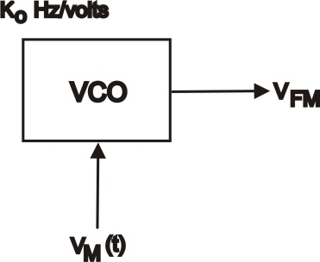
$V_{FM}=A Cos θ (t)$ .............. (1)
$f =f_{C}+ Δf$ ................. (2)
$Δf =K_{O }* V_{M}(t)$............... (3)
Above are the equations which govern the output of the VCO, f is the overall frequency of the frequency modulated output.
$ω=\frac{dθ(t)}{dt}=2πf$ ................. (4)
Taking the angle $θ$(t) from equation 1 and differentiating it will give the angular velocity of the output and equate it to 2$π$ times the effective frequency (f).
$\frac{dθ(t)}{dt}=2πf_{c}+2πΔf$ ............... (5)
$dθ\left(t\right)=2πf_{c}$dt + 2$πΔfdt$ ............. (6)
Multiply across both sides by the change in time (dt)
$θ\left(t\right)=2πf_{c}\int{dt}+2πK_{o}\int{V_{m}}(t)dt$ ............. (7)
$V_{m}\left(t\right)= V_{pk}$ Cos (2$πf_{m}t)$................. (8)
$θ\left(t\right)=2πf_{c}t+\frac{2πK_{O}}{2πf_{m}}$ $V_{pk}$ $sin (2πf_{m}t)$ ................ (9)
Substituting in the equation for the intelligence (baseband) voltage 8 into equation 7 and integrating gives equation 9 which is the angle of the frequency modulated wave of equation 1.
$θ\left(t\right)= 2πf_{c}t + \frac{K_{O}* V_{pk}}{f_{m}}$ $sin (2πf_{m}t)$............... (10)
${ M}_{F}$ = $\frac{K_{o} *{ V}_{pk}}{f_{m}}$ .................. (11)
$M_{F}=\frac{Δf_{c(pk)}}{f_{m}}$ .................... (12)
Tiding up equation 9, and setting the magnitude of the sine wave as${ M}_{F}$, the modulation index for frequency modulation.
$V_{FM}=A Cos θ\left(t\right)=A Cos\left[2πf_{c}t+ M_{F} Sin(2πf_{m}t)\right]$ .............. (13)
The above equation represents the standard equation for frequency modulation.
The equation for the other form of angle modulation, phase modulation is rather similar but has a few subtle differences.
$V_{PM}=A Cos θ\left(t\right) = A Cos\left[2πf_{c}t+ M_{F} Cos(2πf_{m}t)\right]$ .............. (14)
The difference is in the modulation Index and the phase of the varying angle inside the main brackets.
2.4.0.0 Angle modulation Graphs
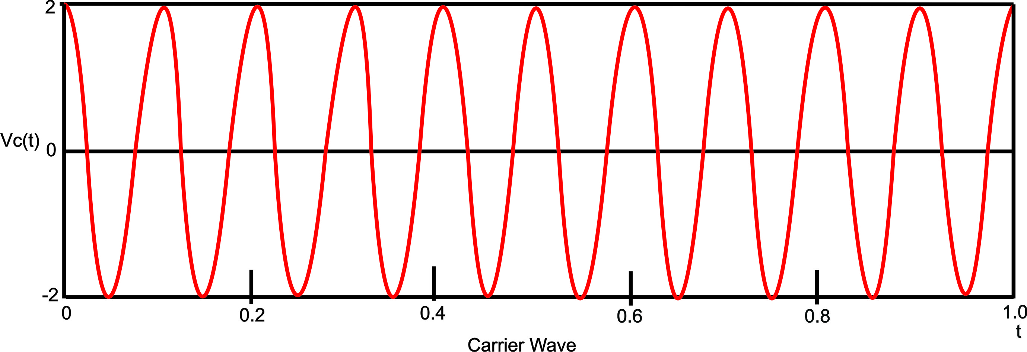
Fig. 2.1

$$V_{C}(t) =A Cos (2πf_{c} t)$$
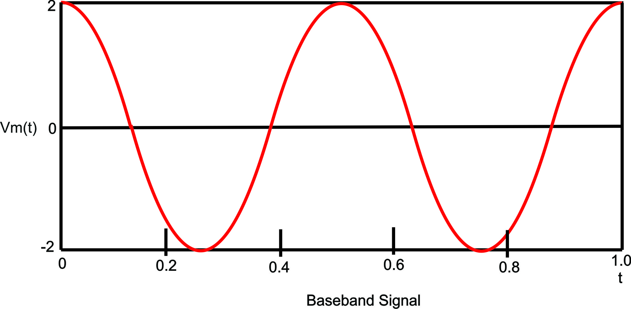
Fig. 2.2

$$V_{m}=(V_{pk} Cos \left(2πf_{m}t\right))$$
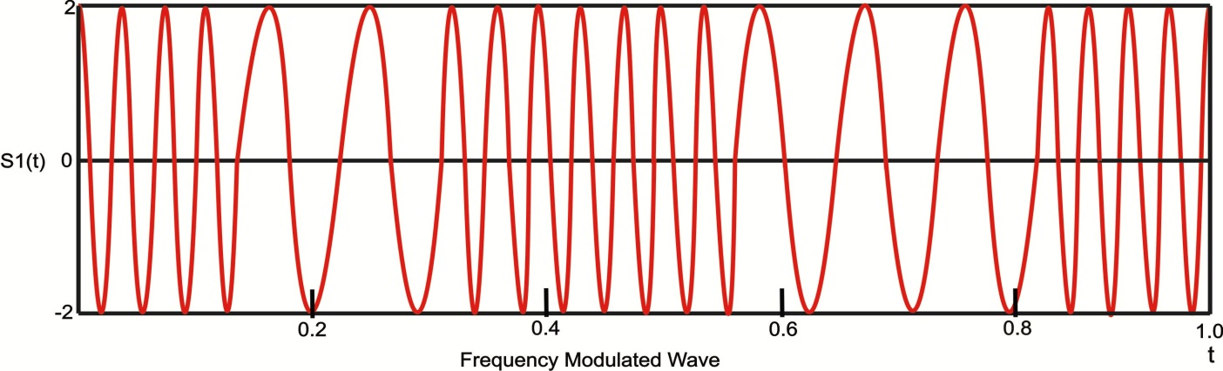
Fig. 2.3
$$S\left(t\right)=A Cos (2πf_{c}t+2πK_{O}\int_{0}^{t}{V_{m}}\left(t\right)dt)$$
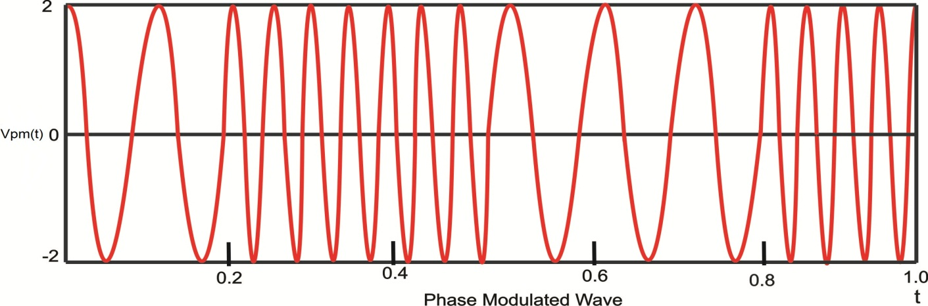
Fig. 2.4

$$V_{pm }(t)=ACos (2πf_{c}t+K_{p}V_{m}\left(t\right))$$
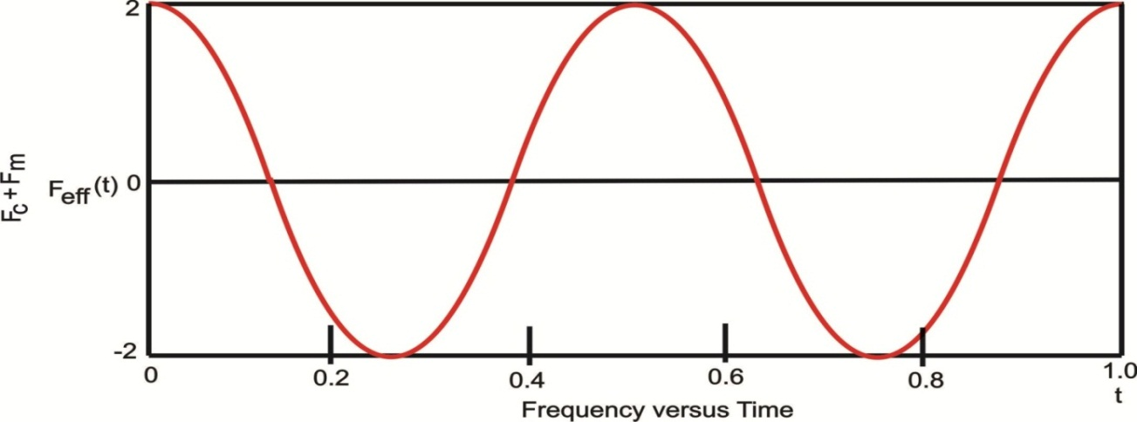
Fig. 2.4
$F_{eff}\left(t\right)=f_{c}+f_{m}Cos\left(\frac{2π}{T}. t\right)$
2.4.1.0 Analysis of the above graphs
There are 5 significant graphs above, the carrier (Fig. 2.1), the Baseband (Fig. 2.2), FM signal (Fig. 2.1), PM signal (Fig. 2.1) and the change of frequency over time (Fig. 2.1). The carrier and baseband are there to show the relative scale, so a link between the carrier and Baseband can be seen.
2.4.1.1 For FM: the carrier’s frequency is proportional to the baseband’s amplitude, the carrier increases frequency proportional to the positive magnitude of the baseband and decreases frequency proportional to the negative magnitude of the baseband.
2.4.1.2 For PM: the carrier’s frequency is proportional to the baseband’s amplitude, the carrier increases frequency proportional to the positive rate of change of the baseband and decreases frequency proportional to the negative rate of change of the baseband.
In other words when the baseband is a maximum or a minimum, there is Zero rate of change in the baseband, and the carrier’s frequency is equal to the its free running value$f_{c}$.
In both systems the rate of modulation is equal to the frequency of modulation (baseband’s frequency). The last graph shows the relationship between the frequency of FM versus Time, this relationship is used (following a limiter which makes sure the amplitude is a constant) by a discriminator at the receiver to extract the Baseband’s
Amplitude at the receiver, resulting in an amplitude modulated wave, the information is then demodulated using a simple diode detector. In common AM/FM receivers for an AM station to be demodulated, the limiter and discriminator can be by passed and the intermediate frequency signal can be fed straight to the diode detector.
2.5.0.0 Differences of Phase over Frequency modulation
The main difference is in the modulation index, PM uses a constant modulation index, whereas FM varies (Max frequency deviation over the instantaneous baseband frequency). Because of this the demodulation S/N ratio of PM is far better than FM.
The reason why PM is not used in the commercial frequencies is because of the fact that PM need a coherent local oscillator to demodulate the signal, this demands a phase lock loop, back in the early years the circuitry for a PLL couldn’t be integrated and therefore FM, without the need for coherent demodulation was the first on the market. One of the advantages of FM over PM is that the FM VCO can produce high- index frequency modulation, whereas PM requires multipliers to produce high-index
phase modulation. PM circuitry can be used today because of very large scale integration used in electronic chips, as stated before to get an FM signal from a phase modulator the baseband can be integrated, this is the modern approach taken in the development of high quality FM transmitters.
For miniaturization and transmission in the commercial bandwidth to be aims for the transmitter, PM cannot be even considered, even though Narrow Band PM can be used to produce Wide band FM (Armstrong Method).
2.6.0.0 FM Signals
FM signals which is a VHF signal is a simple but better form modulation as compared to AM as the amplitude of the modulated carrier remains constant and frequency is varied around the center frequency in accordance with the variations of the modulating signal.
In FM, the modulating frequency has no effect on the amount of deviation. Conversely, the rate of carrier deviation is determined only by the frequency of the modulated signals. The individual amplitudes of the modulating signal have no effect on the rate of deviation. For the fact that the amplitude of the FM wave remains constant, the characteristics provide the greatest advantage of FM over AM that is the superior noise immunity.
2.7.0.0 Signal Modulation
The FM signal modulation is where the amplitude of the modulated carrier remains constant and its frequency is varied around the center frequency in accordance with the variations of the modulating signal. Frequency modulating results in generation of sidebands appear at greater distances from the main carrier. The amplitude of the main carrier also depends on the amount of deviation.
The amount by which the signal frequency varies above and below the center of the main carrier (rest frequency) is called the deviation. The amount of deviation is only determined by the frequencies of the modulating signal; that all modulating signals having the same amplitudes will deviate from the carrier frequency by the same amount.
The amplitude of the sideband which appear at integral multiples of the modulating signal frequency above and below the carrier itself, are a function of the ratio of the deviation to the modulating frequency. The function is rather complicated, but in general, the greater the deviation, the greater the bandwidth of the signal. The ratio of the maximum frequency deviation to the highest modulating frequency is called the modulating index.
$$Modulating index= \frac{Maximum carrier deviation (d)}{Intelligence frequency (Fi)}$$
2.8.0.0 Signal Propagation
The FM signal propagation which is VHF signals is a form of tropospheric propagation which it propagation is by line of sight. Propagation by line of sight occurs at frequency ranged of 50Hz – 3000MHz and beyond 30000MHz. The signal travels at a velocity of light where
V = f λ where λ = wavelength
f = frequency of radiation
But V = $\frac{1}{\sqrt{UE}}$ for any medium

V= $\frac{1}{\sqrt{U_{O}U_{r}E_{O}E_{r}}}$ U_{o} = magnetic constant
U_{r} = Permeability, relative
E_{r} = Permeability, relative
E_{o} = Permeability of free space constant
In free space U_{r} = E_{r} =1
Therefore V= 3×10⁸m/s
$$Velocity ratio=\frac{velocity of propagation medium}{Velocity of propagation in free space}$$
Wave consists of independent electric and magnetic fields which act in direction mutually at right angles to the direction of propagation of the wave. If the electric field act in the vertical direction or the electrical component is vertical the waves are said to be vertically polarized. Such waves are launched and best pick up by vertical aerial. If the electric field is horizontal, the waves are said to be horizontally polarized and horizontal aerial are put to use. The horizontal polarization is used on the high frequency hands for long distance communication. And the vertical polarized is used for mobile work on VHF and UHF bands where the all “around” or omnidirectional characteristics simple vertical aerials area found to be disadvantageous.
2.8.1.0 Amplitude Modulation (AM)
Amplitude Modulation is defined as the process in which the program information is imposed on a carrier signal of constant frequency by varying it amplitude in proportion to program level (Modern Electronic Dictionary of Electronics by Rudolf .F. Graf, page 296). Amplitude Modulation occurs when a voice signal’s varying voltage is applied to a carrier frequency. The carrier frequency’s amplitude changes in accordance with the modulated voice signal, while the carrier’s frequency does not change.
When combined the resultant AM signal consist of the carrier frequency, plus UPPER and LOWER sidebands. This is known as Double Sideband – Amplitude Modulation (DSB-AM), or more commonly referred to as plain AM.
The carrier frequency may be suppressed or transmitted at a relatively low level. This requires that the carrier frequency be generated, or otherwise derived, at the receiving site for demultiplexing. This type of transmission is known as Double Sideband – Suppressed Carrier (DSB-SC).
It is also possible to transmit a SINGLE sideband for a slight sacrifice in low frequency response (it is difficult to suppress the carrier and the unwanted sideband, without some low frequency filtering as well). The advantage is a reduction in analog bandwidth needed to transmit the signal. This type of modulation, known as Single Sideband – Suppressed Carrier (SSB- SC), is ideal for Frequency Division Multiplexing (FDM).
Another type of analog modulation is known as Vertical Sideband. Vertical sideband modulation is a lot like Single Sideband, except frequency is preserved and one of the sidebands is eliminated through filtering. Analog bandwidth requirements are a little more than Single Sideband however.
Vertical sideband transmission is usually found in television broadcasting. Such broadcast channels require 6MHz of ANALOG bandwidth, in which an Amplitude Modulated PICTURE carrier is transmitted along with a Frequency Modulated SOUND carrier.
2.8.2.0 Frequency Modulation (FM)
Frequency modulation is defined as a system in which information sub carriers are frequency modulated and are used to amplitude modulate the carrier.
Frequency modulation occurs when a carrier’s CENTER frequency is changed based upon the input signal’s amplitude. Unlike Amplitude Modulation, the carrier signal’s amplitude is UNCHANGED. This makes FM modulation more immune to noise than AM and improves the overall signal-to-noise ratio of the communication system. Power output is also constant, differing from the varying AM output. The amount of analog bandwidth necessary to transmit a FM signal is greater than the amount necessary for AM, a limiting constraint for some systems.
2.9.0.0 Technical terms associated with FM
Now that FM has been established as a scheme of high quality baseband transmission, some of the general properties of FM will be looked at.
2.9.1.0 Capture Effect
Simply put means that if 2 stations or more are transmitting at near the same frequency FM ha s the ability to pick up the stronger signal and attenuated the unwanted signal pickup.
2.9.2.0 Modulation Index
$M_{F}= \frac{Δf_{c}(pk)}{f_{m}}$ (Was known as the modulation factor)
Modulation Index is used in communications as a measure of the relative amount of information to carrier amplitude in the modulated signal. It is also used to determine the spectral power distribution of the modulated wave. This can be seen in conjunction with the Bessel function. The higher the modulation index the more side-bands are created and therefore the more bandwidth is needed to capture most of the baseband’s information.
2.9.3.0 Deviation Ratio
The deviation can be quantified as the largest allowable modulation index.
$$D_{R}= \frac{Δf_{C}}{f_{m(max)}}=\frac{75KHz}{15KHz}=5 radians$$
For the commercial bandwidth the maximum carrier deviation is 75KHz. The human ear can pick up on frequencies from 20Hz to 20KHz, but frequencies above 15KHz can be ignored, so for commercial broadcasting (with a maximum baseband frequency of 15KHz) the deviation ratio is 5 radians.
2.9.4.0 Carrier Swing
The carrier swing is twice the instantaneous deviation from the carrier frequency.
$$F_{CS}=2.ΔF_{C}$$
The frequency swing in theory can be anything from 0Hz to 150KHz.
2.9.5.0 Percentage Modulation
The % modulation is a factor describing the ratio of instantaneous carrier deviation to the maximum carrier deviation.
$\% Modulation=\frac{ΔF_{C}}{ΔF_{C(pk)}}$ X 100
2.9.6.0 Carson’s Rule
Carson’s Rule gives an indication to the type of Bandwidth generated by an FM transmitter or the bandwidth needed by a receiver to recover the modulated signal.
Carson’s Rule states that the bandwidth in Hz is twice the sum of the maximum carrier frequency deviation and the instantaneous frequency of the baseband.
Bandwidth = 2 ($ΔF_{C(PK)}+ F_{M})$
= 2 $F_{M}$(1 +$M_{F}$)

CHAPTER THREE
3.0.0.0 PRACTICAL ANALYSIS OF ELECTRONIC COMPONENT
3.1.0.0 Introduction
Electronic component are basic electronic element or electronic parts usually packaged in a discrete from with two or more connecting leads or metallic pads. Electronic components are intended to be connected together, usually by soldering to a printed circuit board (PCB), to create an electronic circuit with a particular function (for example a FM transmitter, radio receiver, amplifier, etc.).
Electronic circuits are composed of elements such as resistors, capacitors, diodes, inductors, integrated circuit, transistors, voltage and current sources, all of which may be interconnected to permit the flow of electric currents.
These electronic components can be divided into two categories. They are;
- Passive component
- Active component
3.2.0.0 Passive Component
Components incapable of controlling current by means of another electrical signal are called passive devices. Resistors, capacitors, inductors, transformers, and even diodes are all considered passive devices. Only three of these devices will be treated in this project namely, resistors, capacitors and inductors. Diodes will be treated in amongst active component not because they are one but because they are made up of semiconductor. Resistors form the basic components in any electric circuit; therefore they shall be the first components that will be looked at, followed by capacitors and finally inductors.
3.2.1.0 Resistors
Resistors are the most commonly used component in electronics and their purpose is to create specified values of current and voltage in a circuit. Voltage dropped across a resistor is proportional to the amount of current flowing through the resistor${ V}_{r}= IR$, any current waveform through a resistor will produce the exact same voltage waveform across the resistor. Refer to Fig. 3.1. Although this seems trivial, it is worth keeping it in mind, especially when it comes to dealing with other components such as inductor, capacitor and ordinary wire at a high frequency.

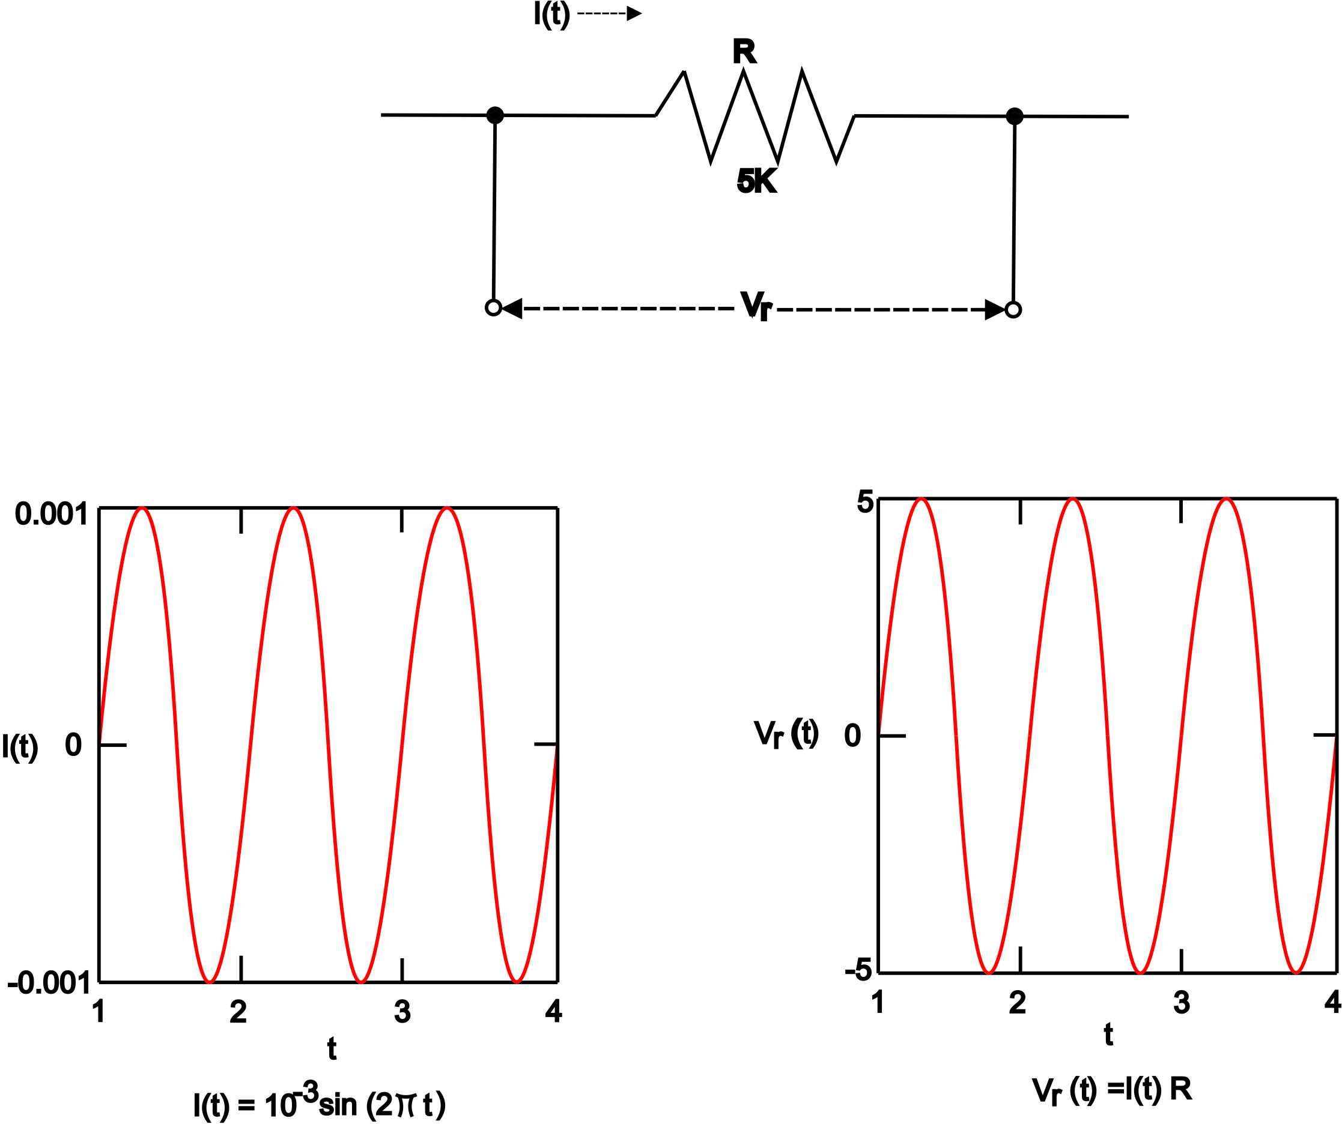
Fig. 3.1 Resistor Performance Graph
A number of different resistors are shown in the photos below. (The resistors are on millimeter paper, with 1cm spacing to give some idea of the dimensions). Photo 3.1a shows some higher-power resistors, while photo 3.1b shows some low-power resistors. Resistors with power dissipation below 5 watt (most commonly used types) are cylindrical in shape, with a wire protruding from each end for connecting to a circuit (photo 3.1b). Resistors with power dissipation above 5 watt are shown below (photo 3.1a).

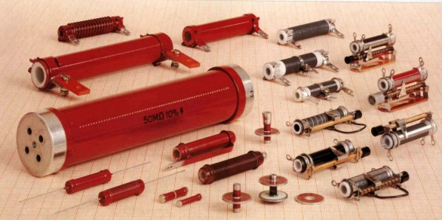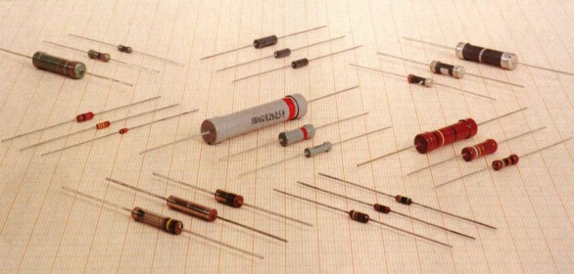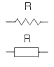
Photo 3.1a Photo 3.1b Fig. 3.2
The symbol for a resistor is shown in Fig. 3.2 (upper: American symbol, lower: European symbol.)
The unit for measuring resistance is the OHM (the Greek letter Ω - called Omega). Higher resistance values are represented by "k" (kilo-ohms) and M (megohms). For example, 120 000 Ω is represented as 120k, while 1 200 000Ω is represented as 1M2. The dot is generally omitted as it can easily be lost in the printing process. In some circuit diagrams, a value such as 8 or 120 represents a resistance in ohms. Another common practice is to use the letter E for resistance in ohms. The letter R can also be used. For example, 120E (120R) stands for 120 Ω, 1E2 stands for 1R2 etc.
3.2.2.0 Resistor Markings
Resistance value is marked on the resistor body. Most resistors have 4 bands. The first two bands provide the numbers for the resistance and the third band provides the number of zeros. The fourth band indicates the tolerance. Tolerance values of 5%, 2%, and 1% are most commonly available.
The following table shows the colors used to identify resistor values:
Table 3.1: Resistor Color Codes.
COLOR | DIGIT | MULTIPLIER | TOLERANCE | TC
Silver |  | x 0.01 W | ±10%
Gold |  | x 0.1 W | ±5%
Black | 0 | x 1 W
Brown | 1 | x 10 W | ±1% | ±100*10⁻⁶/K
Red | 2 | x 100 W | ±2% | ±50*10⁻⁶/K
Orange | 3 | x 1 kW |  | ±15*10⁻⁶/K
Yellow | 4 | x 10 kW |  | ±25*10⁻⁶/K
Green | 5 | x 100 kW | ±0.5%
Blue | 6 | x 1 MW | ±0.25% | ±10*10⁻⁶/K
Violet | 7 | x 10 MW | ±0.1% | ±5*10⁻⁶/K
Grey | 8 | x 100 MW
White | 9 | x 1 GW |  | ±1*10⁻⁶/K
** TC - Temp. Coefficient, only for SMD devices
NOTES:
The resistors above are "common value" 5% types. The fourth band is called the "tolerance" band. Gold = 5% (tolerance band Silver =10% but no modern resistors are 10 %!! "Common resistors" have values 10 ohms to 22M.
When third band of resistor is gold, it indicates the value of the "colors" must be divided by 10. i.e.
Gold = "divide by 10" to get values 1R0 to 8R2
When the third band is silver, it indicates the value of the "colors" must be divided by 100. (Remember: more letters in the word "silver" thus the divisor is "larger.")
Silver = "divide by 100" to get values 0R1 (one tenth of an ohm) to 0R82
e.g.: 0R1 = 0.1 ohm 0R22 = point 22 ohms
The letters "R, k and M" take the place of a decimal point. The letter "E" is also used to indicate the word "ohm."
e.g.: 1R0 = 1 ohm 2R2 = 2 point 2 ohms 22R = 22 ohms
2k2 = 2,200 ohms 100k = 100,000 ohms
2M2 = 2,200,000 ohms
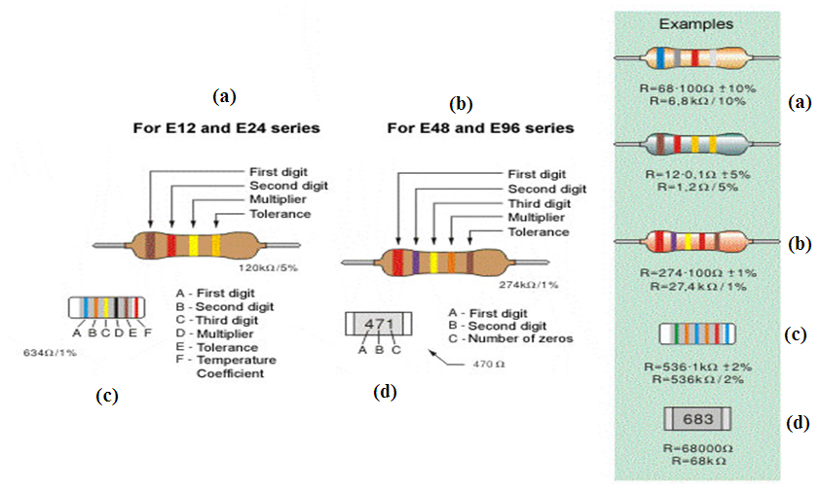
Fig. 3.3: a. Four-band resistor, b. Five-band resistor, c. Cylindrical SMD resistor, d. Flat SMD resistor

Common resistors have 4 bands. These are shown above in Fig.3.3. The first two bands indicate the first two digits of the resistor; the third band is the multiplier (number of zeros that are to be added to the number derived from first two bands) and the fourth represents the tolerance.
Marking the resistance with five bands is used for resistors with tolerance of 2%, 1% and other high-accuracy resistors. The first three bands determine the first three digits; the fourth is the multiplier and fifth represents the tolerance.
For SMD (Surface Mounted Device) the available space on the resistor is very small. 5% resistors use a 3 digit code, while 1% resistors use a 4 digit code.
Some SMD resistors are made in the shape of small cylinder while the most common type is flat. Cylindrical SMD resistors are marked with six bands - the first five are "read" as with common five-band resistors, while the sixth band determines the Temperature Coefficient (TC), which gives us a value of resistance change upon 1-degree temperature change.
The resistance of flat SMD resistors is marked with digits printed on their upper side. First two digits are the resistance value, while the third digit represents the number of zeros. For example, the printed number 683 stands for 68000Ω, that is 68kΩ.
It is self-obvious that there is mass production of all types of resistors. Most commonly used are the resistors of the E12 series, and have a tolerance value of 5%. Common values for the first two digits are: 10, 12, 15, 18, 22, 27, 33, 39, 47, 56, 68 and 82.
The E24 series includes all the values above, as well as: 11, 13, 16, 20, 24, 30, 36, 43, 51, 62, 75 and 91. What do these numbers mean? It means that resistors with values for digits "39" are: 0.39Ω, 3.9Ω, 39Ω, 390Ω, 3.9kΩ, 39kΩ, etc. are manufactured. (0R39, 3R9, 39R, 390R, 3k9, 39k)
For some electrical circuits, the resistor tolerance is not important and it is not specified. In that case, resistors with 5% tolerance can be used. However, devices which require resistors to have a certain amount of accuracy need a specified tolerance.
3.2.3.0 Resistor Dissipation
If the flow of current through a resistor increases, it heats up, and if the temperature exceeds a certain critical value, it can be damaged. The wattage rating of a resistor is the power it can dissipate over a long period of time.
Wattage rating is not identified on small resistors. The following diagrams show the size and wattage rating:
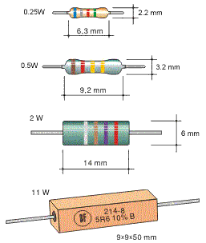
Fig. 3.4: Resistor dimensions

Most commonly used resistors in electronic circuits have a wattage rating of 1/2W or 1/4W. There are smaller resistors (1/8W and 1/16W) and higher (1W, 2W, 5W, etc.).
In place of a single resistor with specified dissipation, another one with the same resistance and higher rating may be used, but its larger dimensions increase the space taken on a printed circuit board as well as the added cost.
Power (in watts) can be calculated according to one of the following formulae, where U is the symbol for Voltage across the resistor (and is in Volts), I is the symbol for Current in Amps and R is the resistance in ohms:
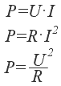
For example, if the voltage across an 820Ω resistor is 12V, the wattage dissipated by the resistors is:
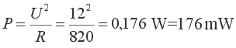
Therefore a 1/4W resistor can be used.
In many cases, it is not easy to determine the current or voltage across a resistor. In this case the wattage dissipated by the resistor is determined for the "worst" case. We should assume the highest possible voltage across a resistor, i.e. the full voltage of the power supply (battery, etc.).
If we mark this voltage as V_{B}, the highest dissipation is:
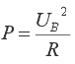
For example, if V_{B} = 9V, the dissipation of a 220Ω resistor is:
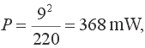
In this case a 0.5W or higher wattage resistor should be used

3.2.4.0 Nonlinear resistors
Resistance values detailed above are a constant and do not change if the voltage or current-flow alters. But there are circuits that require resistors to change value with a change in temperate or light. This function may not be linear, hence the name NONLINEAR RESISTORS.
There are several types of nonlinear resistors, but the most commonly used include: Negative Temperature Co-efficient resistors (NTC), (fig.3.5 a) - their resistance lowers with temperature rise. Positive Temperature Co-efficient resistors (PTC), (fig.3.5 b) - their resistance increases with the temperature rise. Light Dependent Resistors (LDR), (fig.3.5 c) - their resistance lowers with the increase in light. Voltage dependent Resistors (VDR) - their resistance critically lowers as the voltage exceeds a certain value. Symbols representing these resistors are shown below in Fig. 3.5.
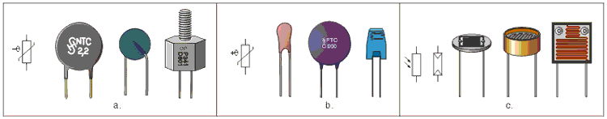
Fig. 3.5: Nonlinear resistors - a. NTC, b. PTC, c. LDR
3.2.5.0 Potentiometers
Potentiometers (also called pots) are variable resistors, used as voltage or current regulators in electronic circuits. By means of construction, they can be divided into 2 groups: coated and wire-wound.
With coated potentiometers, (figure 3.6), insulator body is coated with a resistive material. There is a conductive slider moving across the resistive layer, increasing the resistance between slider and one end of pot, while decreasing the resistance between slider and the other end of pot.
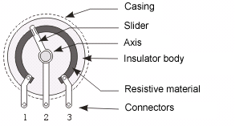
Fig. 3.6: Coated potentiometer
Wire-wound potentiometers are made of conductor wire coiled around insulator body. There is a slider moving across the wire, increasing the resistance between slider and one end of pot, while decreasing the resistance between slider and the other end of pot.
Coated pots are much more common. With these, resistance can be linear, logarithmic, inverse-logarithmic or other, depending upon the angle or position of the slider. Most common are linear and logarithmic potentiometers, and the most common applications are radio-receivers, audio amplifiers, and similar devices where pots are used for adjusting the volume, tone, balance, etc.
Wire-wound potentiometers are used in devices which require more accuracy in control. They feature higher dissipation than coated pots, and are therefore in high current circuits.
Potentiometer resistance is commonly of E6 series, including the values: 1, 2.2 and 4.7. Standard tolerance values include 30%, 20%, 10% (and 5% for wire-wound pots).
Potentiometers come in many different shapes and sizes, with wattage ranging from 1/4W (coated pots for volume control in amps, etc.) to tens of watts (for regulating high currents). Several different pots are shown in the photo 3.2, along with the symbol for a potentiometer.
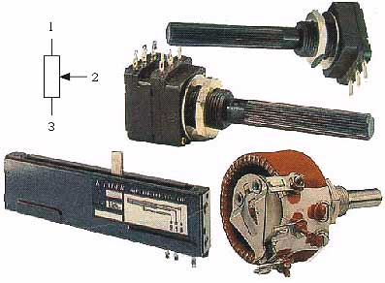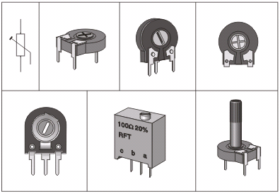
Photo 3.2: Potentiometers Fig. 3.7: Trim pots

The upper model represents a stereo potentiometer. These are actually two pots in one casing, with sliders mounted on shared axis, so they move simultaneously. These are used in stereophonic amps for simultaneous regulation of both left and right channels, etc. The lower left is the so called slider potentiometer and the Lower right is a wire-wound pot with wattage of 20W, commonly used as rheostat (for regulating current while charging a battery etc.).
For circuits that demand very accurate voltage and current values, trimmer potentiometers (or just trim pots) are used. These are small potentiometers with a slider that is adjusted via a screwdriver.
Trim pots also come in many different shapes and sizes, with wattage ranging from 0.1W to 0.5W. Fig. 3.7 shows several different trim pots, along with their symbol.
Resistance adjustments are made via a screwdriver. Exception is the trim pot on the lower right, which can be adjusted via a plastic shaft. Particularly fine adjusting can be achieved with the trim pot in the plastic rectangular casing (lower middle). Its slider is moved via a screw, so that several full turns are required to move the slider from one end to the other.
3.2.6.0 Factors to consider when choosing a resistor
There are three main factors to consider when choosing a resistor for an intended application. They are;
- Tolerance
- Power rating
- Stability

TABLE 3.2: Types of resistor and their ratings.
 | Thick Film | Metal Film | Carbon Film | Wire-wound
Max. value | 1MΩ | 10 MΩ | 10 MΩ | 22kΩ
Tolerance | ±1% to ±5 | ±1% to ±5 | ±1% to ±5 | ±1% to ±5
Power Rating | 0.1 to 1W | 0.125 to 0.75W | 0.125 to 2W | 2.5W
Temp. Coefficient. | ± 100 to 200 ppm/ºC | ±50 to 200 ppm/ºC | 0 to 700ppm/ºC | ±30 to 500 ppm/ºC
Stability | Very Good | Very Good | Very Good | Very Good
Typical Use | For accurate wok | Accurate work | General purpose | For low values

3.2.7.0 Testing Resistor the Accurate Way
There are two ways to testing resistor such as using the analog and digital multimeter. Normally if a resistor fails, they will either increase in value or open up (open circuit). You can check the resistor’s resistance with an ohmmeter (photo. 3.2) or digital multimeter (photo. 3.3). If the resistor is in circuit, you will generally have to remove the resistor so that you will be testing only the resistor value and not the other components in the circuit. Always be aware of possible back (parallel circuit) circuits when checking in-circuit resistance measurements.
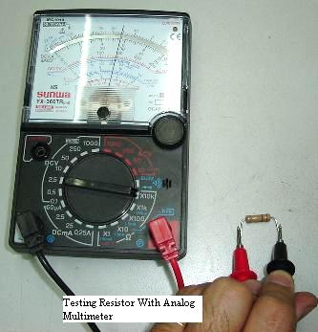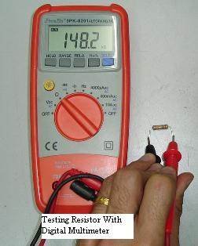
Photo 3.2 Testing a resistor with an analog multimeter. Photo 3.3 Testing a resistor with a digital multimeter.
As a technician or engineers, many times we wants to repair and solve electronic problems as fast as we could and by removing all resistors from the board and check the resistors one by one will take up a lot of our repair time. There must be a simple and easy way to test resistor on board. Using analog meter to check resistor on board often produced an inaccurate reading. This is due to the reasons that the output from the analog meter probe is about 3 volt to 12 volt.
The voltages produced by the analog mater are quite high and it can trigger the semiconductor devices around the resistors circuit such as the diode, SCR, transistor and ICs. This is because semiconductors devices needs only 0.6 volt in order to conduct and since the output voltage from the analog meter is higher than the semiconductors, checking the resistor in circuit won't give you an accurate reading! In order to measure resistors while it is still in circuit, you need to get a multimeter that has an output of less than 0.6 volt. This is to avoid conducting the semiconductor devices around the circuit that you want to test. A Greenlee digital meter that have output around 0.2 volt can be used. Though it cannot give a 100% accurate reading at least it can help to speed up repair job. Why not 100%? This is because some electronic circuits have resistors that are directly parallel to each other.
3.3.0.0 Capacitors
The voltage across a capacitor lags the current through it. Refer to Fig. 3.8a. The reason for this lags in voltage is that the voltage is proportional to the integral of current entering the capacitor. Looking at the plotted graph in Fig.3.8b, the current will reach a maximum 90⁰ into the cycle , the voltage will reach a maximum when the area under the current’s curve is added up this doesn’t happen until 180⁰ into the currents cycle, giving a 90 degrees voltage lag. The impedance of the capacitor can be found to be $-j\frac{1}{ω_{C}}$ which also takes into account of the capacitors voltage lag.
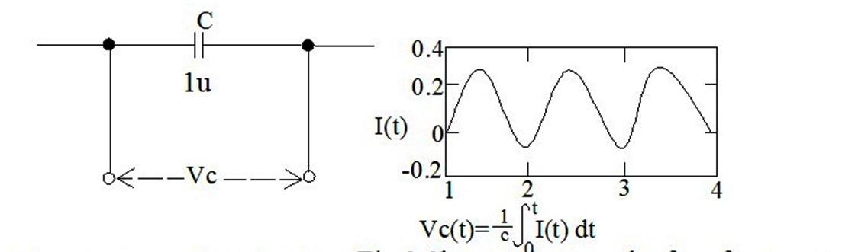
Fig.3.8a A capacitor circuit Fig.3.8b capacitor graph of performance.
Capacitors are common components of electronic circuits, used almost as frequently as resistors. The basic difference between the two is the fact that capacitor resistance (called reactance) depends on the frequency of the signal passing through the item. The symbol for reactance is X_{C} and it can be calculated using the following formula:
$$X_{C}=\frac{1}{2πfC}$$Where f = frequency in Hz
C= Capacitance in Farads.
For example, 5nF-capacitor's reactance at f = 125 kHz equals:
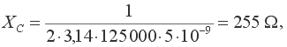
while, at f=1.25MHz, it equals:
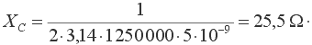
A capacitor has an infinitely high reactance for direct current, because f=0.
Capacitors are used in circuits for many different purposes. They are common components of filters, oscillators, power supplies, amplifiers, etc.
The basic characteristic of a capacitor is its capacity - the higher the capacity, the higher is the amount of electricity it can hold. Capacity is measured in Farads (F). As one Farad represents fairly high capacity, smaller values such as microfarad (µF), nanofarad (nF) and picofarad (pF) are commonly used. As a reminder, relations between units are: 1F=10⁶µF=10⁹nF=10¹²pF, which is 1µF=1000nF and 1nF=1000pF. It is essential to remember this notation, as same values may be marked differently in some circuits. For example, 1500pF is the same as 1.5nF and 100nF is 0.1µF.
A simpler notation system is used as with resistors. If the mark on the capacitor is 120 the value is 120pF, 1n2 stands for 1.2nF, n22 stands for 0.22nF, while .1µ (or .1u) stands for 0.1µF.
Capacitors come in various shapes and sizes, depending on their capacity, working voltage, type of insulation, temperature coefficient and other factors. All capacitors can be divided in two groups: those with changeable capacity values and those with fixed capacity values. These will covered in the following section.
3.3.1.0 Block-capacitors
Capacitors with fixed values (the so called block-capacitors) consist of two thin metal plates (these are called "electrodes" or sometimes called the "foil"), separated by a thin insulating material such as plastic. The most commonly used material for the "plates" is aluminium, while the common materials used for insulator include paper, ceramic, mica, etc. after which the capacitors get named. Some of them are Electrolytic capacitors, tantalum capacitors, Ceramic Capacitors, Multilayer Ceramic Capacitors, Polystyrene Film Capacitors, Electric Double Layer Capacitors (Super Capacitors), Polyester Film Capacitors, Polypropylene Capacitors, Mica Capacitors and Metallized Polyester Film Capacitors. Photo 3.4 shows different block-capacitors below. A symbol for a capacitor is in the upper right corner of the image.
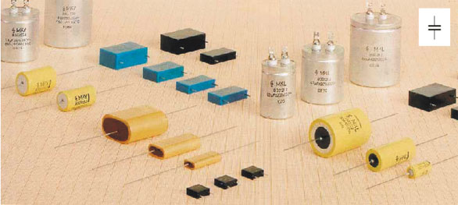
Photo 3.4: Block capacitors

Most of the capacitors, block-capacitors included, are non-polarized components, meaning that their leads are equivalent in respect of the way the capacitor can be placed in a circuit. Electrolytic capacitors represent the exception as their polarity is important.
3.3.2.0 Marking the block-capacitors
Commonly, capacitors are marked by a set of numbers representing the capacity. Beside this value is another number representing the maximal working voltage, and sometimes tolerance, temperature coefficient and some other values are printed as well. But on the smallest capacitors (such as surface-mount) there are no markings at all and you must not remove them from their protective strips until they are needed. The size of a capacitor is never an indication of its value as the dielectric and the number of layers or "plates" can vary from manufacturer to manufacturer. The value of a capacitor on a circuit diagram, marked as 4n7/40V, means the capacitor is 4,700pF and its maximal working voltage is 40v. Any other 4n7 capacitor with higher maximal working voltage can be used, but they are larger and more expensive.
Sometimes, capacitors are identified with colors, similar to the 4-band system used for resistors (fig. 3.9). The first two colors (A and B) represent the first two digits, third color (C) is the multiplier, fourth color (D) is the tolerance, and the fifth color (E) is the working voltage.
With disk-ceramic capacitors (fig. 3.9b) and tubular capacitors (fig. 3.9c) working voltage is not specified, because these are used in circuits with low DC voltage. If a tubular capacitor has five color bands on it, the first color represents the temperature coefficient, while the other four specify the capacity in the previously described way.
Table 3.3: Capacitor Color Code
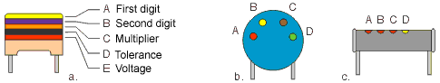 | 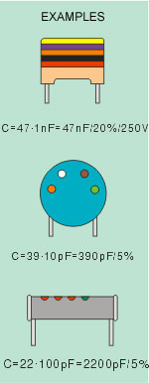
COLOR | DIGIT | MULTIPLIER | TOLERANCE | VOLTAGE
Black | 0 | x 1 pF | ±20%
Brown | 1 | x 10 pF | ±1%
Red | 2 | x 100 pF | ±2% | 250V
Orange | 3 | x 1 nF | ±2.5%
Yellow | 4 | x 10 nF |  | 400V
Green | 5 | x 100 nF | ±5%
Blue | 6 | x 1 µF
Violet | 7 | x 10 µF
Grey | 8 | x 100 µF
White | 9 | x 1000 µF | ±10%

Fig. 3.9: Marking the capacity using colours

The fig. 3.10 shows how the capacities of miniature tantalum electrolytic capacitors are marked by colors. The first two colors represent the first two digits and have the same values as with resistors. The third color represents the multiplier, to get the capacity expressed in µF. The fourth color represents the maximal working voltage.
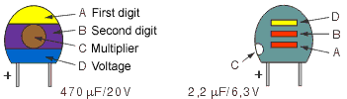
Fig. 3.10: Marking the tantalum electrolytic capacitors

Table 3.4: Capacitor color code for tantalum capacitors.
COLOR | DIGIT | MULTIPLIER | VOLTAGE
Black | 0 | x 1 µF | 10V
Brown | 1 | x 10 µF
Red | 2 | x 100 µF
Orange | 3
Yellow | 4 |  | 6.3V
Green | 5 |  | 16V
Blue | 6 |  | 20V
Violet | 7
Grey | 8 | x .01 µF | 25V
White | 9 | x .1 µF | 3V
Pink |  |  | 35V

One important note on the working voltage: The voltage across a capacitor must not exceed the maximal working voltage as the capacitor may get destroyed. In the case when the voltage is unknown, the "worst" case should be considered. There is the possibility that, due to malfunction of some other component, the voltage on capacitor equals the power supply voltage. If, for example, the supply is 12V, the maximal working voltage for the capacitor should be higher than 12V.
3. 3.3.0 Electrolytic capacitors
Electrolytic capacitors represent the special type of capacitors with fixed capacity value. Thanks to special construction, they can have exceptionally high capacity, ranging from one to several thousand µF. They are most frequently used in circuits for filtering, however they also have other purposes.
Electrolytic capacitors are polarized components, meaning they have positive and negative leads, which is very important when connecting it to a circuit. The positive lead or pin has to be connected to the point with a higher positive voltage than the negative lead. If it is connected in reverse the insulating layer inside the capacitor will be "dissolved" and the capacitor will be permanently damaged.
Explosion may also occur if capacitor is connected to voltage that exceeds its working voltage. In order to prevent such instances, one of the capacitor's connectors is very clearly marked with a + or -, while the working voltage is printed on the case.
Several models of electrolytic capacitors, as well as their symbols, are shown on the picture below.
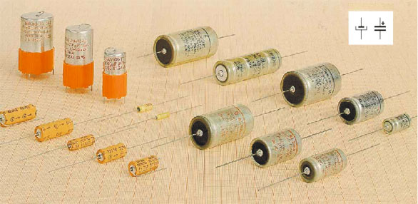
Fig. 3.5: Electrolytic capacitors

Tantalum capacitors represent a special type of electrolytic capacitor. Their parasitic inductance is much lower than standard aluminum electrolytic capacitors so that tantalum capacitors with significantly (even ten times) lower capacity can completely substitute an aluminum electrolytic capacitor.
3. 3.4.0 Variable capacitors
Variable capacitors are capacitors with variable capacity. Their minimal capacity ranges from 1pF and their maximum capacity goes as high as few hundred pF (500pF max). Variable capacitors are manufactured in various shapes and sizes, but common features for them are a set of fixed plates (called the stator) and a set of movable plates. These plates are fitted into each other and can be taken into and out of mesh by rotating a shaft. The insulator (dielectric) between the plates is air or a thin layer of plastic, hence the name variable capacitor. When adjusting these capacitors, it is important that the plates do not touch.
Below are photos of air-dielectric capacitors as well as Mylar-insulated variable capacitors (3.6a).
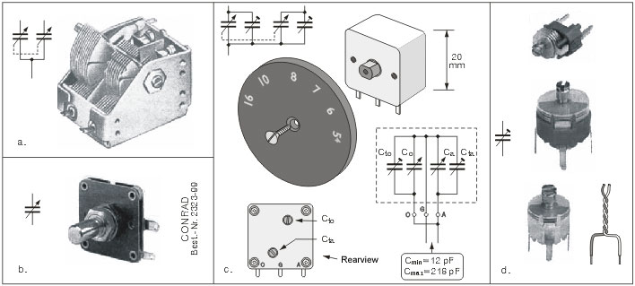
Photo 3.6: a, b, c. Variable capacitors, d. Trimmer capacitors
The first photo shows a "ganged capacitor" in which two capacitors are rotated at the same time. This type of capacitor is used in radio receivers. The larger is used for the tuning circuit, and the smaller one in the local oscillator. The symbol for these capacitors is also shown in the photo.
Beside capacitors with air dielectric, there are also variable capacitors with solid insulator. With these, thin insulating material such as Mylar occupies the space between stator and rotor. These capacitors are much more resistant to mechanical damage. They are shown in photo 3.6b.
The most common devices containing variable capacitors are radio receivers and transmitters, where these are used for frequency adjustment. Semi-variable or trim capacitors are miniature capacitors, with capacity ranging from several pF to several tens of pFs. These are used for fine tuning radio receivers, radio transmitters, oscillators, etc. Three trimmers, along with their symbol, are shown on the photo 3.6d.
3.3.5.0 Practical examples
Several practical examples using capacitors are; electrolytic capacitor is used for DC blocking and allowing AC in power supplies. In amplifiers, it allows the signals to pass from one stage to the next while prevent the DC on one stage from being passed to the next stage. This occurs because the capacitor acts like a resistor of very low resistance for the AC signals and as a resistor of high resistance for DC.
3.3.6.0 Things to consider when choosing Capacitors
The most important factors when choosing a capacitor are;
- Leakage resistance
- Polarized/ non-polarized
- Temperature Coefficient
Table 3.5: Capacitor types and ratings
 | Silvered Mica | Ceramic | Electrolytic | Tantalum | Polystyrene
Range | 22pF to 10nF | 1nF to 100nF | 0.1μF to 47mF | 1μF to 100μF | 22pF to 0.1μF
Tolerance | ±1% | -20% to 80% | -10t%to 50% | ±20% | ±1%
Temp. Coefficient. | +35ppm/ºC | +20ppm/ºC | ±1500ppm/ºC | ±500ppm/ºC | -150ppm/ºC
Leakage resistance | Very High | High | Very Low | Low | Very High
Stability | Excellent | Good | Fair | Good | Excellent

3.3.7.0 Testing Capacitors the Accurate Way.

There are three methods of testing capacitor as described in this project. This can be achieved by using Analog, Digital or Equivalent Series Resistance (ESR) meters.
Before you start testing your capacitor, you must first discharge it to prevent shock and other inconveniences.
Before testing a capacitor using an analog multimeter, set the knob to X1 ohm range and connect a capacitor to the test probe. Watch the display panel to see if the pointer flicks up and comes down or not, which represent charging and discharging of the capacitor. If it does not flick or response then set your meter to X10 ohm and then to X1k ohm and lastly to X10 kilo ohm range. If it still does not flick then the capacitor under test have developed an open circuit. Refer to fig. 3.11. This is rather an old method to test capacitors because even though a capacitor can charge and discharge, this does not mean the capacitor value is good. Due to this problem, digital capacitance meter was developed.

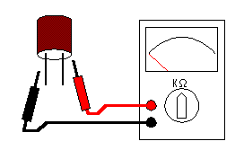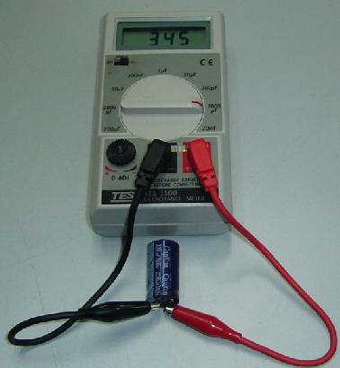
Fig. 3.11 Using an analog multimeter Photo 3.7 Using a Digital multimeter Capacitance

The second method used to test a capacitor is to use digital capacitance meter and is a little more accurate comparing it to analog multimeter. Connect the test probe to the capacitor and read the result from the meter LCD display. Example, a 100 microfarad should have the reading of somewhere 90 microfarad to 110 microfarad. Remember, capacitors have tolerance just like resistors.
Be sure to discharge capacitor first before testing. A reading of 60 microfarad means the capacitor has lost its capacitance and need to be replaced. This meter is more expensive than analog meter. Somehow digital capacitance meter have its own disadvantage, which is, it can’t check capacitor that is breaking down when under load and it can’t check capacitors in circuit. It’s still worth to invest in this meter because it can check almost 80-90 % of capacitors failure.

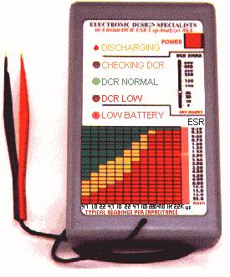
Photo 3.8 Eds Capanalyser 88A ESR Meter used to test capacitors

The third and most accurate method is to use an ESR meter which stand for equivalent series resistance. This is the latest technology in testing capacitors. It can only check electrolytic capacitors and the advantage is that you can perform capacitor testing while the capacitor is still in circuit and have the accuracy of 99% compare to other meters. It is fast and can discharge a capacitor before it begin to test the capacitor and save you a lot of time. ESR meter is the most reliable and accurate meter so far.
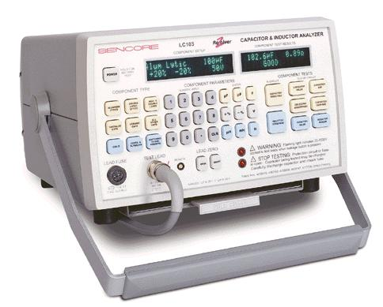
Photo 3.9. A Sencore LC103 Capacitor & Inductor Analyzer

If you have the budget, you may consider investing in the high end capacitor tester such as the Sencore LC meter LC102 OR LC103, (photo 3.9) these meters have the capabilities of measuring any type of capacitors with four tests;
- measure capacitor values
- checking for leakage
- equivalent series resistance (ESR) and
- Dielectric absorption
It can test aluminium electrolytic capacitor, film capacitor, ceramic, high voltage capacitor and etc. It also has the function to check inductors or coils too. A capacitor failure when under load is very rare. Using ESR capacitor meter alone can solve most of the electrolytic capacitor problem.
3.4.0.0 Inductor
An inductor or a reactor is a passive electrical component that can store energy in a magnetic field created by the electric current passing through it. An inductor's ability to store magnetic energy is measured by its inductance, in units of Henries (H). Typically an inductor is a conducting wire shaped as a coil, the loops helping to create a strong magnetic field inside the coil due to Faraday's Law of Induction. The symbol used to represent an inductor in electronic circuits is shown in Fig 3.12.
Fig. 3.12 Electronic symbol of an inductor.
Inductors are one of the basic electronic components used in electronics where current and voltage change with time, due to the ability of inductors to delay and reshape alternating currents. The voltage across an inductor leads the current through it by ${90}^{0}$, this is due to the fact that the voltage across an inductor depends on the rate of change of current entering the inductor.
The impedance of an inductor (z) is +j$ω$L. where ($ω$ = 2πf), which reflect the fact that the voltage leads the current. This analysis is vital in working out the phase shift through complicated LC networks.
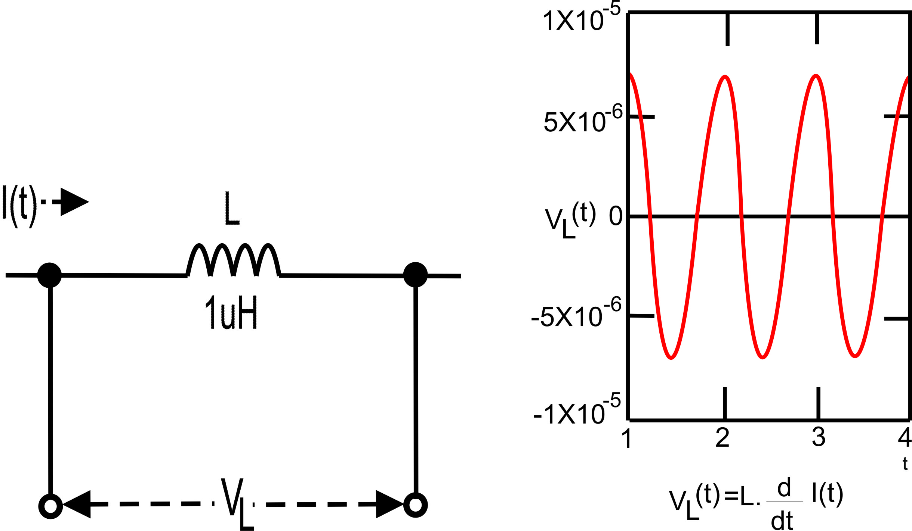
Fig.3.13a Shows the current flowing through an inductor and Fig. 3.13b Shows the relationship between the load Corresponding load voltage across it. Voltage, current and time.

An inductor opposes changes in current. An ideal inductor would offer no resistance to a constant direct current; however, only superconducting inductors have truly zero electrical resistance.
In general, the relationship between the time-varying voltage v (t) across an inductor with inductance L and the time-varying current I (t) passing through it is described by the differential equation:
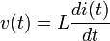
When there is a sinusoidal alternating current (AC) through an inductor, a sinusoidal voltage is induced. The amplitude of the voltage is proportional to the product of the amplitude (I_{P}) of the current and the frequency (f) of the current.
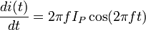
In this situation, the phase of the current lags that of the voltage by 90 degrees. Refer to Fig.3.13b.
If an inductor is connected to a DC current source, with value I via a resistance, R, and then the current source short circuited the differential relationship above shows that the current through the inductor will discharge with an exponential decay:

3.4.1.0 Laplace circuit analysis (s-domain)
When using the Laplace transform in circuit analysis, the transfer impedance of an ideal inductor with no initial current is represented in the s domain by:
Where L is the inductance, and
s is the complex frequency
If the inductor does have initial current, it can be represented by:
- adding a voltage source in series with the inductor, having the value:
Where L is the inductance, and
I₀ is the initial current in the inductor.
(Note that the source should have a polarity that is aligned with the initial current)
- or by adding a current source in parallel with the inductor, having the value:
3.4.2.0 Inductor Networks (Series and parallel circuits)
Inductors in a parallel configuration each have the same potential difference (voltage). To find their total equivalent inductance (L_{eq}):
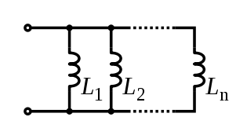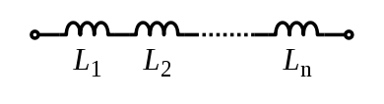
Fig.3.14a Inductors in parallel Fig.3.14b inductors in series
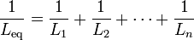
The current through inductors in series stays the same, but the voltage across each inductor can be different. The sum of the potential differences (voltage) is equal to the total voltage. To find their total inductance:
These simple relationships hold true only when there is no mutual coupling of magnetic fields between individual inductors.

3.4.3.0 Stored Energy
The energy (measured in joules, in SI) stored by an inductor is equal to the amount of work required to establish the current through the inductor, and therefore the magnetic field. This is given by:
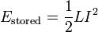 Where L is inductance and I is the current through the inductor.

3.4.4.0 The Q Factor of an Inductor
An ideal inductor will be lossless irrespective of the amount of current through the winding. However, typically inductors have winding resistance from the metal wire forming the coils. Since the winding resistance appears as a resistance in series with the inductor, it is often called the series resistance. The inductor's series resistance converts electrical current through the coils into heat, thus causing a loss of inductive quality. The quality factor (or Q) of an inductor is the ratio of its inductive reactance to its resistance at a given frequency, and is a measure of its efficiency. The higher the Q factor of the inductor, the closer it approaches the behavior of an ideal, lossless, inductor.
The Q factor of an inductor can be found through the following formula, where R is its internal electrical resistance and ωL is capacitive or inductive reactance at resonance:
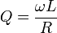
By using a ferromagnetic core, the inductance is greatly increased for the same amount of copper, multiplying up the Q. Cores however also introduce losses that increase with frequency. A grade of core material is chosen for best results for the frequency band. At VHF or higher frequencies an air core is likely to be used.
Inductors wound around a ferromagnetic core may saturate at high currents, causing a dramatic decrease in inductance (and Q). This phenomenon can be avoided by using a (physically larger) air core inductor. A well designed air core inductor may have a Q of several hundred.
An almost ideal inductor (Q approaching infinity) can be created by immersing a coil made from a superconducting alloy in liquid helium or liquid nitrogen. This super cools the wire, causing its winding resistance to disappear. Because a superconducting inductor is virtually lossless, it can store a large amount of electrical energy within the surrounding magnetic field (see superconducting magnetic energy storage). Bear in mind that for inductors with cores, core losses still exist.

3.4.5.0 Inductance Formula
The table below lists some common formula for calculating the theoretical inductance of several inductor constructions.
Table 3.6: Inductance construction and formulae
Construction | Formula | Dimensions
Cylindrical coil | 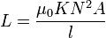 | - L = inductance in henries (H)  - μ₀ = permeability of free space = 4π × 10⁻⁷ H/m  - K = Nagaoka coefficient^{[2]}  - N = number of turns  - A = area of cross-section of the coil in square metres (m²)  - l = length of coil in metres (m)
Straight wire conductor | 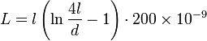 | - L = inductance (H)  - l = length of conductor (m)  - d = diameter of conductor (m)
 | 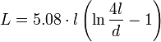 | - L = inductance (nH)  - l = length of conductor (in)  - d = diameter of conductor (in)
Short air-core cylindrical coil | 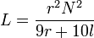 | - L = inductance (µH)  - r = outer radius of coil (in)  - l = length of coil (in)  - N = number of turns
Multilayer air-core coil | 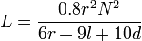 | - L = inductance (µH)  - r = mean radius of coil (in)  - l = physical length of coil winding (in)  - N = number of turns  - d = depth of coil (outer radius minus inner radius) (in)
Flat spiral air-core coil | 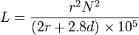 | - L = inductance (H)  - r = mean radius of coil (m)  - N = number of turns  - d = depth of coil (outer radius minus inner radius) (m)
 | 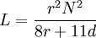 | - L = inductance (µH)  - r = mean radius of coil (in)  - N = number of turns  - d = depth of coil (outer radius minus inner radius) (in)
Toroidal core (circular cross-section) | 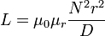 | - L = inductance (H)  - μ₀ = permeability of free space = 4π × 10⁻⁷ H/m  - μ_{r} = relative permeability of core material  - N = number of turns  - r = radius of coil winding (m)  - D = overall diameter of toroid (m)

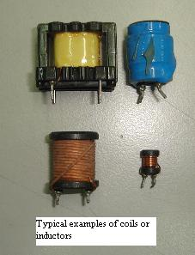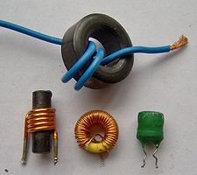
Photo 3.10 shows how typical inductors or coil look like.

3.4.6.0 Overview
Inductance (L) (measured in henries) is an effect resulting from the magnetic field that forms around a current-carrying conductor which tends to resist changes in the current. Electric current through the conductor creates a magnetic flux proportional to the current, and a change in this current creates a corresponding change in magnetic flux which, in turn, by Faraday's Law generates an electromotive force (EMF) that opposes this change in current. Inductance is a measure of the amount of EMF generated per unit change in current. For example, an inductor with an inductance of 1 henry produces an EMF of 1 volt when the current through the inductor changes at the rate of 1 ampere per second. The number of loops, the size of each loop, and the material it is wrapped around all affect the inductance. For example, the magnetic flux linking these turns can be increased by coiling the conductor around a material with a high permeability such as iron. This can increase the inductance by 2000 times, although less so at high frequencies.

3.4.7.0 Hydraulic model
Electric current can be modeled by the hydraulic analogy. An inductor can be modeled by the flywheel effect of a heavy turbine rotated by the flow. When water first starts to flow (current), the stationary turbine will cause an obstruction in the flow and high pressure (voltage) opposing the flow until it gets turning. Once it is turning, if there is a sudden interruption of water flow the turbine will continue to turn by inertia, generating a high pressure to keep the flow moving.

3.4.8.0 Ideal and Real Inductors
An "ideal inductor" has inductance, but no resistance or capacitance, and does not dissipate or radiate energy. A real inductor may be partially modeled by a combination of inductance, resistance (due to the resistivity of the wire and losses in core material), and capacitance. At some frequency, usually higher than the working frequency, some real inductors behave as resonant circuits (due to their self-capacitance). At some frequency the capacitive component of impedance becomes dominant. In addition to dissipating energy in the resistance of the wire, magnetic core inductors may dissipate energy in the core due to hysteresis, and at high currents (bias currents) show gradual departure from ideal behavior due to nonlinearity caused by magnetic saturation. At higher frequencies, resistance and resistive losses in inductors grow due to skin effect in the inductor's winding wires. Core losses also contribute to inductor losses at higher frequencies. Additionally, real-world inductors work as antennas, radiating a part of energy processed into surrounding space and circuits, and accepting electromagnetic emissions from other circuits, taking part in electromagnetic interference. Real-world inductor applications deal heavily with "parasitic" parameters, while the "inductance" may be of minor significance.

3.4.9.0 Types of Coils
There many type of coils based on their core. Some of them have been described below.

3.4.9.1 Air Core Coil
The term air core coil describes an inductor that does not use a magnetic core made of a ferromagnetic material to achieve its specified inductance. The term refers to coils wound on plastic, ceramic, or other nonmagnetic forms, as well as those that actually have air inside the windings. Air core coils have lower inductance than ferromagnetic core coils, but are often used at high frequencies because they are free from energy losses called core losses that occur in ferromagnetic cores, which increase with frequency. Those used at high frequencies (above 3 MHz) are often made with a single layer of winding, to reduce their parasitic capacitance and thus increase their self-resonant frequency.
One disadvantage of the air core coil is 'microphony': mechanical vibration of the windings can cause variations in the inductance unless it is rigidly supported on a suitable plastic or ceramic form.
For construction, formulae and dimensions please look at table.

3.4.9.2 Ferromagnetic Core Coil
Ferromagnetic-core or iron-core inductors use a magnetic core made of a ferromagnetic or ferrimagnetic material such as iron to increase the inductance. A magnetic core can increase the inductance of a coil by a factor of several thousand, by increasing the magnetic field due to its higher magnetic permeability. However the magnetic properties of the core material cause several side effects which alter the behavior of the inductor and require special construction:
- Core losses: A time varying current in a ferromagnetic inductor, which causes a time varying magnetic field in its core, causes energy losses in the core material which are dissipated as heat, due to two processes:
  - Eddy currents: From Faraday's law of induction, the changing magnetic field can induce circulating loops of electric current in the conductive metal core. The energy in these currents is dissipated as heat because of the resistance of the core material. The amount of energy lost increases with the area inside the loop of current.
  - Hysteresis: Changing or reversing the magnetic field in the core also causes losses due to the motion of the tiny magnetic domains it is composed of. The energy loss is proportional to the area of the hysteresis loop in the BH graph of the core material. Materials with low coercivity have narrow hysteresis loops and so low hysteresis losses.
For both of these processes, the energy loss per cycle of AC current is constant, so core losses increase linearly with frequency.
- Nonlinearity: If the current through a ferromagnetic core coil is high enough that the magnetic core saturates, the inductance will not remain constant but will change with the current through the device. This is called nonlinearity and results in distortion of the signal. For example, audio signals can suffer intermodulation distortion in saturated inductors. To prevent this, in linear circuits the current through iron core inductors must be limited below the saturation level.

3.4.9.3 Laminated Core Inductor
Low frequency inductors are often made with laminated cores to prevent eddy currents, using construction similar to transformers. The core is made of stacks of thin steel sheets or laminations oriented parallel to the field, with an insulating coating on the surface. The insulation prevents eddy currents from flowing between the sheets, so any remaining currents must flow within the cross sectional area of the individual laminations, reducing the area of the loop and thus the energy loss greatly. The laminations are made of low coercivity silicon steel, to reduce hysteresis losses.

3.4.9.4 Ferrite Core Inductor
For higher frequencies, inductors are made with cores of ferrite. Ferrite is a ceramic ferrimagnetic material that is nonconductive, so eddy currents cannot flow within it. For inductor cores soft ferrites are used, which have low coercivity and thus low hysteresis losses. Another similar material is powdered iron cemented with a binder.

3.4.9.5 Toroidal Core Coils
In an inductor wound on a straight rod-shaped core, the magnetic field lines emerging from one end of the core must pass through the air to reenter the core at the other end. This reduces the field, because much of the magnetic field path is in air rather than the higher permeability core material. So higher magnetic fields and inductance can be achieved by winding the coil on a toroidal or doughnut shaped ferrite core. The magnetic field lines form closed loops within the doughnut without leaving the core material. Toroidal inductors also have the advantage that since little of the magnetic flux is outside the core, they radiate less electromagnetic interference than straight coils.
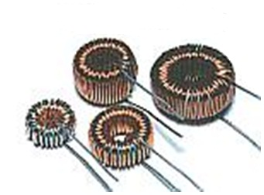
Photo 3.11 shows toroidal inductors.

3.4.9.6 Honeycomb Coil
Honeycomb coils are coils wound using a crisscross weave. This reduces the parasitic capacitance of the coil by preventing straight sections of adjacent turns of wire from laying parallel to each other. These are used in the tuning circuits of radios in the medium and long wave frequency ranges, allowing the coils to achieve high inductance in a small volume.

3.4.9.7 Variable Inductor
A variable inductor can be constructed by making one of the terminals of the device a sliding spring contact that can move along the surface of the coil, increasing or decreasing the number of turns of the coil included in the circuit. An alternate construction method is to use a moveable magnetic core, which can be slid in or out of the coil. Moving the core farther into the coil increases the permeability, increasing the inductance.

3.4.10.0 Inductor Construction
Before we start constructing let us look at the types of inductor pertaining to how they come about or are made.
There are two types of inductors that can be discussed, and they are;
- Manufactured inductor
- Self-made inductor
3.4.10.1 Manufactured inductor
When choosing an inductor from a manufacture, the core in the coil and the overall Q factor will have to be taken into account. The core should preferably be made of soft ferrite which will in turn minimize the energy losses of the inductor and therefore increase the Q factor. The ferrite core can be adjusted to give a slight change in inductance. There are a number of various manufactured air cored formers on the market.
3.4.10.2 Self-made inductor
Inductor can be easily wound around air cored formers. Self-made inductors are very useful when a particular inductance is desired and it can be made by the individual.
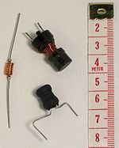
Photo 3.12 shows some manufactured and self-made Inductors.
An inductor is usually constructed as a coil of conducting material, typically copper wire, wrapped around a core either of air or of ferromagnetic or ferrimagnetic material. Core materials with a higher permeability than air increase the magnetic field and confine it closely to the inductor, thereby increasing the inductance. Low frequency inductors are constructed like transformers, with cores of electrical steel laminated to prevent eddy currents. 'Soft' ferrites are widely used for cores above audio frequencies, since they don't cause the large energy losses at high frequencies that ordinary iron alloys do. This is because of their narrow hysteresis curves, and their high resistivity prevents eddy currents. Inductors come in many shapes. Most are constructed as enamel coated wire wrapped around a ferrite bobbin with wire exposed on the outside, while some enclose the wire completely in ferrite and are called "shielded". Some inductors have an adjustable core, which enables changing of the inductance. Inductors used to block very high frequencies are sometimes made by stringing a ferrite cylinder or bead on a wire.
Small inductors can be etched directly onto a printed circuit board by laying out the trace in a spiral pattern. Some such planar inductors use a planar core.
Small value inductors can also be built on integrated circuits using the same processes that are used to make transistors. Aluminum interconnect is typically used, laid out in a spiral coil pattern. However, the small dimensions limit the inductance, and it is far more common to use a circuit called a "gyrator" which uses a capacitor and active components to behave similarly to an inductor.

3.4.11.0 Applications of Inductors.
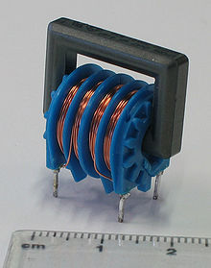
Photo 3.13 shows an inductor with two 47mH windings, as may be found in a power supply.
Inductors are used extensively in analog circuits and signal processing. Inductors in conjunction with capacitors and other components form tuned circuits which can emphasize or filter out specific signal frequencies. Applications range from the use of large inductors in power supplies, which in conjunction with filter capacitors remove residual hums known as the Mains hum or other fluctuations from the direct current output, to the small inductance of the ferrite bead or torus installed around a cable to prevent radio frequency interference from being transmitted down the wire. Smaller inductor/capacitor combinations provide tuned circuits used in radio reception and broadcasting, for instance.
Two (or more) inductors which have coupled magnetic flux form a transformer, which is a fundamental component of every electric utility power grid. The efficiency of a transformer may decrease as the frequency increases due to eddy currents in the core material and skin effect on the windings. Size of the core can be decreased at higher frequencies and, for this reason, aircraft use 400 hertz alternating current rather than the usual 50 or 60 hertz, allowing a great saving in weight from the use of smaller transformers.
An inductor is used as the energy storage device in some switched-mode power supplies. The inductor is energized for a specific fraction of the regulator's switching frequency, and de-energized for the remainder of the cycle. This energy transfer ratio determines the input-voltage to output-voltage ratio. This X_{L} is used in complement with an active semiconductor device to maintain very accurate voltage control.
Inductors are also employed in electrical transmission systems, where they are used to depress voltages from lightning strikes and to limit switching currents and fault current. In this field, they are more commonly referred to as reactors.
Larger value inductors may be simulated by use of gyrator circuits.

3.4.12.0 Testing Inductors the Accurate Way
Three ways to test inductors or coil have been discussed in this project. They are;
- With Analogue meter,
- Digital inductor meter and
- Flyback Tester.
Testing coil is very easy comparing it to checking three leads components such as SCR, FET and etc. In general, a coil consists of many turns or wire wrapped around a common core. The core could be made of iron or even air.
When an electric current passes through the coil, a magnetic field is produced. A coil in some respect s acts just opposite a capacitor. A capacitor blocks DC while allowing AC to flow through it; a coil allows DC to flow through it while restricting AC current flow. Another name for a coil is an inductor.
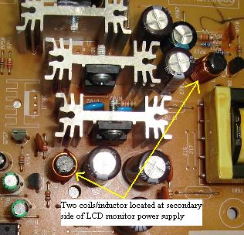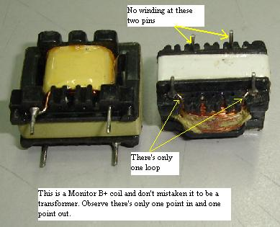
Photo 3.14a showing inductors/coils located at the Photo 3.14b showing a monitor’s B+ coils.
Secondary side of an LCD monitor’s power supply.
Coil or inductor can be test using an analog, inductance or a coil meter such as the dick smith flyback tester. A coil that is small in size would usually be tested with analog meter and you could check it on board too. Set your analog meter to X1 ohm and place the probes across the small coil. The meter should show some reading (or continuity) and this proved that the coil winding is okay. Refer to photo 3.15a Small coils seldom spoilt because it have less winding compares to big coils where it could have many turns of winding and chances for it to go shorted is very high.
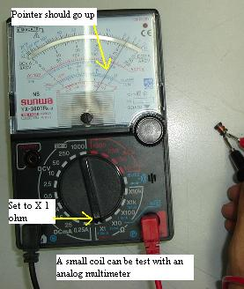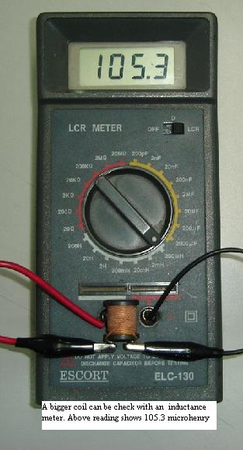
Photo 3.15a Using an analog multimeter to Photo 3.15bUsing a digital inductor multimeter to test test a small inductor. a bigger inductor.
Testing bigger coil or inductor such as the computer monitor B+ coil, you need an inductance meter to find out the exact inductance value which is in the unit of henry (h). Refer to photo 3.15b. From experienced using an inductance meter to check coils to see if it good or bad is not recommended because a shorted coil (shorted between winding) could have a good inductance value and you would miss out checking a bad coil. Unless you want to use the inductance meter to calculate the reading and do rewinding, looping and etc. on that coil. I will recommend you only test a big coil with dick smith flyback meter. Any shorted winding in it could be easily detected by this meter. Refer to Photo 3.16b.

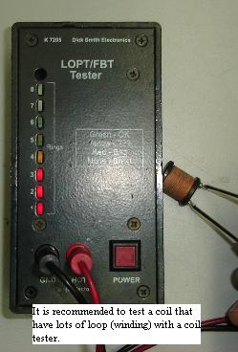
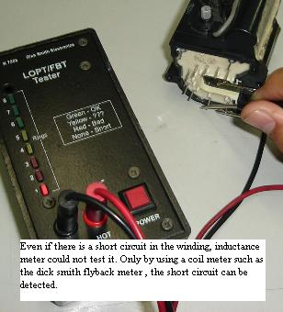
Photo 3.16a Using flyback tester to test an inductor. Photo 3.16b Using flyback tester to test flyback transformer
3.4.13.0 Resonant Circuits
In the last section, the resistor, inductor and capacitance were looked at briefly from a voltage, current and impedance point of view. These components will be the basic building blocks used in any radio frequency section of any transmitter/receiver. What makes them important is their response at certain frequencies. At low frequency the impedance of an inductor is very small and the impedance of a capacitor is quite high.
At high frequency the inductor’s impedance becomes quite high and the capacitor’s impedance drops. The resistor in theory maintains its resistive impedance at low and high impedance. At certain frequency the capacitor’s impedance will equal to that of an inductor. This is called the resonant frequency and can be calculated by letting the impedance of a capacitor to that of inductor’s and then solving for ω (angular velocity in radians per second) and then finding the resonant frequency f_{c} ( it normally represented as F_{o}, but in relation to FM it especially represents the oscillator carrier frequency) in hertz.
$$ω_{c}=\frac{1}{\sqrt{LC}}$$

$$F_{C}=\frac{1}{2π\sqrt{LC}}$$
There are two configurations of RLC circuits, the series and parallel arrangements which will now be looked at below.

3.4.13.1 Series resonant circuit
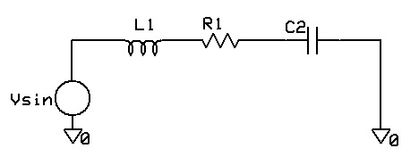
Series resonant circuit
At low frequencies the capacitor impedance will dominate the overall impedance of the series circuit and the current is low. At high frequencies the inductor will dominate and the current will also be low. But at the resonant frequency the complex impedance will cancel that of the inductor’s and only the resistance of the resistor will remain effective, this is when the current through the circuit will be at a maximum.
$Z\left(f\right)=r+j\left(2πfL-\frac{1}{2πfC}\right)$ is at minimum at F_{C.}
3.4.13.2 Parallel resonant circuits
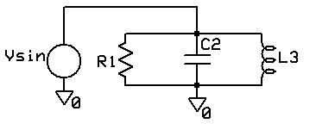
Parallel resonant circuits
The circuit above (known as LC tank) takes the same advantage of the resonant frequency but this time the impedance will be at maximum and the current will be minimum at F_{C}. This is due to the fact that the minimum impedance in a parallel circuit dominates the overall impedance of the tank.
The impedance will be equal to (R // +jX_{L}//-jX_{C}).

3.4.13.3 The Q factor of resonant circuits

The Q factor of a tuned circuit is the ratio of inductance of a circuit at the resonant frequency to its radio frequency resistance. It is a measure of the increase in
voltage that is developed across the tuned circuit at resonant frequency. If the Q factor of a tuned circuit is high, the voltage developed across it is high and its selecting is good.
Quality of the component has to be taken into account. The Q factor is a measure of the energy stored to that which is lost in the component due to its resistive elements at low or high frequencies. Inductors store energy in the dielectric between its plates. The energy is stored in one half of an AC cycle and returned in the second half. Any energy lost in the cycle is associated with a dissipative resistance and this gives rise to the Quality factor Q. The ratio of maximum energy stored to the amount lost per ac cycle.

For a series RLC circuit at Fc

$$Q=\frac{2πf_{C}L}{R_{Series}} or Q=\frac{1}{(2πf_{C}C)R_{series}}$$

For a parallel RLC circuit at F_{C}

$$Q=\frac{R_{P}}{2πf_{C}L}$$
In circuits where there is no $R_{series}$ or $R_{parallel}$(only an L and C) the inherent resistive properties of the inductor (skin effect) and capacitor (dielectric permittivity) at high frequencies can be taken into account.
This implies that the higher the Q the less the energy dissipated.
3.5.0.0 Active Components
An active device is any type of circuit component with the ability to electrically control electron flow. In order for a circuit to be properly called electronic, it must contain at least one active device.
Active devices include, but are not limited to, vacuum tubes, transistors, silicon-controlled rectifiers (SCRs), and TRIACs. All active devices control the flow of electrons through them. Some active devices allow a voltage to control this current while other active devices allow another current to do the job.
Devices utilizing a static voltage as the controlling signal are, not surprisingly, called voltage controlled devices. Devices working on the principle of one current controlling another current are known as current-controlled devices. For the record, vacuum tubes are voltage-controlled devices while transistors are made as either voltage-controlled or current controlled types. The first type of transistor successfully demonstrated was a current-controlled device.
In this section of the project transistors, diodes and integrated circuit(IC) will be discussed. Diodes and ICs have being added because they are also made of semiconductors just like transistors.
3.5.1.0 Diodes
A diode is a semiconductor device which allows current to flow through it in only one direction. A diode is specifically made to allow current to flow through it in only one direction. The picture of different diode types is shown below in Photo 3.17.
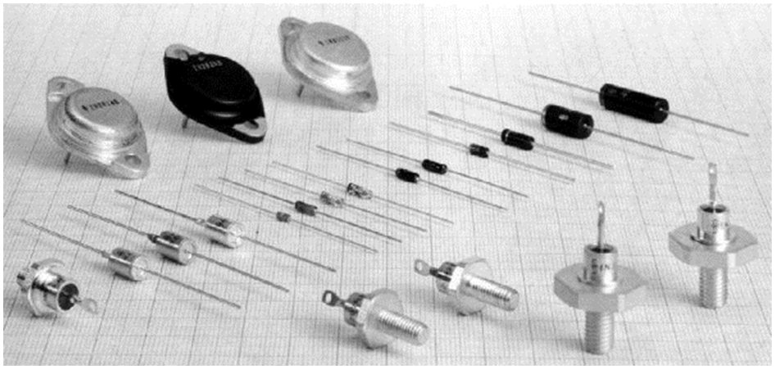
Photo 3.17 Different diode types
Some ways in which the diode can be used are listed here.
- A diode can be used as a rectifier that converts AC (Alternating Current) to DC (Direct Current) for a power supply device.
- Diodes can be used to separate the signal from radio frequencies.
- Diodes can be used as an on/off switch that controls current.
A real diode and the symbol used to indicate it in a circuit are shown in Fig. 3.15 below.
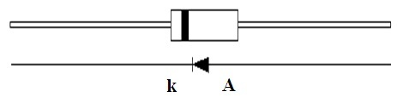
Fig.3.15 A real diode and its symbol. (k) is Cathode and (A) Anode

The meaning of the symbol (k) is Cathode and (A) Anode. Current flows from the anode side to the cathode side. Although all diodes operate with the same general principle, there are different types suited to different applications. For example, the following devices are best used for the applications noted.
3.5.2.0 Voltage regulation diode (Zener Diode)
It is used to regulate voltage, by taking advantage of the fact that Zener diodes tend to stabilize at a certain voltage when that voltage is applied in the opposite direction. Diodes marked as ZPD5.6V or ZPY15V have operating voltages of 5.6V and 15V respectively. Refer to Fig.3.15 c, d. Breakdown diodes (3.15i) are actually Zener diodes. They are used in various devices for protection and voltage regulation. It passes current only when voltage rises above a pre-defined value.
The important characteristics for a Zener diode are Zener voltage (V_{Z}), Zener current (I_{Z}) and maximum dissipation power (P_{D}).
3.5.3.0 Photo diodes
Photo diodes (Fig.3.15e) are constructed in a way that they allow light to fall on the P-N connection. When there is no light, a photo diode acts as a regular diode. It has high resistance in one direction, and low resistance in opposite direction. When there is light, both resistances are low. Photo diodes and LEDs are the main items in an optocoupler.
3.5.4.0 Light emitting diode (LED)
This type of diode emits light when current flows through it in the forward direction (Forward biased).
Light emitting diodes must be chosen according to how they will be used, because there are several colors available. The most common colors are red and green, but there are even blue ones.
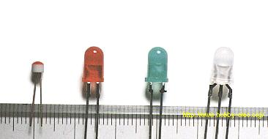 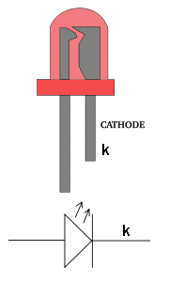
Photo 3.20 Photograph of some common LEDs Fig. 3.18 Identifying leads of a LED.

The device on the far right in photo 3.20 combines a red LED and green LED in one package. The component lead in the middle is common to both LEDs. As for the remaining two leads, one side is for the green, the other for the red LED. When both are turned on simultaneously, it becomes orange.
LEDs have a cathode and anode lead and must be connected to DC around the correct way. The cathode lead is identified on the body by a flat-spot on the side of the LED. The cathode lead is the shorter lead when the LED is new. Refer to Fig. 3.18.
The polarity of an LED can also be determined using a resistance meter, or even a 1.5 V battery.
When using a test meter to determine polarity, set the meter to a low resistance measurement range. Connect the probes of the meter to the LED. If the polarity is correct, the LED will glow. If the LED does not glow, switch the meter probes to the opposite leads on the LED. In either case, the side of the diode which is connected to the black meter probe when the LED glows, is the Anode side. Positive voltage flows out of the black probe when the meter is set to measure resistance.
It is possible to use an LED to obtain a fixed voltage. The voltage drop (forward voltage or V_{F}) of an LED is comparatively stable at just about 2V. You can also test an LED by forming the circuit below in Fig. 3.19a. One of the most important things to remember about a LED is the characteristic voltage that appears across it when connected to a voltage. This does not change with brightness and cannot be altered.
For a red LED, this voltage is 1.7v and if you supply it with more than this voltage, it will be damaged.
The easy solution is to place a resistor on one lead as shown in the diagram in Fig. 3.19 below:
With LEDs it is important to know the maximum value of current it is capable of passing. The natural characteristic voltage across a LED depends on the color and starts at 1.7V for red to more than 2.4v for green and blue.
Current starts at 1mA for a very small glow and goes to about 40mA. High brightness LEDs and "power LEDs" require up to 1 amp and more. You must know the exact current required by the LED you are using as the wrong dropper resistor will allow too much current to flow and the LED will be damaged instantly.
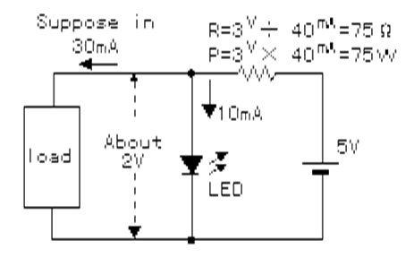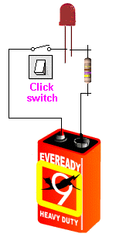
Fig. 3.19a A simple circuit to test an LED Fig.3.19b Testing a LED
3.5.5.0 Tunnel diodes
These are (3.15f and 3.15g) are commonly used in oscillators at very high frequencies.
3.5.6.0 Schottky diodes
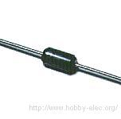
Photo 3.21 A picture of a schottky diode
Schottky diodes (3.15h) are used in high frequency circuits because of its low voltage drop in the forward direction.
Diodes are used to rectify alternating current into direct current. However, rectification will not occur when the frequency of the alternating current is too high. This is due to what is known as the "reverse recovery characteristic." The reverse recovery characteristic can be explained as follows:
If the opposite voltage is suddenly applied to a forward-biased diode, current will continue to flow in the forward direction for a brief moment. This time until the current stops flowing is called the Reverse Recovery Time. The current is considered to be stopped when it falls to about 10% of the value of the peak reverse current.
The Schottky barrier diode has a short reverse recovery time, which makes it ideally suited to use in high frequency rectification.
The schottky barrier diode has the following characteristics.
- The voltage drop in the forward direction is low.
- The reverse recovery time is short.
However, it has the following disadvantages.
- The diode can have relatively high leakage current.
- The surge resistance is low.
Because the reverse recovery time is short, this diode is often used for the switching regulators in a high frequency circuit.

3.5.7.0 Variable capacitance (Varicap) diode
The current does not flow when applying the voltage of the opposite direction to the diode. In this condition, the diode has a capacitance like the capacitor. It is a very small capacitance. With the change of this capacitance, the frequency of the oscillator can be changed. A Varicap diode (3.15j) is used instead of a variable capacitor in high frequency circuits. When the voltage across it is changed, the capacitance between cathode and anode also changes. This diode is commonly used in radio receivers, transceivers and oscillators.
When working with capacitive diodes it is important to know their maximum and minimum capacitance, as well as values of DC voltage during which these capacitances occur. Below are symbol and name of diodes. Refer to Fig. 3.15.
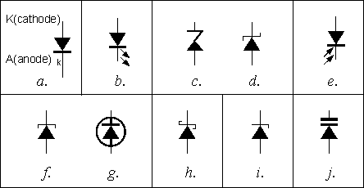
Fig. 3.15: Diode symbols: a - standard diode, b - LED,
c, d - Zener, e - photo, f and g - tunnel, h - Schottky, i - breakdown,
j – variable capacitance (varicap).
3.5.8.0 Peak Inverse Voltage Characteristics Of Diodes
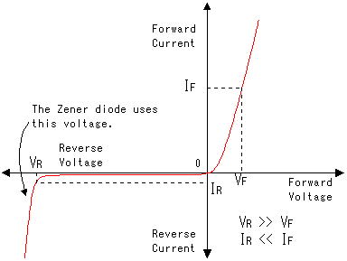
Fig. 3.16 Peak inverse voltage characteristics of diodes.
The graph on the above Fig. 3.16 shows the electrical characteristics of a typical diode. When a small voltage is applied to the diode in the forward direction, current flows easily. Because the diode has a certain amount of resistance, the voltage will drop slightly as current flows through the diode. A typical diode causes a voltage drop of about 0.6 - 1V (V_{F}) (In the case of silicon diode, almost 0.6V). This voltage drop needs to be taken into consideration in a circuit which uses many diodes in series. Also, the amount of current passing through the diodes must be considered.
When voltage is applied in the reverse direction through a diode, the diode will have a great resistance to current flow. Different diodes have different characteristics when reverse-biased. A given diode should be selected depending on how it will be used in the circuit. The current that will flow through a diode biased in the reverse direction will vary from several mA to just µA, which is very small.
The limiting voltages and currents permissible must be considered on a case by case basis. For example, when using diodes for rectification, at times they will be required to withstand a reverse voltage. If the diodes are not chosen carefully, they will break down.
3.5.9.0 Diode identification
European diodes are marked using two or three letters and a number. The first letter is used to identify the material used in manufacturing the component (A - germanium, B - silicon), or, in case of letter Z, a Zener diode. The second and third letters specify the type and usage of the diode. Some of the varieties are:
A - low power diode, like the AA111, AA113, AA121, etc. - they are used in the detector of a radio receiver;
BA124, BA125: Varicap diodes used instead of variable capacitors in receiving devices, oscillators, etc.
BAY80, BAY93, etc.: switching diodes used in devices using logic circuits. BA157, BA158, etc. - these are switching diodes with short recovery time.
B - Two capacitive (varicap) diodes in the same housing, like BB104, BB105, etc.
Y - Regulation diodes, like BY240, BY243, BY244, etc. - these regulation diodes come in a plastic
packaging and operate on a maximum current of 0.8A. If there is another Y, the diode is intended for
higher current. For example, BYY44 is a diode whose absolute maximum current rating is 1A.When
Y is the second letter in a Zener diode mark (ZY10, ZY30, etc.) it means it is intended for higher
Current.
G, PD - different tolerance marks for Zener diodes. Some of these are ZF12 (5% tolerance), ZG18 (10%
tolerance), ZPD9.1 (5% tolerance). The third letter is used to specify a property (high current, for.
American markings begin with 1N followed by a number, 1N4001, for example (regulating diode), 1N4449 (switching diode), etc.
Japanese style is similar to American; the main difference is that instead of N there is S, 1S241 being one of them. Some of the common diodes are dealt with in details below.
3.5.10.0 Rectification / Switching / Regulation Diode
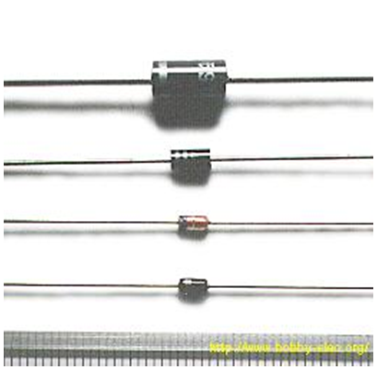
Photo 3.17 Rectification diodes
The stripe stamped on one end of the diode indicates the polarity of the diode. The stripe shows the cathode side. The devices shown in photo 3.17 are pictures of diodes used for rectification. They are made to handle relatively high currents. The device on top can handle as high as 6A, and the one below it can safely handle up to 1A.
However, it is best used at about 70% of its rating because this current value is a maximum rating.
The third device from the top (red color) has a part number of 1S1588. This diode is used for switching, because it can switch on and off at very high speed. However, the maximum current it can handle is 120 mA. This makes it well suited to use within digital circuits. The maximum reverse voltage (reverse bias) this diode can handle is 30V.
The device at the bottom of the picture is a voltage regulation diode with a rating of 6V. When this type of diode is reverse biased, it will resist changes in voltage. If the input voltage is increased, the output voltage will not change. (Or any change will be an insignificant amount.) While the output voltage does not increase with an increase in input voltage, the output current will.
This requires some thought for a protection circuit so that too much current does not flow. The rated current limit for the device is 30 mA.
Generally, a three (3)-terminal voltage regulator is used for the stabilization of a power supply. Therefore, this diode is typically used to protect the circuit from momentary voltage spikes. Three (3)-terminal regulators use voltage regulation diodes inside.
The most important characteristics when using power diodes is the maximum current in the forward direction (I_{Fmax}), and maximum voltage in the reverse direction (V_{Rmax}).
3.5.10.1 Bridged diode
Rectification diodes are used to make DC from AC. It is possible to do only 'half wave rectification' using 1 diode. When 4 diodes are combined, 'full wave rectification' occurs.
Devices that combine 4 diodes in one package are called diode bridges. They are used for full-wave rectification.
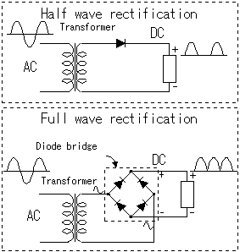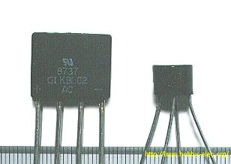
Fig.3.17 Half wave and full wave rectification circuit. Photo 3.18 Examples of bridged diodes.
The photograph on the right that is photo 3.18 shows two examples of diode bridges. The cylindrical device on the right in the photograph has a current limit of 1A. Physically, it is 7 mm high, and 10 mm in diameter. The flat device on the left has a current limit of 4A. It is has a thickness of 6 mm, is 16 mm in height, and 19 mm in width.
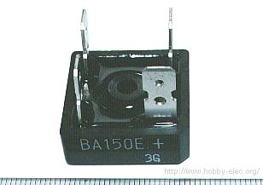
Photo 3.19 A bridged high-power diode
The photograph above, photo 3.19 shows a large, high-power diode bridge. It has a current capacity of 15A. The peak reverse-bias voltage is 400V. Diode bridges with large current capacities like this one require a heat sink. Typically, they are screwed to a piece of metal, or the chassis of device in which they are used. The heat sink allows the device to radiate excess heat. As for size, this one is 26 mm wide on each side, and the height of the module part is 10 mm.
Beside universal transistors TUN and TUP there are universal diodes as well. They are marked with DUS (Diode Universal Silicon) and DUG (Diode Universal Germanium) on circuit diagrams.

3.5.11.0 Testing Diodes the Accurate Way
When it comes to testing diode, you need a special method to test it. If you do not know how to accurately check a diode, you will not be able to repair or troubleshoot electronic equipment because you may think that a spoilt diode is good which will definitely waste your precious time. Usually a rectifier diode can fail in one of the four ways. It can become open circuit, short circuit, leaky or breakdown when under full load. An analog multimeter or digital multimeter can be used to test or check for all the first three conditions except the last one which is the diode breakdown in full operating voltage. Diode breakdown when under full load means the diode tests okay with your meters but failed when a high voltage flows through it.
From my experienced in the electronic troubleshooting field, i discovered that testing diode using an analog multimeter is more accurate or precise than using a digital multimeter. I could explain to you in details why i preferred analog meter. I do not know about you because i really came across quite a number of diodes where it tested ok with digital multimeter but failed when check with analog multimeter. The first step on how to test a diode accurately is to remove one of the diode lead. You can't always be certain if a diode is good or bad if you perform in-circuit test, because of back circuits (parallel connection) through other components.
To be absolutely sure, you will need to lift, or disconnect, one diode lead from the circuit to avoid back circuits. Unless you are very sure about the board you are checking. Sometimes i do find bad diodes when checking it on board. Your experienced will tell you whether to test a diode on-board or off-board. If you are a beginner, i highly suggest that you measure a diode with a lead removed from the board to avoid any confusion results from your meter.

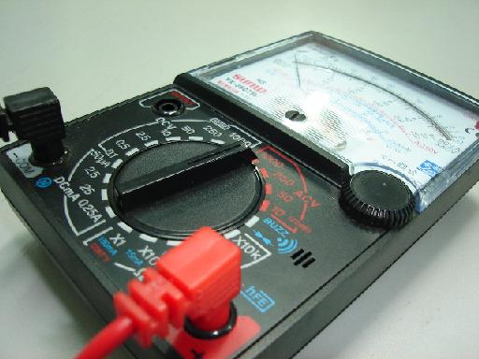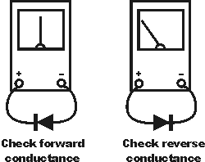
Photo 3.22 Use Analog Meter to Test Diode Fig. 3.20 Check for diode forward and reverse Conductance.
Set your analog meter to x1 ohms range to check for diode forward and reverse conductance. Connecting the red probe (+) of your meter to the cathode and black probe (–COM) to the anode, the diode is forward biased and the meter should read some value of resistance. This is known as checking the forward conductance of the diode. Refer to the left photograph in Fig. 3.20 Touch the black probe (–COM) of your meter to the cathode and red probe (+) to the anode, the diode is reverse biased and should look like an open reading-the meter pointer must not move. Refer to the right photograph in Fig. 3.20. If you get two readings then most probably the diode is shorted or leaky and you should replace it.
If you don't get any reading either forward or reverse bias, the diode is considered open circuit. The real problem when testing a diode using the diode test function of a digital meter is that an open or leaky diode, will sometimes reads okay (0.6). This is due to the digital meter diode test output voltage (which you can measure using another meter) is around 500mv to 2v. An analog meter set to x1 ohms range have output about 3V (remember the two 1.5V batteries you installed in the meter!). The 3V voltage is adequate to show you the accurate reading of a diode when under test.
Even if you have a good reading at x1 ohms range checking a diode, this doesn't mean that the diode is good. You now have to select your meter to x10Kohm range to test the diode again. The output voltage of x10k ohms is about 12 Volt (remember the 9 volt battery in your meter-1.5 volt + 1.5 volt + 9 volt = 12 volt). Again the diode under test should show only one reading. There is an exception to Schottky diode which has two readings, but not a shorted reading.
If the meter showed one reading then the diode under test is good. If it has two readings then most probably the diode is either shorted or leaky. The digital meter can't test it because the output from the meter is only about 500mv to 2 volt.
If a diode breakdown when under full load, there is no way to test the diode (unless you have a very expensive diode checker or tester which is specially designed to track this type of fault). Substituting with a known good diode is often the only way to prove that an intermittent diode is causing a particular problem. Sometimes an intermittent diode could be located using a coolant spray and hair blower.
Be certain that power is removed from any circuit before performing any of the following diode checks, otherwise meter or circuit damage could result. In order to correctly testing diode you need to use analog multimeter and set the range to x1 ohm and x10 kilo ohms range. With this tips I am sure you will have the confident to check any diodes that comes on your way.

3.6.0.0 Transistors
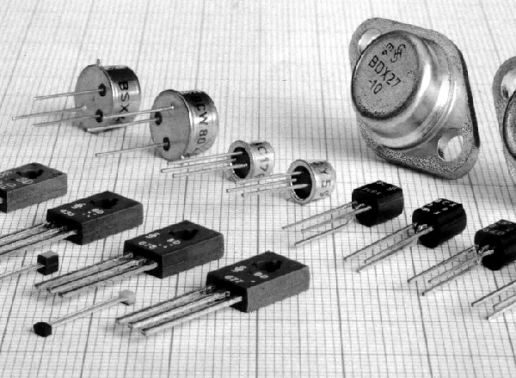
Photo 3.23. Shows some common transistors

Transistors are active components and are found everywhere in electronic circuits. They are used as amplifiers and switching devices. As amplifiers, they are used in high and low frequency stages, oscillators, modulators, detectors and in any circuit needing to perform a function. In digital circuits they are used as switches.
The diodes detailed in the earlier section can be used in this section, which form the basis of most amplifiers. There are two types of transistors they are;
- Bipolar Junction Transistor (BJT);
- Field Effect Transistor (FET).
The table below shows the various transistor symbols used in electronic circuits.

Table 3.6: Transistor symbols: a - bipolar, b - FET, c - MOSFET, d - dual gate MOSFET, e - inductive channel
MOSFET, f - single connection transistor
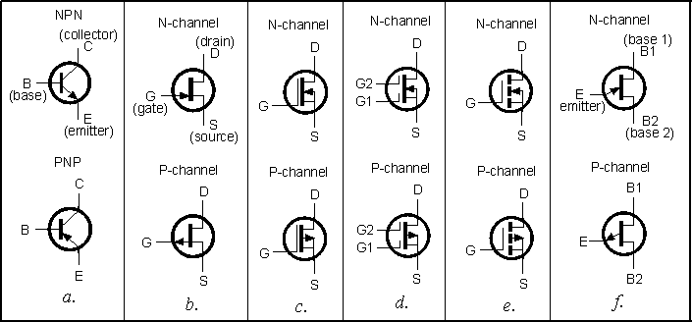

The most common type of transistors are BJTs and this project is going to delve much into them.
3.6.1.0 Bipolar Junction Transistor (BJT)
Their construction-material is most commonly silicon (their marking has the letter B) or germanium (their marking has the letter A). Original transistors were made from germanium, but they were very temperature-sensitive. Silicon transistors are much more temperature-tolerant and much cheaper to manufacture.
A bipolar junction transistor is a combination of two junction diode and consists of either a thin layer of p-type semiconductor sandwiched between two n-type semiconductors as in Fig.3.21a and referred to as NPN transistor, its electronic symbol is shown in Fig.3.21c. A thin layer of n-type semiconductor sandwiched between two p-type semiconductors as in Fig.3.21b and referred to as PNP transistor its electronic symbol is shown in Fig.3.21d.
The junction diode formed by n₁-p Fig.3.21 (a) is biased in the forward direction by a battery B₁ so that the free electrons are urged from n₁ towards p. Hence n₁ is termed an emitter (E). On the other hand, the junction diode formed by n₂ –p in Fig.3.21 (a) is biased in the reverse direction by battery B₂ so that if battery B₁ were disconnected, i.e. with zero emitter current, no current would flow between n₂ and apart from that due to thermally generated minority carriers. However with B₁ connected as in Fig. (a), the electrons from the emitter n₁ enter p and diffuse through the base (B) until they come within the influence of n₂, which is connected to the positive terminal of battery B₂. Consequently the electrons which reach n₂ are collected by the metal electrodes attached to n₂; hence n₂ is termed a collector (C).
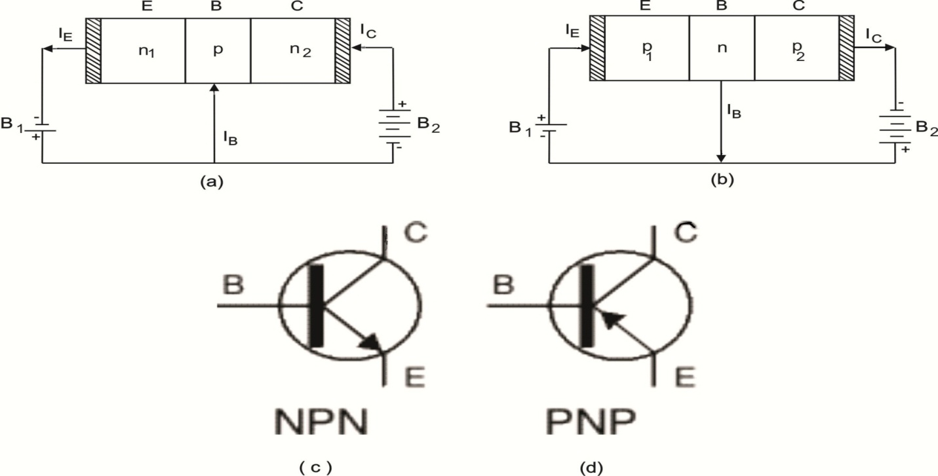
Fig.3.21 The arrangement of a bipolar junction transistor (BJT). (a)NPN, (b) PNP, (c) NPN (d) PNP circuit symbol.

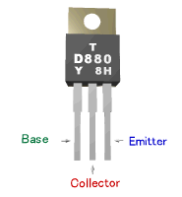
Fig.3.22 A real transistor with its pin out.

3.6.2.0 Function of Transistors
The operation of a transistor is difficult to explain and understand in terms of its internal structure. It is more helpful to use this functional model:
The base-emitter junction behaves like a diode. Refer to Fig.3.23. A base current I_{B} flows only when the voltage V_{BE} across the base-emitter junction is 0.7V or more. The small base current I_{B} controls the large collector current I_{C}.
I_{C} = h_{FE} × I_{B} (Unless the transistor is full on and saturated)
h_{FE} is the current gain (strictly the DC current gain), a typical value for h_{FE} is 100 (it has no units because it is a ratio).
The collector-emitter resistance R_{CE} is controlled by the base current I_{B}: when I_{B} = 0 R_{CE} = infinity and the transistor will be off.
When I_{B} is small R_{CE} will be reduced and the transistor will be partly on. When I_{B} is increased then R_{CE} = 0 and the transistor will fully on ('saturated'). A transistor that is full on (with R_{CE} = 0) is said to be 'saturated'.
When a transistor is saturated the collector-emitter voltage V_{CE} is reduced to almost 0Vand the collector current I_{C} is determined by the supply voltage and the external resistance in the collector circuit, not by the transistor's current gain. As a result the ratio Ic/I_{B} for a saturated transistor is less than the current gain h_{FE}.
The emitter current I_{E} = I_{C} + I_{B}, but I_{C} is much larger than I_{B}, so roughly I_{E} = I_{C}.
A resistor is often needed in series with the base connection to limit the base current I_{B} and prevent the transistor being damaged. Transistors have a maximum collector current I_{c} rating. The current gain h_{FE} can vary widely, even for transistors of the same type!
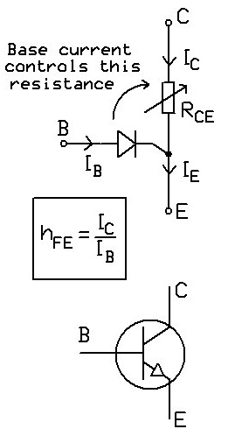
Fig.3.23 shows the base-emitter junction behavior of a transistor

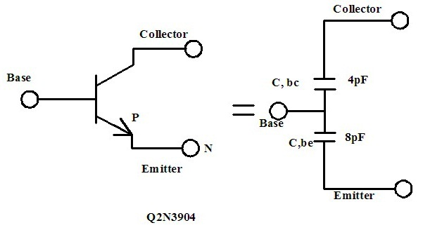
Fig 3.24 NPN Transistor
PNP bipolar and P channel J-Fet’s are widely used at low frequency, the preference for high frequency systems lies with the NPN and N channel J-FETs. This is due to the electrons being the majority carriers in both the BJT’s and J-Fet’s conduction channels. The NPN, BJT is the most commonly used for the rest of this discussion will be transistor that will be focused on.
- The bias current acts as a controlled flow source which steadily open up the collector emitter channel enabling charge carriers to flow, this can be analogous to a slues gate, this rate of flow is controlled by the current gain β=I_{C}/I_{B}.
- Transistors are nonlinear especially when biased in the saturation region. The input impedance drops as the biasing current being sinked to the collector increases.
- As the base current increases to allow more collector current through, the current gain β also increases.
- The collector-emitter voltage has a maximum value that cannot exceed at an instant in time.

3.6.3.0 High frequency Response
The most interesting property is the junction capacitance from the base to emitter and base-collector, fig. 3.24 shows that for the 2N3904, the base-emitter capacitance is larger than the base –collector, because of heavier extrinsic doping and it’s forward biasing the depletion region is naturally smaller than the base-collector’s. As the frequencies are increased the two capacitances will drop. Because the capacitors are effective in series, the smaller one dominates (base-collector capacitance). The capacitance is also influenced by the rate of charge in base current magnitudes.
A resistance exists of typically in the order of ohms at the base; this parasitic is caused by impure contact between the base’s polysilicon to silicon junction. This transistor R_{in} = (R_{base} = Re); as stated previously they are inevitable drops that makes the system rather unstable, as R_{base} is essentially parasitic impedance. To increase stability RE, (which is normally RF bypassed) will have to be introduced.
Another inherent flaw which might be used to some advantage in the high frequency response of the NPN model is that of output collector signals are to be fed back to the importance of this flaw can be seen when oscillator will be discussed in section 3.5.

3.6.4.0 The working principle of a transistor
Transistors are used in analog circuits to amplify a signal. They are also used in power supplies as a regulator and you will also find them used as a switch in digital circuits.

3.6.4.1 Transistor Amplifiers
Now that the basic electronic components have been considered, a look at the 3 types of amplifiers will also be considered. Transistor amplifier is worthwhile prelude to the next Chapter, which contain references and examples of these amplifiers. The three amplifiers are;
- Common Emitter,
- Common Collector and
- Common Base.
3.6.4.2 Common Emitter
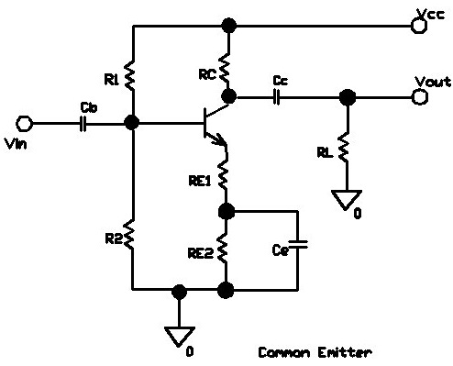
Fig.3.25 A Common emitter circuit.
R_{C} and Re are the junction resistances at the collector and emitter respectively. R’c is seen as infinite (reverse bias current); r’c is equal to the threshold voltage VT divided by the emitter.
I_{C}=I_{B}+I_{E}, is relatively small compared to I_{B} the base current =>I_{C} = I_{E}.
All capacitors used here are DC opens and AC shorts. The supply ideally has no impedance and therefore no voltage dropped across it. So it is an AC ground.
DC Analysis
Voltage at the base, V_{b}= (R2/R1+R2) V_{CC}, Voltage at the Emitter, V_{e}=V_{b}-0.7.
Emitter Current, I_{e} = Ve/ (RE1+RE2) =I_{C}, Voltage at collector, V_{C}=V_{CC}-(I_{C} .R_{C})
AC Analysis
- Rin _{(base)} = Input Impedance, Rin=R1// R2//Rin _{(base)}.
- Output impedance, Rout= (RC//R_{C})>>RC, therefore R_{out} = RC.

- Voltage gain, Av=RC/(RE1=Re), note RE1 is not a bypass because it is more independent of temperature change than Re and therefore increasing stability against temperature change.
- Current gain, A_{i} = I_{C}/ I_{B}
Power gain, A_{p} = A_{V} x A_{i}

3.6.4.3 Common Collector (emitter follower)
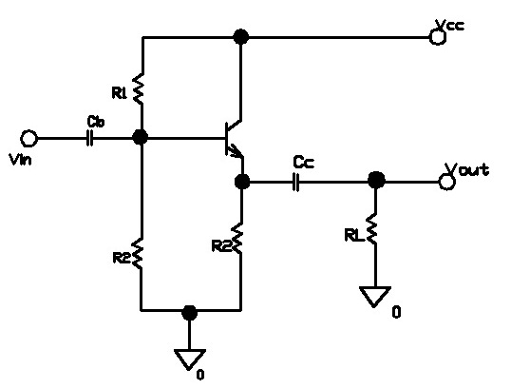
Fig 3.26 Common Collector or Emitter Follower configuration

AC analysis
Input impedance is the same as the common emitter.
Output impedance, Rout=RE1//Re; RE1>>Re => Rout = Re (quite low!)
Voltage gain, A_{V}= RE/ (RE1+Re); RE1>>Re => Av=1
Current gain, A_{i}= I_{E}/I_{B}
Power gain, A_{P}; same as common emitter.

3.6.4.4 Common Base
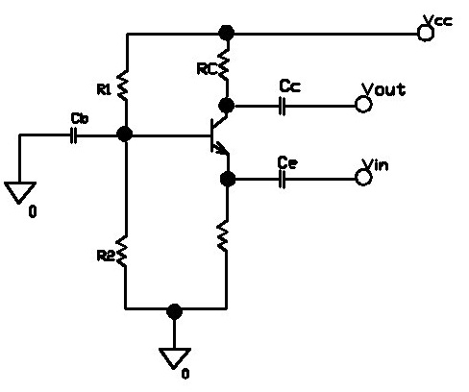
Fig 3.27 Common Base Configuration

DC analysis is similar to the common emitter
AC analysis
- Input impedance, R_{in} = RE 1// Re RE1>>Re →Rout ≈ Re
- Output impedance, R_{out} = (RC//Re); Re >>RC, therefore R_{out} ≈ RC.
- Voltage gain, A_{V} = RC / Re
- Current gain, A_{i} = I_{C} / I_{E} ≈ 1
- Power gain, A_{p} = A_{v} x A_{i} ≈ A_{v} x 1 → A_{P} ≈ A_{v}
The best way to explore the basics of transistors is by experimenting. A simple circuit is shown below. It uses a power transistor to illuminate a globe. You will also need a battery, a small light bulb (taken from a flashlight) with properties near 4.5V/0.3A, a linear potentiometer (5k) and a 470 ohm resistor. These components should be connected as shown in Fig.3.28.
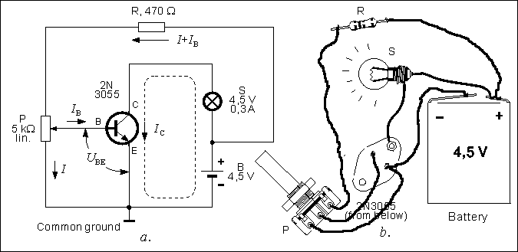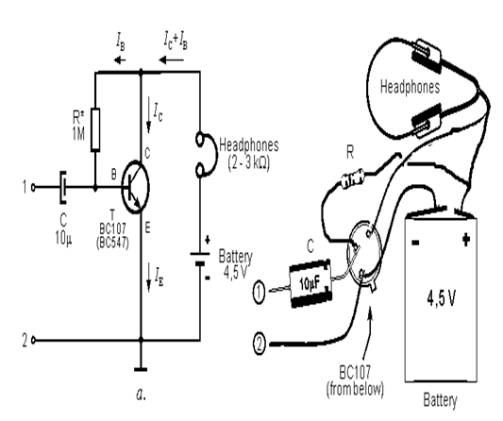
Fig.3.28 A transistor used as a switch Fig.3.29 A simple transistor amplifier
Resistor (R) isn't really necessary, but if you don't use it, you mustn't turn the potentiometer (pot) to its high position, because that would destroy the transistor - this is because the DC voltage V_{BE} (voltage between the base and the emitter), should not be higher than 0.6V, for silicon transistors.
Turn the potentiometer to its lowest position. This brings the voltage on the base (or more correctly between the base and ground) to zero volts (V_{BE} = 0). The bulb doesn't light, which means there is no current passing through the transistor.
As we already mentioned, the potentiometers lowest position means that V_{BE} is equal to zero. When we turn the knob from its lowest position V_{BE} gradually increases. When V_{BE} reaches 0.6v, current starts to enter the transistor and the globe starts to glow. As the pot is turned further, the voltage on the base remains at 0.6v but the current increases and this increases the current through the collector-emitter circuit. If the pot is turned fully, the base voltage will increase slightly to about 0.75v but the current will increase significantly and the globe will glow brightly. Refer to Fig.3.28.
If we connected an ammeter between the collector and the bulb (to measure I_{C}), another ammeter between the pot and the base (for measuring I_{B}), and a voltmeter between the ground and the base and repeat the whole experiment, we will find some interesting data. When the pot is in its low position V_{BE} is equal to 0V, as well as currents I_{C} and I_{B}. When the pot is turned, these values start to rise until the bulb starts to glow when they are: V_{BE} = 0.6V, I_{B} = 0.8mA and I_{B} = 36 mA (if your values differ from these values, it is because the 2N3055 I used doesn't have the same specifications as the one you use, which is common when working with transistors).
The end result we get from this experiment is that when the current on the base is changed, current on the collector is changed as well.
Let's look at another experiment which will broaden our knowledge of the transistor. It requires a BC107 transistor (or any similar low power transistor), supply source (same as in previous experiment), 1M resistor, headphones and an electrolytic capacitor whose value may range between 10u to 100µF with any operating voltage.
A simple low frequency amplifier can be built from these components as shown in Fig.3.29. It should be noted that the schematic Fig.3.28 is similar to the one on Fig.3.29. The main difference is that the collector is connected to headphones. The "turn-on" resistor, on the base is 1M. When there is no resistor, there is no current flow I_{B}, and no I_{c} current. When the resistor is connected to the circuit, base voltage is equal to 0.6V, and the base current I_{B} = 4µA. The transistor has a gain of 250 and this means the collector current will be 1 mA. Since both of these currents enter the transistor, it is obvious that the emitter current is equal to I_{E} = I_{C} + I_{B}. And since the base current is in most cases insignificant compared to the collector current, it is considered that:
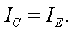
The relationship between the current flowing through the collector and the current flowing through the base is called the transistor's current amplification coefficient, and is marked as hFE. In our example, this coefficient is equal to:
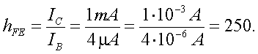
Put the headphones on and place a fingertip on point 1. You will hear a noise. Your body picks up the 50Hz AC "mains" voltage. The noise heard from the headphones is that voltage, only amplified by the transistor. Let's explain this circuit a bit more. Ac voltage with frequency 50Hz is connected to transistor's base via the capacitor C. Voltage on the base is now equal to the sum of a DC voltage (0.6 approx.) via resistor R, and AC voltage "from" the finger. This means that this base voltage is higher than 0.6V, fifty times per second, and fifty times slightly lower than that. Because of this, current on the collector is higher than 1mA fifty times per second, and fifty times lower. This variable current is used to shift the membrane of the speakerphones forward fifty times per second and fifty times backwards, meaning that we can hear the 50Hz tone on the output.
Listening to a 50Hz noise is not very interesting, so you could connect to points 1 and 2 some low frequency signal source (CD player or a microphone).
There are literally thousands of different circuits using a transistor as an active, amplifying device. And all these transistors operate in a manner shown in our experiments, which means that by building this example, you're actually building a basic building block of electronics.

3.6.5.0 Basic characteristics of transistors
Selecting the correct transistor for a circuit is based on the following characteristics: maximum voltage rating between the collector and the emitter V_{CEmax}, maximum collector current I_{Cmax} and the maximum power rating P_{Cmax}.
If you need to change a faulty transistor, or you feel comfortable enough to build a new circuit, pay attention to these three values. Your circuit must not exceed the maximum rating values of the transistor. If this is disregarded there are possibilities of permanent circuit damage. Beside the values we mentioned, it is sometimes important to know the current amplification, and maximum frequency of operation.
When there is a DC voltage V_{CE} between the collector (C) and emitter (E) with a collector current, the transistor acts as a small electrical heater whose power is given with this equation:
$$P_{C}{=V}_{CE}{.I}_{C}$$
Because of that, the transistor is heating itself and everything in its proximity. When V_{CE} or I_{CE} rise (or both of them), the transistor may overheat and become damaged. Maximum power rating for a transistor is P_{Cmax} (found in datasheets). What this means is that the product of V_{CE} and I_{C} should not be higher than P_{Cmax}:$$P_{Cmax}{=V}_{CE}{.I}_{C}$$
So, if the voltage across the transistor is increased, the current must be dropped.
For example, maximum ratings for a BC107 transistor are:
I_{Cmax}=100mA,
V_{CEmax} = 45V and
P_{Cmax} = 300mW
If we need I_{c} = 60mA, the maximum voltage is:
$$V_{CE}=\frac{P_{C max}}{I_{C}}=\frac{300mW}{60mA}=5V$$
For V_{CE} = 30V, the maximum current is:
$$I_{C}=\frac{P_{C max}}{V_{CE}}=\frac{300mW}{30V}=10mA$$
Among its other characteristics, this transistor has current amplification coefficient in range between
h_{FE}= 100 to 450, and it can be used for frequencies under 300MHz. According to the recommended values given by the manufacturer, optimum results (stability, low distortion and noise, high gain, etc.) are with V_{CE}=5V and I_{C} = 2mA.
There are occasions when the heat generated by a transistor cannot be overcome by adjusting voltages and current. In this case the transistors have a metal plate with hole, which is used to attach it to a heat-sink to allow the heat to be passed to a larger surface.
Current amplification is of importance when used in some circuits, where there is a need for equal amplification of two transistors. For example, 2N3055H transistors have h_{FE} within range between 20 and 70, which means that there is a possibility that one of them has 20 and other 70. This means that in cases when two identical coefficients are needed, they should be measured. Some multimeters have the option for measuring this, but most don't.
3.6.6.0 Transistor codes
The most common type of transistor is called bipolar and these are divided into NPN and PNP types. Before you can decode transistors, it is vital to understand their markings. There are three major steps involved. They are;
- The first letter signifies the construction-material which is mostly silicon (their marking has the letter B) or germanium (their marking has the letter A). Originally transistors were made from germanium, but they were very temperature-sensitive. Silicon transistors are much more temperature-tolerant and much cheaper to manufacture.
- The second letter in transistor’s marking describes its primary use:
C - low and medium power Low Frequency (LF) transistor,
D - high power LF transistor,
F - low power High Frequency (HF) transistor,
G - other transistors,
L - high power HF transistors,
P - photo transistor,
S - switch transistor,
U - high voltage transistor.
Here are few examples:
AC540 - germanium core, LF, low power,
AF125 - germanium core, HF, low power,
BC107 - silicon, LF, low power (0.3W),
BD675 - silicon, LF, high power (40W),
BF199 - silicon, HF (to 550 MHz),
BU208 - silicon (for voltages up to 700V),
BSY54 - silicon, switching transistor.
- There is a possibility of a third letter (R and Q - microwave transistors, or X - switch transistor), but these letters vary from manufacturer to manufacturer. The number following the letter is of no importance to users.
Some coding does not follow the normal marking as described above. Some of these are;
- American transistor: their manufacturers have different marks, with a 2N prefix followed by a number (2N3055, for example). This mark is similar to diode marks, which have a 1N prefix (e.g. 1N4004).
- Japanese bipolar transistor are prefixed with a: 2SA, 2SB, 2SC or 2SD, and FET-s with 3S:
2SA - PNP, HF transistors,
2SB - PNP, LF transistors,
2SC - NPN, HF transistors,
2SD - NPN, HF transistors.
- Some are named after the manufacturers. An example is TIP which refers to the manufacturer: Texas Instruments Power transistor. The letter at the end identifies versions with different voltage ratings.

3.6.7.0 Choosing a transistor
Most projects will specify a particular transistor, but if necessary you can usually substitute an equivalent transistor from the wide range available. The most important properties to look for are the maximum collector current I_{C} and the current gain h_{FE}. To make selection easier most suppliers group their transistors in categories determined either by their typical use or maximum power rating.
To make a final choice you will need to consult the tables of technical data which are normally provided in catalogues. They contain a great deal of useful information but they can be difficult to understand if you are not familiar with the abbreviations used. The table below shows the most important technical data for some popular transistors, tables in catalogues and reference books will usually show additional information but this is unlikely to be useful unless you are experienced. The quantities shown in the table are explained below.
Table 3.7: Data sheet of some common transistors.
NPN transistors
Code | Structure | Case  style | I_{C}  max. | V_{CE}  max. | h_{FE}  min. | P_{tot}  max. | Category  (typical use) | Possible  substitutes
BC107 | NPN | TO18 | 100mA | 45V | 110 | 300mW | Audio, low power | BC182 BC547
BC108 | NPN | TO18 | 100mA | 20V | 110 | 300mW | General purpose, low power | BC108C BC183 BC548
BC547 | NPN | TO92C | 100mA | 45V | 200 | 500mW | Audio, low power | BC107B
BC548B | NPN | TO92C | 100mA | 30V | 220 | 500mW | General purpose, low power | BC108B
2N3053 | NPN | TO39 | 700mA | 40V | 50 | 500mW | General purpose, low power | BFY51
BFY51 | NPN | TO39 | 1A | 30V | 40 | 800mW | General purpose, medium power | BC639
TIP31A | NPN | TO220 | 3A | 60V | 10 | 40W | General purpose, high power | TIP31C TIP41A
TIP31C | NPN | TO220 | 3A | 100V | 10 | 40W | General purpose, high power | TIP31A TIP41A
TIP41A | NPN | TO220 | 6A | 60V | 15 | 65W | General purpose, high power
Please note: the data in this table was compiled from several sources which are not entirely consistent! Most of the discrepancies are minor, but please consult information from your supplier if you require precise data.
PNP transistors
Code | Structure | Case  style | I_{C}  max. | V_{CE}  max. | h_{FE}  min. | P_{tot}  max. | Category  (typical use) | Possible  substitutes
BC177 | PNP | TO18 | 100mA | 45V | 125 | 300mW | Audio, low power | BC477
BC178 | PNP | TO18 | 200mA | 25V | 120 | 600mW | General purpose, low power | BC478
BC477 | PNP | TO18 | 150mA | 80V | 125 | 360mW | Audio, low power | BC177
BC478 | PNP | TO18 | 150mA | 40V | 125 | 360mW | General purpose, low power | BC178
TIP32A | PNP | TO220 | 3A | 60V | 25 | 40W | General purpose, high power | TIP32C
Please note: the data in this table was compiled from several sources which are not entirely consistent! Most of the discrepancies are minor, but please consult information from your supplier if you require precise data.

Structure | This shows the type of transistor, NPN or PNP. The polarities of the two types are different, so if you are looking for a substitute it must be the same type.
Case style | There is a diagram showing the leads for some of the most common case styles in the Connecting section above. This information is also available in suppliers' catalogues.
I_{C} max. | Maximum collector current.
V_{CE} max. | Maximum voltage across the collector-emitter junction.  You can ignore this rating in low voltage circuits.
h_{FE} | This is the current gain (strictly the DC current gain). The guaranteed minimum value is given because the actual value varies from transistor to transistor - even for those of the same type! Note that current gain is just a number so it has no units.  The gain is often quoted at a particular collector current I_{C} which is usually in the middle of the transistor's range, for example '100@20mA' means the gain is at least 100 at 20mA. Sometimes minimum and maximum values are given. Since the gain is roughly constant for various currents but it varies from transistor to transistor this detail is only really of interest to experts.  Why h_{FE}? It is one of a whole series of parameters for transistors, each with their own symbol. There are too many to explain here.
P_{tot} max. | Maximum total power which can be developed in the transistor, note that a heat sink will be required to achieve the maximum rating. This rating is important for transistors operating as amplifiers; the power is roughly I_{C} × V_{CE}. For transistors operating as switches the maximum collector current (I_{C} max.) is more important.
Category | This shows the typical use for the transistor, it is a good starting point when looking for a substitute. Catalogues may have separate tables for different categories.
Possible substitutes | These are transistors with similar electrical properties which will be suitable substitutes in most circuits. However, they may have a different case style so you will need to take care when placing them on the circuit board.
It is important to have the manufacturer’s catalog or a datasheet to know which lead is connected to what part of the transistor. These documents hold the information about the component's correct use (maximum current rating, power, amplification, etc.) as well as a diagram of the pin outs, placement of leads and different housing types. Some commonly used transistors are shown in table 3.8.

Table 3.8: Some commonly used transistor pin out, placement and housing types
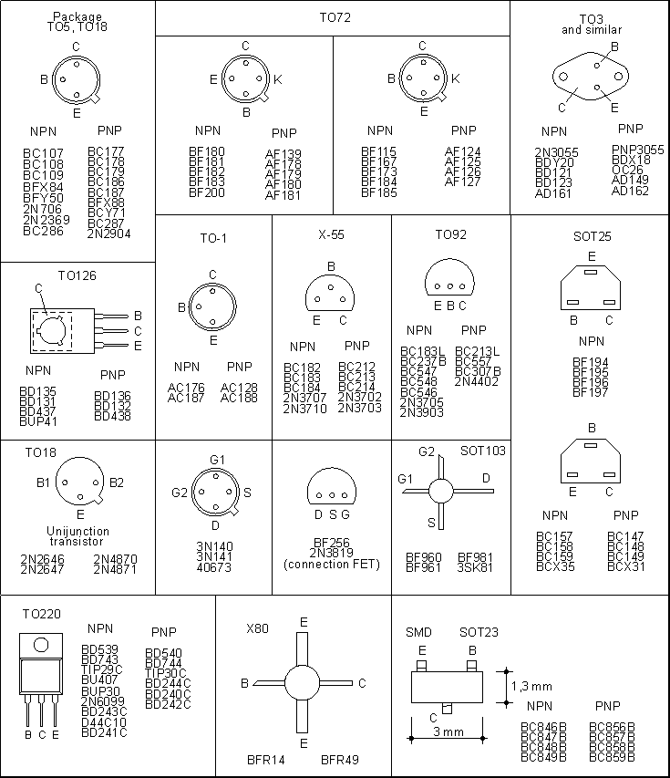
3.6.8.0 Testing Bipolar Transistors the Accurate Way

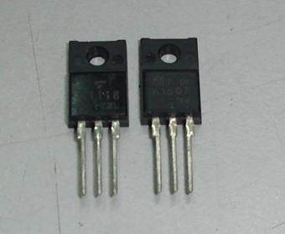
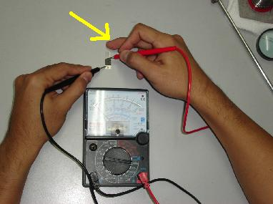
Photo 3.24a. A picture of a transistor. Photo 3.24b. Testing a transistor using an analog meter.

With the meter set to measure ohms, clip one meter lead to the base connection of the transistor.
Touch the other lead first onto the collector lead and then onto the emitter lead. The readings should both be the same, either high resistance or low resistance. Now reverse the leads and repeat the procedure. The results should be the opposite of those obtained before.
If they were both high before they should now be both low. If they were both low before they should now be high. Now measure the resistance between emitter and collector. It should read high resistance in both directions.
If you don’t know the transistor connections consult a data book. If you can’t find the data sheet then measure between the three connections in both directions. You should now be able to identify the base connection and then decide if the transistor is OK. For this to work the internal battery of the meter must supply a voltage high enough to overcome the forward resistances of the transistors.
Many meters have a position marked with a diode symbol which must be selected when checking transistors or diodes. Note that NPN transistors have low resistances whilst PNP have high, and vice versa.
If you do not have a multimeter you can build a simple one as provided in the circuit below in Fig. 3.30 to test a transistor. All you need is an option on your multimeter for measuring DC current up to 5mA. Both diodes (1N4001, or similar general purpose silicon diodes) and 1k resistors are used to protect the instrument if the transistor is "damaged". As we said, current gain is equal to h_{FE} = I_{C} / I_{B}. In the circuit, when the switch S is pressed, current flows through the base and is approximately equal to I_{B}=10uA, so if the collector current is displayed in milliamps. The gain is equal to:
For example, if the multimeter shows 2.4mA, h_{FE} = 2.4x100 = 240.
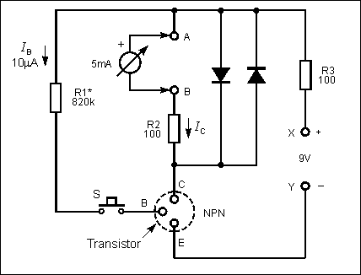
Fig. 3.30: Measuring the hFE

While measuring NPN transistors, the supply should be connected as shown in the diagram. For PNP transistors the battery is reversed. In that case, probes should be reversed as well if you're using analog instrument (one with a needle). If you are using a digital meter (highly recommended) it doesn't matter which probe goes where, but if you do it the same way as you did with NPN there would be a minus in front of the read value, which means that current flows in the opposite direction. You can also use the digital multimeter to test it.
3.7.0.0 Integrated circuits(IC)
Integrated Circuits play a very important part in electronics. Most are specially made for a specific task and contain up to thousands of transistors, diodes and resistors. Special purposes IC's such as audio-amplifiers, FM radios, logic blocks, regulators and even a whole microcomputer in the form of a micro controller can be fitted inside a tiny package. Some of the simple Integrated Circuits are shown in Photo 3.25.
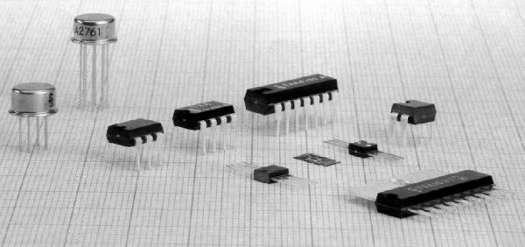
Photo 3.25: Integrated circuits
Depending on the way they are manufactured, integrated circuits can be divided into two groups namely:
- Hybrid and
- Monolithic.
Hybrid circuits have been around longer. If a transistor is opened, the crystal inside is very small. This means a transistor doesn't take up very much space and many of them can be fitted into a single Integrated Circuit.
The pin-out for some of the common packages is shown in Fig. 3.31.
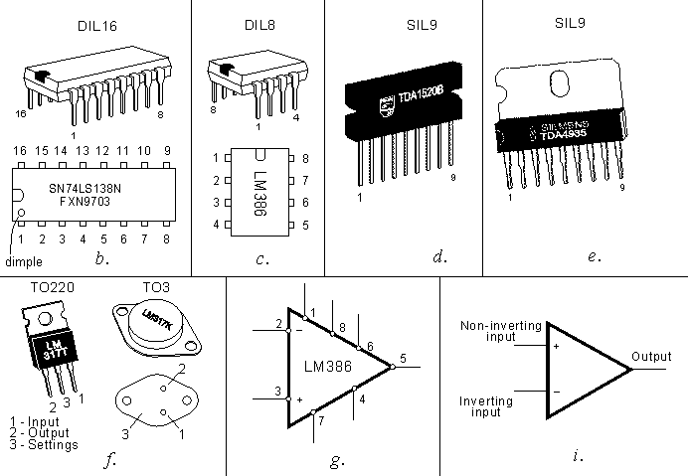
Fig. 3.31: Pin-out and symbols for some common integrated circuits
Most integrated Circuits are in a DIL package - Dual In Line, meaning there are two rows of pins. (DIL16 and DIL8 are shown in 3.31b and 3.31c). The device is viewed from the top and the pins are numbered in an anti-clockwise direction.
High power integrated circuits can generate a lot of heat and they have a metal tag that can be connected to a heat sink to dissipate the heat. Examples of these IC's are shown in 3.31d and 3.31e, and 3.31f.
Symbols used to represent integrated circuits are shown in 3.31g and 3.31i. Symbol 3.31g is commonly used to represent amplifiers.
Figure 3.31i shows an operational amplifier. Signs + and - represent inverting and non-inverting inputs. The signal to be amplified is applied between one of the inputs and ground (ground and supply aren't represented, but are necessary for the circuit to operate).
Integrated circuits can be divided into two further groups:
- Analogue (linear) and
- Digital.
The output voltage of a linear circuit is continuous, and follows changes in the input. Typical representative of a linear IC is an integrated audio amplifier. When a signal from a microphone is connected to the input the output will vary in the same way as the voltage from the microphone. If watched on an oscilloscope, the signal on the output will be the same shape as the mic's signal, only the voltage will be higher depending on the amplification of the integrated circuit.
It is a different situation with digital IC's. Their output voltage is not continuous. It is either LOW or HIGH and it changes from one state to the other very quickly.
3.7.1.0 Analog integrated circuits
While on the topic of analog circuits, we will look at the LM386 IC. It has all the components for a complete audio-amplifier. Fig. 3.32b shows an example of an amplifier made with this integrated circuit, which can be used as a complete amplifier for a Walkman, interphone, cassette player or some other audio device. It can also be used as a test circuit for troubleshooting.
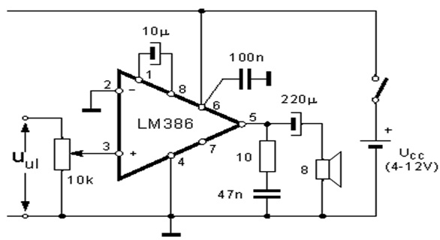
Fig. 3.32a: Audio amplifier.
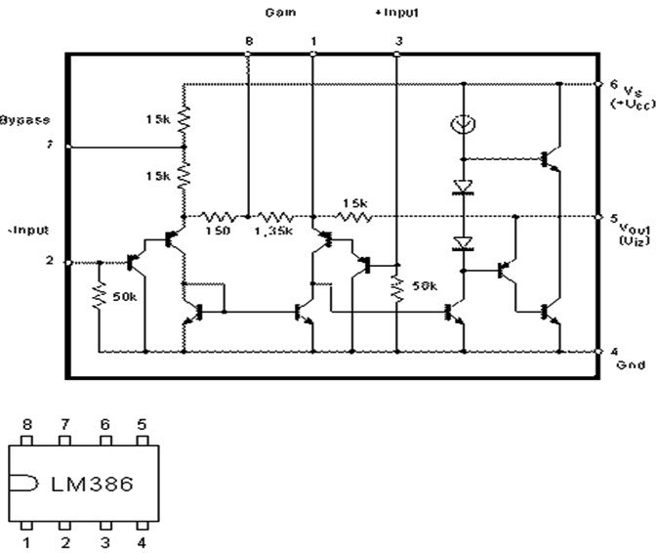
Fig. 3.32b - A low frequency amplifier using the LM386
The signal is brought to the non-inverting input (between pin 3 and ground). Inverting input (pin 2) is connected to ground. If 10µF is placed between pins 1 and 8 a voltage amplification of 200 is created. If this capacitor is removed the amplification is 20. It is possible to achieve in-between amplification by adding a resistor and connecting it in series with the capacitor.
One of the essential components in this circuit is the 100nF capacitor which is placed between pin 6 (which is connected to the positive of the supply) and ground. The capacitor should be ceramic and should be mounted as close to the integrated circuit as possible. This is common practice when working with integrated circuits, even when it isn't shown in the diagram as a capacitor connected between the positive and negative stabilizes the voltage and protects the circuit from spikes and a phenomenon called instability. This is due to inductance in the power supply tracks allowing high currents taken by the IC to upset its operation.
3.7.2.0 Digital integrated circuits
Digital ICs are ones that produce a discrete out put it either zero(0) or one (1), low or high etc. we will be discussing some family and types of ICs.

3.7.2.1 The 555 and 556 Timers
The 8-pin 555 timer IC is used in many projects, a popular version is the NE555. Most circuits will just specify '555 timer IC' and the NE555 is suitable for these. The 555 output (pin 3) can sink and source up to 200mA. This is more than most ICs and it is sufficient to supply LEDs, relay coils and low current lamps. To switch larger currents you can connect a transistor.
The 556 is a dual version of the 555 housed in a 14-pin package. The two timers (A and B) share the same power supply pins.
Low power versions of the 555 are made, such as the ICM7555, but these should only be used when specified (to increase battery life) because their maximum output current of about 20mA (with 9V supply) is too low for many standard 555 circuits. The ICM7555 has the same pin arrangement as a standard 555. The 555 is mostly used in monostable, bistable and astable circuits. They are also used as analog to digital converters. The pin out diagram of a 555 timer and a 556 timer is shown in Fig. 3.33 below.
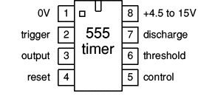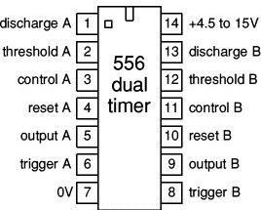
Fig. 3.33 The pin out diagram of the 555 and 556 timer.

3.7.3.0 Logic ICs (chips)
Logic ICs process digital signals and there are many devices, including logic gates, flip-flops, shift registers, counters and display drivers. They can be split into two groups according to their pin arrangements: the 4000 series and the 74 series which consists of various families such as the 74HC, 74HCT and 74LS.
For most new projects the 74HC family is the best choice. The older 4000 series is the only family which works with a supply voltage of more than 6V. The 74LS and 74HCT families require a 5V supply so they are not convenient for battery operation.
The table below summarizes the important properties of the most popular logic families:
Table 3.9: Summary of the important properties of the most popular logic families
Property | 4000 Series | 74 Series  74HC | 74 Series  74HCT | 74 Series  74LS
Technology | CMOS | High-speed CMOS | High-speed CMOS  TTL compatible | TTL Low-power Schottky
Power Supply | 3 to 15V | 2 to 6V | 5V ±0.5V | 5V ±0.25V
Inputs | Very high impedance. Unused inputs must be connected to +V_{S} or 0V. Inputs cannot be reliably driven by 74LS outputs unless a 'pull-up' resistor is used (see below). |  | Very high impedance. Unused inputs must be connected to +V_{S} or 0V. Compatible with 74LS (TTL) outputs. | 'Float' high to logic 1 if unconnected. 1mA must be drawn out to hold them at logic 0.
Outputs | Can sink and source about 5mA (10mA with 9V supply), enough to light an LED. To switch larger currents use a transistor. | Can sink and source about 20mA, enough to light an LED. To switch larger currents use a transistor. | Can sink and source about 20mA, enough to light an LED. To switch larger currents use a transistor. | Can sink up to 16mA (enough to light an LED), but source only about 2mA. To switch larger currents use a transistor.
Fan-out | One output can drive up to 50 CMOS, 74HC or 74HCT inputs, but only one 74LS input. | One output can drive up to 50 CMOS, 74HC or 74HCT inputs, but only 10 74LS inputs. |  | One output can drive up to 10 74LS inputs or 50 74HCT inputs.
Maximum Frequency | about 1MHz | about 25MHz | about 25MHz | about 35MHz
Power consumption  of the IC itself | A few µW. | A few µW. | A few µW. | A few mW.

3.7.3.1 The 4000 Series CMOS
This family of logic ICs is numbered from 4000 onwards, and from 4500 onwards. They have a B at the end of the number (e.g. 4001B) which refers to an improved design introduced some years ago. Most of them are in 14-pin or 16-pin packages. They use CMOS circuitry which means they use very little power and can tolerate a wide range of power supply voltages (3 to 15V) making them ideal for battery powered projects. CMOS is pronounced 'see-moss' and stands for Complementary Metal Oxide Semiconductor.
However the CMOS circuitry also means that they are static sensitive. Touching a pin while charged with static electricity (from your clothes for example) may damage the IC. In fact most ICs in regular use are quite tolerant and earthing your hands by touching a metal water pipe or window frame before handling them will be adequate. ICs should be left in their protective packaging until you are ready to use them because they more sensitive and expensive. ICs special equipment is available, including earthed wrist straps and earthed work surfaces which are to be worn when handling them.
The CD4011 will be our "show-and-tell" IC to cover the main characteristics of digital circuits. It is a 14 pin DIL package. The pin-out is shown in Fig. 3.34a. Note the small half-round slit on one end of the IC. It identifies pin 1. Pins 7 and 14 connect to a supply (battery or DC power supply). Negative is connected to pin 7. Positive is connected to pin 14.
There are four logic NAND gates in a CD4011 IC. Each has two inputs and one output. For gate N1 the inputs are pins 1 and 2, and output is pin 3. The symbol for a NAND gate is displayed in Fig. 3.34b. The inputs are marked A and B and output is F. The supply voltage can be up to 16v and as low as 5V. The output will deliver up to 10mA at 12v but this is reduced as the supply voltage is reduced.
Fig. 3.34b shows the truth table for a NAND gate. It shows the output voltage (voltage between F and ground) with different input states. It is called this way because there are only two voltages for every pin, we call them states, with logic zero when the voltage is zero, and logic one when the voltage on the pin is the same as the supply voltage.
From this we can read the second row of the truth table: if logic zero is on both input pins, output is logic one, third row is similar: if the first input is one, and the second one is zero, output is logic one, fourth row: if the first input is zero, and the second one is one, output is logic one. Fifth row is different, since both of its inputs are one, the definition of NAND gate states that the output is zero.
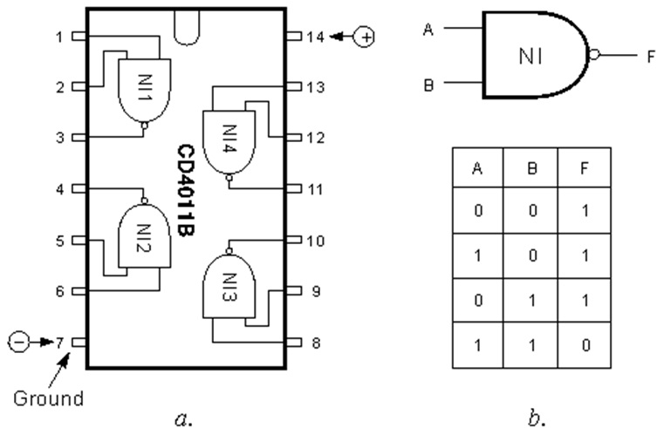
Fig. 3.34: a - 4011 pin placements, b - symbol and the truth table for NAND gates,
Logic circuits have many applications, but their main use is in computer circuits.
The following circuit is a simple example to show how the gates can be connected to produce a project that turns on a globe when a finger is placed on a "touch pad."
The globe turns off after a period of time, determined by the value of the 470u and 2M2 resistor.
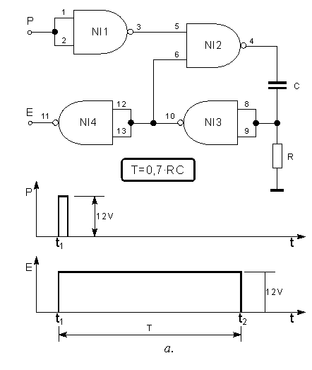
Fig. 3.35a. The operation of a NAND gate
Let’s look at the functionalities of the following circuit. Both inputs of NI1 are connected to each other, so when input P is HIGH, output is zero. This logic zero is passed on to NI2, so no matter what is on the input 6, output 4 is logic one. This means that, between the ground and pin 4, the voltage is equal to 12V.
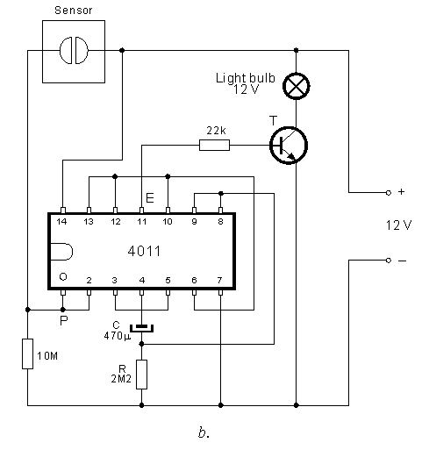
Fig. 3.35b: Sensor switch using a 4011

Current flows through capacitor C and resistor R, so capacitor begins to charge. Every uncharged capacitor behaves like a short circuit. Because of that, when 12V appears on pin 4, it is also present on resistor R and also on pins 8 and 9. Pin 10 shows logic zero because of this which is connected to pin 6. From now on, logic zero on pin 5 is no longer needed because only one input needs to be zero for the output to be logic one. So input P is no longer needed. Gates NI2 and NI3 maintain logic zero on pin 4. How long will this last? It depends on the value of the capacitor and resistor. As the capacitor charges, the voltage on the resistor drops and when it falls to 1/2 of the supply voltage (6V in our case), NI3 detects a low on its inputs so logic one appears on pin 10. Since logic one is now on input 5 (no logic one present on P), and on input 6, output 4 is zero, capacitor dumps its charge via diodes on the inputs on pins 8 and 9 and the circuit starts operating again.
As we saw, for a certain period of time, which is equal to T=0.7xRC output of pin 10 was logic zero. During that time output E (pin 11) is logic one.
For example, if R = 2M2 and C=47µF, for time
$$T=0.7x2.2x{10}^{6}x47x{10}^{-6}=72.38 sec$$
From the moment impulse on input P subsided, voltage on output E is 12V.
The end result of our experiment is on Fig. 3.35a. Short positive pulses appearing on P in the time t1 caused a longer variable pulse on output E.
Schematic Fig. 3.35b displays this circuit which allows us to light a bulb using four NAND gates interconnected in the way shown on picture Fig. 3.35a.
The sensor is two copper (or some other conducting material) plates glued to some non-conducting material (plastics, wood, etc.) in close proximity to each other. So, when we touch the sensor with the tip of our finger, we close the circuit. 12V appears on input P, which in turn conducts the voltage to the output E, resistor R = 22k conducts base current and the bulb lights. When we remove our finger, output E will last for 94 seconds, after which it goes to logic zero and the light goes out.
Transistor T is selected so that its maximum allowed collector current is higher than the current of the globe.
(The globes current flow value is found by dividing its power by its voltage. For example, if its power is P = 6W and voltage is V = 12V, current through the globe is I = P/V = 6W/12V = 0.5A or higher. One thing you must remember with a globe is the starting or "turn-on" current. It is about six times the operating current and the transistor must be able to pass this current for the globe to illuminate.

3.7.3.2 The 74 Series: 74LS, 74HC and 74HCT
There are several families of logic ICs numbered from 74xx00 onwards with letters (xx) in the middle of the number to indicate the type of circuitry, e.g. 74LS00 and 74HC00. The original family (now obsolete) had no letters, e.g. 7400.
The 74LS (Low-power Schottky) family (like the original) uses TTL (Transistor-Transistor Logic) circuitry which is fast but requires more power than later families.
The 74HC family has High-speed CMOS circuitry, combining the speed of TTL with the very low power consumption of the 4000 series. They are CMOS ICs with the same pin arrangements as the older 74LS family. Note that 74HC inputs cannot be reliably driven by 74LS outputs because the voltage ranges used for logic 0 are not quite compatible, use 74HCT instead.
The 74HCT family is a special version of 74HC with 74LS TTL-compatible inputs so 74HCT can be safely mixed with 74LS in the same system. In fact 74HCT can be used as low-power direct replacements for the older 74LS ICs in most circuits. The minor disadvantage of 74HCT is a lower immunity to noise, but this is unlikely to be a problem in most situations.
The 74 series is often still called the 'TTL series' even though the latest ICs do not use TTL!

The CMOS circuitry used in the 74HC and 74HCT series ICs means that they are static sensitive. Touching a pin while charged with static electricity (from your clothes for example) may damage the IC. In fact most ICs in regular use are quite tolerant and earthing your hands by touching a metal water pipe or window frame before handling them will be adequate. ICs should be left in their protective packaging until you are ready to use them.
3.7.3.3 PIC microcontrollers
A PIC is a Programmable Integrated Circuit microcontroller, a 'computer-on-a-chip'. They have a processor and memory to run a program responding to inputs and controlling outputs, so they can easily achieve complex functions which would require several conventional ICs.
For more information you can search on the internet or any electronic data book.
3.7.4.0 Testing Integrated Circuits(IC) the Accurate Way
Integrated Circuits are very difficult to test because of their numerous varieties but I can give you some clues which can help. If you are testing logic gate IC's, not the signal ones, you can use any search engine on the internet for example Google to search for the IC's number or search from electronic component data book. Apply your source to V_{CC} and ground (GND) pins, then apply your 5 V or ground to whatever inputs you desire and test the out. If there is 5V between the out and ground, then your output combination is true, and if you have 5V between your output and source voltage, then the output is low.
For signal IC's you need an oscilloscope to display the signals on the screen.

CHAPTER FOUR
4.0.0.0 Basic Building Block for an FM Transmitter
4.1.0.0 Introduction
When creating a system for transmitting a frequency modulated wave a number of basic building block have to been considered, the diagram below gives a broad impression of the transmitter and its individual parts.
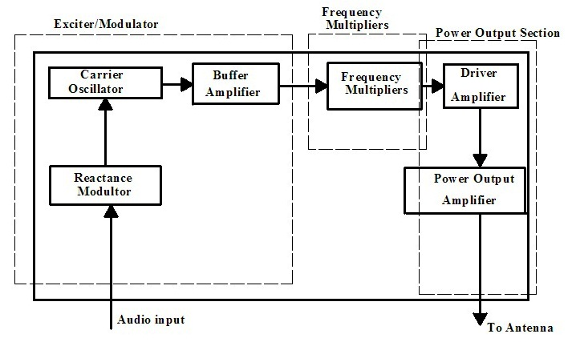
Fig 4.1 Basic block diagram of FM transmitter

4.2.0.0 General Overview
This gives the detail information about the block diagram above;
4.3.0.0 Exciter/Modulator
- Carrier oscillator generates a stable sine wave for the carrier wave. Linear frequency even when modulated with little or no amplitude change.
- Buffer amplifier act as a high impedance load on oscillator to help stabilized frequency.
- The Modulator deviates the audio input about the carrier frequency. The peak plus the audio will give a decreased frequency and the peak minus the audio will give an increase of frequency.

4.4.0.0 Frequency Multipliers
- Frequency multipliers tuned-input and tuned-output RF amplifiers. In which the output resonance circuit is tuned to a multiple of the input.
4.5.0.0 Power output section
- This develops the final carrier power to be transmitter. Also included here is an impedance matching network, in which the output impedance is the same as that on the load (antenna).
4.6.0.0 The Microphone
Microphones are acoustic to electrical transducers. The four best known variations of these are the moving coil (dynamic), ribbon, piezo-electric (crystal), and electrets (capacitor).The electrets type will be discussed because of incredibly small size and high performance at audio frequencies.
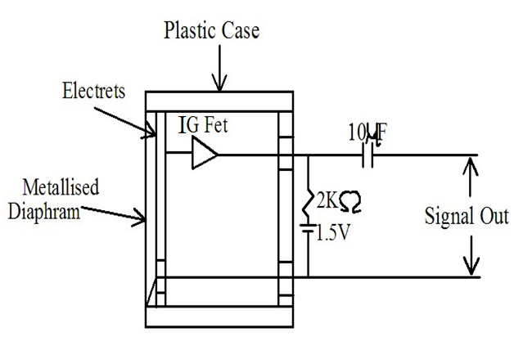
Fig 4.2 Microphone

A light weight metallized diaphragm forms one plate of a capacitor and the other plate is fixed, the capacitance thus varies in sympathy with the acoustic signal. The capacitance acquires a fixed charge, via a high value resistor (input impedance of FET) and since the voltage across a capacitor is equal to its charge divided by its capacitance, it will have a voltage output which is proportional to the incoming audio (base band).
The fixed plate at the back is known as Electrets which holds an electrostatic charge (dielectric) that is built in during manufacture and can be held for about 100 years. The IGFET (need to be powered by a 1.5 volt battery via a 1kΩ resistor) output is then coupled to the output by an electrolytic capacitor.
4.7.0.0 Pre - emphasis
Improving the signal to noise ratio in FM can be achieved by filtering, but no amount of filtering will remove the noise from RF circuits. But noise control is achieved in the low frequency (audio) amplifiers through the use of a high pass filter at the transmitter (pre-emphasis) and a low pass filter in receiver (de-emphasis).The measurable noise is 2KHz. At the transmitter, the audio circuits are tailored to provide a higher level; the greater the signal voltage yield, the better signal to noise ratio. At the receiver, when the upper audio frequencies signals are attenuated to form a flat frequency response, the associated noise level is also attenuated.
4.8.0.0 The Oscillator
The carrier oscillator is used to generate a stable sine-wave at the carrier frequency, when no modulating signal is applied to it. When fully modulated, it must change frequency linearly like a voltage controlled oscillator. At frequencies higher than 1MHz a colpitts (spilt capacitor configuration) or Hartley oscillator (spilt inductor configuration) may be deployed.
A parallel LC circuit is the heart of the oscillator with an amplifier and a feedback network (positive feedback). The Barkhausen criteria of oscillation require that the loop gain be unity and that the total phase shift through the system is 360º. In that way an impulse or noise applied to the LC circuit is fed back and is amplified (due to the fact that in practice the loop gain is slightly greater than unity and sustains a ripple through the network at a resonant frequency of $\frac{1}{ 2π\sqrt{LC}}$ Hz.
The Barkhaussen criteria for sine-wave oscillation may be deduced from the following block diagram.
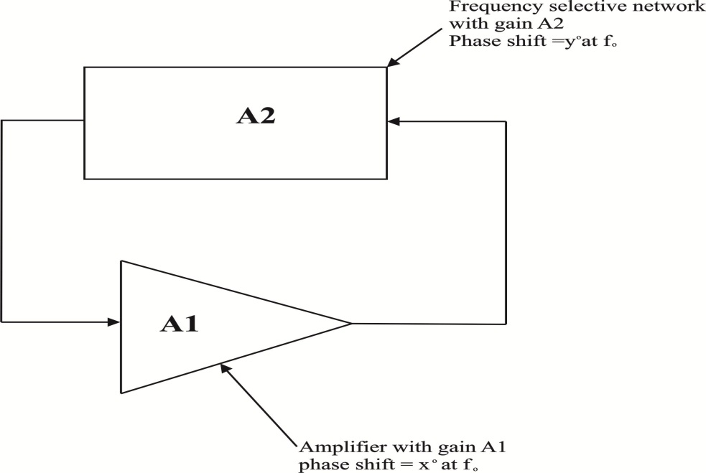
Fig 4.3 Block diagram for sine wave oscillator

Condition for oscillation is when
xº + yº = 0 or 360º
Condition for sine wave generation is when
A1 X A2 = 1
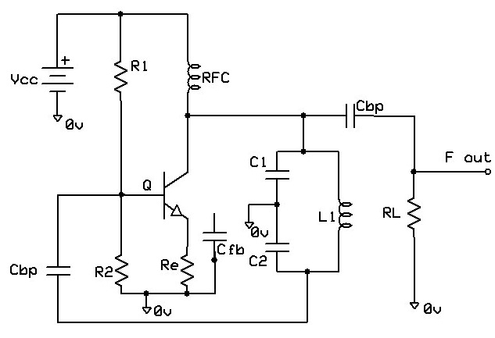
FIG. 4.4 An FM transmitter with colpitts oscillator

The above circuit diagram is an example of a colpitts oscillator; an LC (L1, C1 & C2) tank shown here which is aided by the common emitter amplifier and a feedback capacitor (Cfb) which sustains the oscillator. From the small signal analysis, in order for oscillation to kick off and be sustained
G_{m} x R_{L} = $\frac{C_{2}}{C_{1}}$ the frequency of the oscillator is found to be
$\frac{1}{2π√LC}$ , where C is $\frac{C_{1} x{ C}_{2}}{C_{1}+C_{2}}$
4.9.0.0 Reactance modulator
The nature of FM as described above is when the base band signal is zero, the carrier is at its carrier frequency, when it peak of the carrier deviation is at a maximum and when it troughs the deviation is at it minimum. This deviation is simply quickening or slowing down of frequency around the carrier frequency by an amount proportional to the base signal. In order to convey the characteristic of FM on the carrier wave the inductor or capacitance (of the tank) must be varied by the base band. Normally the capacitance of the tank is varied by varactor diode. The varactor diode (seen below) when reverse bias has a capacitance across it proportional to the magnitude of the reverse bias applied to it. The formula for working out the instantaneous capacitance is decreased.
VARACTOR DIODE CAPACITANCE
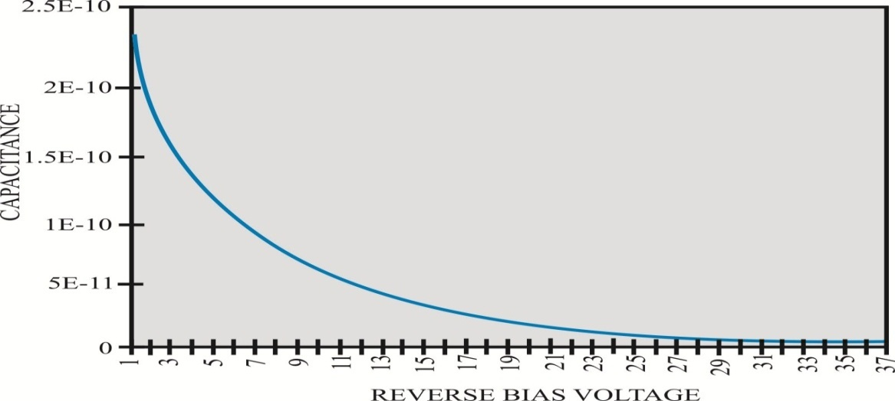
Graph 4.1 Reactance modulator of varactor diode capacitor.

$CD=\frac{C_{O}}{\sqrt{1+2\left|V_{R}\right|}}$ Where $C_{O}$ is the capacitance at zero Reverse bias voltage.
Applying this to an LC tank; as the capacitance decreases the frequency increases. So placing a fixed reverse bias on the varactor will yield a fixed capacitance which can be placed in parallel to the capacitor and inductor. A bypass capacitor can be used to feed the base band voltage to the diode, the sine-wave base band voltage has the effect of varying the capacitance of the varactor up and down from the level set by the fixed reverse bias voltage. As the base band peak varactor capacitance is at it minimum, the overall frequency will increase; applying this logic to when the base band trough frequency will decrease. Looking at the three cases for the varactor diode that is maximum capacitance, nominal capacitance set by bias (no modulation) and minimum capacitance and observing the frequency will show that by modulating the reactance of the tank circuit will bring about Frequency Modulation.
$$F_{NOM} =\frac{1}{2π\sqrt{L (C1 + C_{d NOM})}}$$
With no baseband influence (the carrier frequency)
$F_{MIN} =\frac{1}{2π\sqrt{L (C1 + C_{d MIN})}}$ OR $F_{MAX} =\frac{1}{2π\sqrt{L (C1 + C_{d MAX})}}$
With peak negative baseband influence with peak positive baseband influence
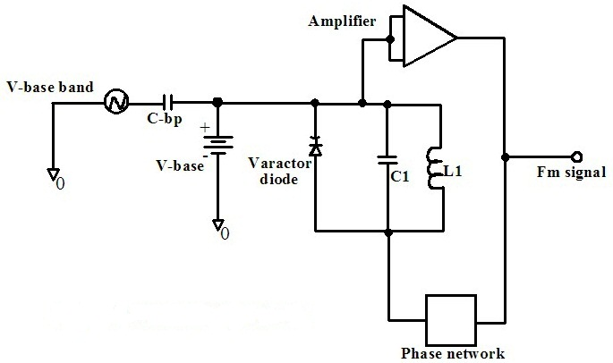
Fig. 4.5 Rector modulator circuit.

The diagram above shows a proposed modulation scheme, with the amplifier and phase network discussed earlier in the oscillator section.
4.10.0.0 Buffer Amplifier
The buffer amplifier acts as a high input impedance with a low gain and low output impedance associated with it. The high input impedance prevents loading effects from the oscillator section, this high input impedance may be looked upon as RL in the oscillator frequency.
Looking at the Buffer amplifier as an electronic block, circuit, it may resemble a common emitter with low voltage gain or simply an emitter follower transistor configuration.
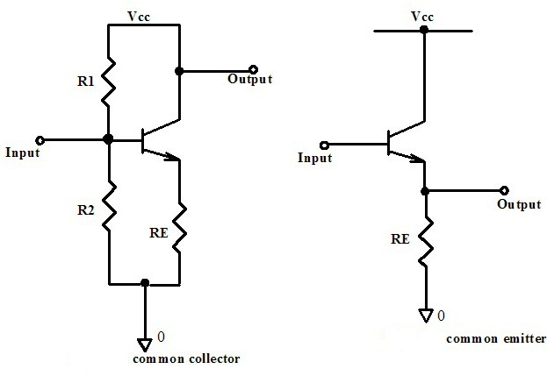
Fig.4.6 common collector and common emitter amplifier.

4.11.0.0 Frequency Multipliers
Frequency modulation of the carrier by the base band can be carried out with a high modulation index, but this is prone to frequency drift of the LC tank. To combat this drift, modulation can take place at lower frequencies where the Q factor of the tank circuit is quite high (low bandwidth or less current deviation) and the carrier can be created by a crystal controlled oscillator. At low frequency deviations the crystal oscillator can produce modulated signals that can keep an audio distortion under 1%. This narrow band angle modulated wave can then be multiplied up to the required transmission frequency; the deviation brought about by the base band is also multiplied up, which means that the percentage modulation and Q remain unchanged. This ensures a higher performance system that can produce a carrier deviation of ±75KHz.
The frequency multipliers are tuned input, tuned output RF amplifier, where the output resonant tank frequency is a multiple of the frequency. The diagram of the simple multiplier below shows the output resonant parallel LC tank which is a multiple of input frequency.
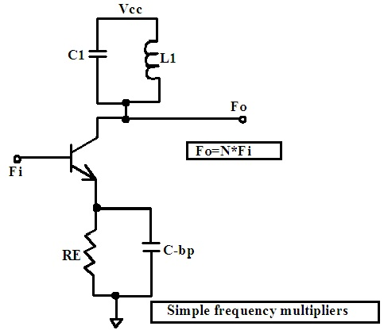
Fig.4.7 Frequency multiplexer
4.12.0.0 Driver Amplifier
The driver amplifier can be seen to do the same function as the buffer amplifier, i.e. a high input impedance, low gain (close to unity) and low output impedance between the frequency multiplier and power output stages of the transmitter. The circuitry is the same as in the buffer amplifier description.

4.13.0.0 Power Output Amplifier
The power amplifier takes the energy drawn from the DC power supply and converts it to the AC signal power that is to be radiated. The efficiency or lack of it in most amplifiers is affected by heat being dissipated in the transistor and surrounding circuitry. For this reason the final power amplifier is usually a class C amplifier for high powered modulated system or just a class B push-pull amplifier for use in a low level power modulated transmitter. Therefore the choice of amplifier type depends greatly on the output power and intended range of the transmitter.
4.14.0.0 Antenna
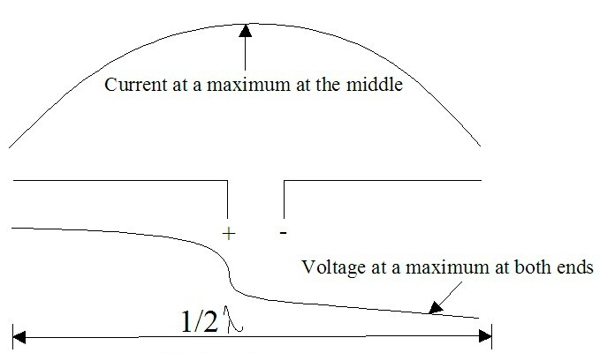
Fig.4.8 Antenna
The final stage of any transmitter is the Antenna. This is where the electronic FM signal is converted to electromagnetic waves, which are radiated into the atmosphere. Antennas can be vertically or horizontally polarized, which is determined by their relative position with the earth’s surface (i.e. antenna parallel with ground is horizontally polarized). A transmitting antenna that is horizontally polarized transmits better to a receiving antenna that is horizontally polarized; this is also true for vertically polarized antennas. One of the intended uses for the transmitter is as a tour guiding aid or for dissemination of information on campus, where a Walkman shall be used as the receiver. For a Walkman the receiving antenna is the co-axial shielding around the earphone wire. The earphone wire is normally left vertical; therefore a vertically polarized whip antenna will be the chosen antenna for this particular application.
4.15.0.0 Radiation Resistance
The power radiated by an antenna is giving by the Pointing vector theorem ρ = E × H watts/m². By getting the cross product of the E (electric field) and H (magnetic field strength) field, multiply it by certain area (π r²) and equating the resulting power to I² Rr, Rr the radiation may be obtained. I is the current through the resistance.
I²Rr = Power = 80 π² I² ${\left(\frac{dl}{λ}\right)}^{n}$
Rr = 80 π² ${\left(\frac{dl}{λ}\right)}^{n}$
Where dl is the length of the antenna, λ is the wavelength and n is an exponent value that can be found by using (dl/ λ) on the y-axis and then n can be found on the x-axis.

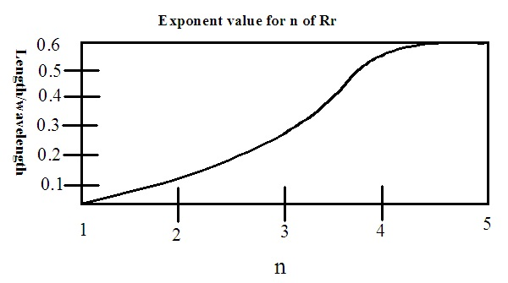
Graph 2.2 A graph of Radiation Resistance

Taking a center fed dipole with a length of approximately half a wavelength in practice is shorter (95% of the theoretical length). For dl half the wavelength, n is found to be 3.2.
Rr = 789.5 x (0.5 x 0.95) ^{3.2} = 72.9Ω or 73 Ω.
For an end fed half wavelength making a few elementary changes to the above equation, i.e making the length 97% and halving and then negating the exponent to give n = -1.6 which results in the radiation resistance equal to 789.5 x (0.5 x 0.975) ^{– 1.6} = 2493 = 2.5k Ω
4.16.0.0 Power transfer
Maximum power transfer between the antenna and the electronic circuitry will have to be looked at in order to produce an antenna that will be efficient in transmitting an audio signal to receiver. Taking the case of the receiver with an antenna of impedance Z_{in} connected with the input terminal, which is terminated with a resistance R_{g}. The maximum power transfer theorem shows that with a voltage induced in the antenna the current flowing into the receiver will be I= $\frac{V}{(Zin + Rg)}$. The power transferred will be I².R_{g}, differencing the power with respect to R_{g} and letting derivatives equal to zero for maximum power transfer, it is shown that Z_{in} + R_{g} = 2R_{g}, which means that R_{g} will be equal to Z_{in}.

4.17.0.0 Reciprocity
In transmitting system, a radio-frequency signal is developed, amplified, modulated and applied to the antenna. The RF currents flowing through the antenna produce electromagnetic waves that radiate into the atmosphere. In a receiving system, electromagnetic waves “cutting” through the antenna induce alternating currents for use by the receiver.
Antenna serves either or both of the following two functions:
- generation
- collection of electromagnetic energy.
Any receiving antenna transfers energy from the atmosphere to its terminals with the same efficiency with which it transfers energy from the transmitter into the atmosphere. This property of interchangeability for transmitting and receiving operations is known as Antenna Reciprocracy. (Modern Electronic Communication fifth edition by Gary M. Miller page 549)
4.18.0.0 Hertz Dipole
The hertz antenna provides the best transmission of electromagnetic waves above 2MHz, with a total length of ½ the wavelength of the transmitted wave. Placing the + and – terminal in the middle at the antenna and ensuring that the impedance at the terminals is high (2500 Ω) and the impedance at the opens ends is low (73 Ω). This will ensure that the voltage will be at a minimum at the terminal and at a maximum at the ends, which will efficiently accept electrical energy and radiate it into space as electromagnetic waves. The gap at the center of the antenna is negligible for frequencies above 14MHz.
4.19.0.0 Monopole or Marconi Antenna
Guillermo Marconi opened a whole new area of experimentation by popularizing the vertically polarized quarter wave dipole antennas, it was theorized that earth would act as the second quarter wave dipole antenna. Comparing the signal emanating from the quarter wave antenna in μV/m, it has been shown experimentally that for a reduction in the antenna from λ/2 to λ/4 a reduction of 40% (μV/m) takes place, for a reduction $\frac{λ}{4} to\frac{λ}{10}$ a reduction of only 5% in μV/m . This slight reduction of 0.05 in transmitted power for a decrease of 0.75 in antenna length seems impressive, but there is decrease in the area of coverage.
When considering an antenna type and size for this project, two things have to be taken into account:
- the frequency of transmission
- the portability of the antenna.
Transmitting in a frequency range of 88 to 108MHz, the mean frequency is (88 x 108) ^{½} = 97.5MHz, rounding this off to 100MHz , calculating the wavelength gives (3 x 108/ 100 x106) yield a wavelength of approximately 3 meters, λ/2 = 1.5m, λ/4 = 0.75m, λ/10 = 30cm.
The above analysis concludes that the use of an adjustable end fed whip antenna with an effective length of 30cm to 75cm could be used with considerable effect.
4.20.0.0 Impedance Matching
Between the final power amplifier of the transmitter and the antenna, an impedance matching network maybe considered. One of the possible surprises in power amplifiers is the realization that output impedance matching the load to the device output impedance result in power transfer at 50% efficiency.
An impedance matching system maybe merely a special wide-band transformer which is used for broadband matching (i.e. between 88 to 108 MHz), which maybe a two pole LC band-pass or low pass resonant circuits to minimize noise and spurious signal harmonics. The purpose of the impedance matching network is to transform load impedance to impedance approximate for optimum circuit operation. Detailed analysis and calculations will be used latter on when evaluating the final design of the system.
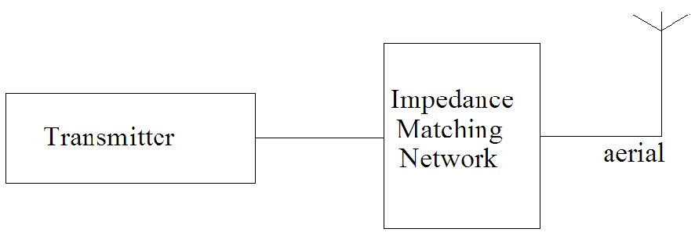
Fig.4.9 A block diagram of impedance matching.
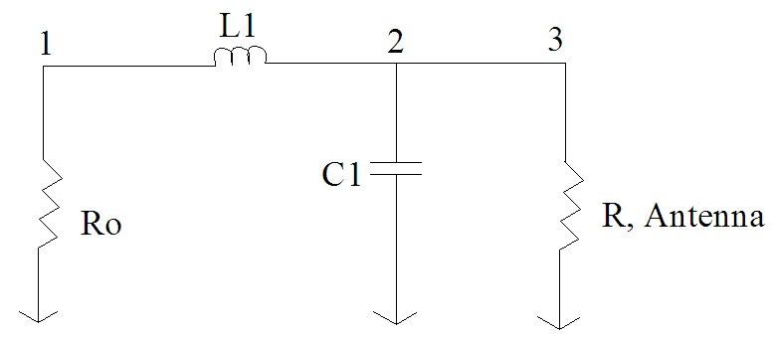
Fig.4.10 Circuit analysis in impedance matching

Here are a few equations that determine the inductance and capacitor values of fig. 4.10, when R_{L} (resistance of the antenna) and R_{o} (the output impedance of the antenna) are known
$$Q=\sqrt{\left(\frac{R_{L}}{R_{O}}\right)-1}$$
$X_{L}=\sqrt{R_{O}R_{L}-R_{O}}$²
$X_{C }$=$\frac{R_{O}R_{L}}{X_{L}}$
The use of this matching network is predicted on the fact that R_{o} < R_{L} according to the equation for calculation the inductance X_{L}. This method of matching is similar to the so called quarter wave transformer for transmission lines.

CHAPTER FIVE
5.0.0.0 DESIGN, CONSTRUCTION AND ASSEMBLY
5.1.0.0 Introduction
Considering all the factors ranging from frequency modulation theory (chapter 1) to basic building block for an FM transmitter (chapter 4), it is now possible to have a look at complete FM transmitter designs. There are two different possible designs covered in this chapter, each includes a diagram and a brief explanation on how it works and discussion on whether it meets the criteria of this project, i.e. (easy to design and the component can be easily gotten from the market) after which the chosen transmitter will be designed, constructed and then assembled.
5.2.0.0 The Two Transistor FM Transmitter
Although only low power this circuit may be tuned to operate over the range 87-108MHz with a range of 20 or 30 feet.
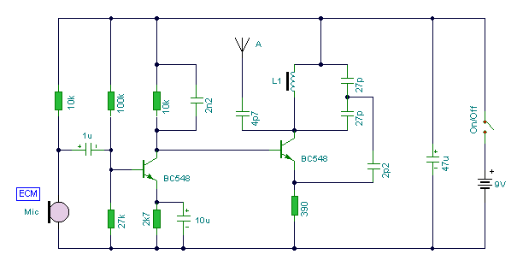
Fig. 5.1 schematic of a two transistor transmitter.
This FM transmitter is built around two amplifiers, the first transistor BC 548 is a common emitter with a dc gain of 1 and AC gain that can be set by the 10K resistor on the collector of this transistor. This will amplify the signal from the Electret Condenser Microphone (ECM) and pass it on to the next stage.
The next transistor, BC548 is the heart of the RF section. The RF section is a colpitts oscillator in the common-base mode. The inductor L1 is a variable one and the effective capacitance of the two 27pF work out the center frequency. The base-collector junction capacitance (which acts like a varactor diode) is varied as the amplified base-band signal changes its reverse-bias voltage, this capacitance will inevitable be part of the overall tuning capacitance of the resonant tank. The antenna, (very short end fed wire) can be resistively matched by an ordinary low –value resistor.
This is a nice design but it has some flaws. Some of these flaws are;
- There is no coupling capacitor between the two transistors to prevent DC from entering the RF section hence there might be distortions in the output.
- Though the oscillator is a colpitts oscillator it uses an inductor with a ferrite core which makes it a variable inductor. This type of inductor is difficult to design and rear in the Ghanaian market.
Some of these flaws will be improved in the next design to make things better.
5.3.0.0 A Second Two Transistor Transmitter.
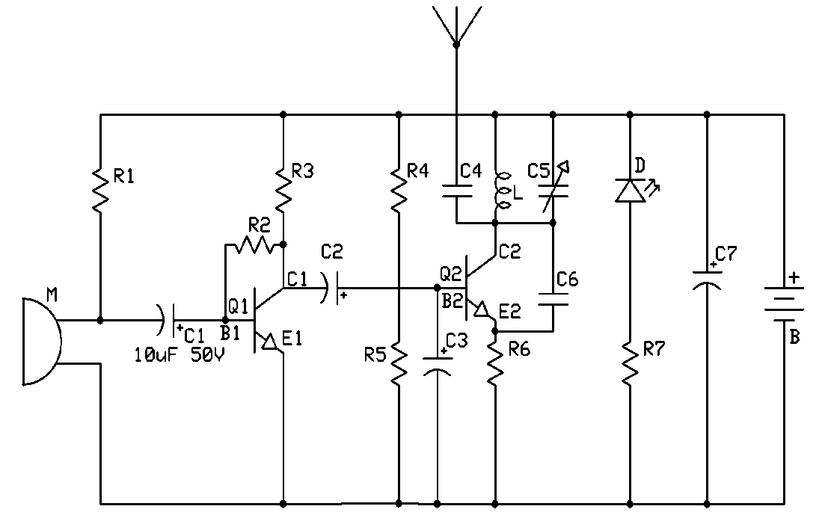
Fig. 5.2 Schematic diagram of an easy to do and better two transistor FM transmitter.
The circuit above is an FM transmitter which can transmit audio signals which will easily penetrate over 30feet in an apartment building and go over 60 feet in the open air. The audio signals enter the transmitter through the microphone (M).
First amplification stage: this is a standard self-biasing common emitter amplifier. The capacitor C1 is a coupling capacitor which isolates the microphone from the base voltage of the transistor and only allows alternating current (AC) signals to pass. R2 and R3 are base bias resistors that provide transistor Q2 its base current. R3 is the load resistor which produces an output voltage. C2 is a coupling capacitor which allows the amplified AC signal to be transferred to the base of transistor Q2. R4 and R5 also provide bias voltages to transistor Q2.
The tank (LC) circuit: every FM transmitter needs an oscillator to generate the radio Frequency (RF) carrier waves. The tank (LC) circuit, the transistor Q2 and the feedback capacitor C6 are the oscillator in the transmitter. An input signal is not needed to sustain the oscillation. The feedback signal makes the base-emitter current of the transistor vary at the resonant frequency. This causes the emitter-collector current to vary at the same frequency. This signal is fed to the aerial and radiated as radio waves. The coupling capacitor C4 on the aerial is to minimize the effect of the aerial capacitance on the LC circuit. The name 'tank' circuit comes from the ability of the LC circuit to store energy for oscillations. In a pure LC circuit (one with no resistance) energy cannot be lost. (In an AC network only the resistive elements will dissipate electrical energy. The purely reactive elements, the C and the L simply store energy to be returned to the system later.) Note that the tank circuit does not oscillate just by having a DC potential put across it. Positive feedback must be provided.
The transmitter above is a very good transmitter and it’s an effective transmitter which can be easily designed and has a good range. This design will be chosen as the final design and improved upon because it meets the criteria of the project.
5.4.0.0 Final Design
This section i will discuss the final design in detail and give instructions on how it can be built and implemented.
After considering many circuits available this design can be applied for transmitting human voice and audio sound across the commercial bandwidth (88MHz to 108MHz). Although the variable capacitor C6 is set up to transmit from 88 to 108MHz, the transmitter only has effective tuning range 87.5MHz.this is due to the feedback capacitor C7 been at the right impedance for positive feedback to occur.

5.5.0 .0 Transmitter Circuit Diagram
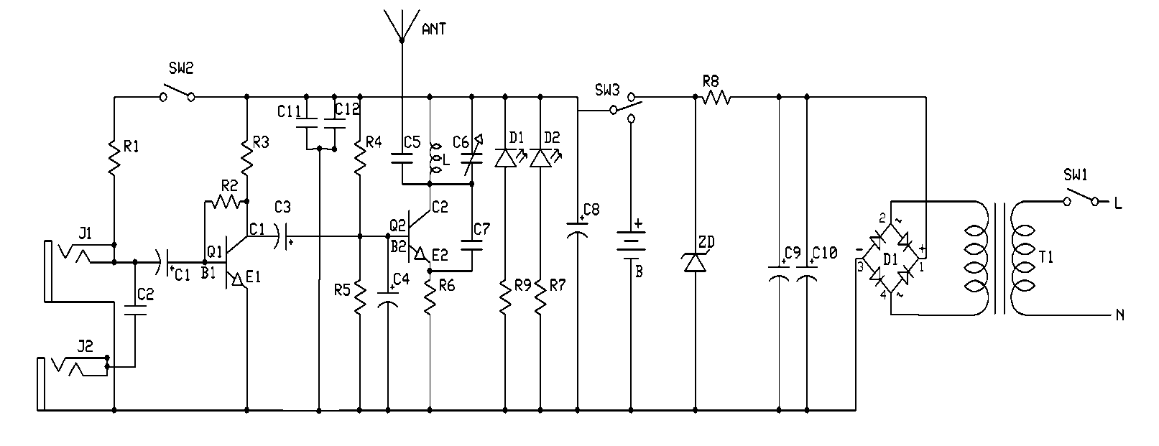
Fig. 5.3 Schematic of the final design of a two transistor FM transmitter.
The circuit diagram in section 5.3.0.0 has been modified in this section. Now the transmitter has two in puts. Input J1 is a jack plug into which a microphone can be plugged. This is done to make the mic detachable. Switch SW2 is used to isolate the mic from the circuit when the phono socket J2 is in use and R1 provides a DC bias for the mic, the greater the resistance, the less sensitive the microphone. The smaller the resistance the more sensitive the microphone.
Phono socket J2 is used to input audio or music from a computer or any device with an audio output. C2 is a coupling capacitor joining J2 to the base of Q1.
After amplification by the transistor Q1 the signal is coupled to the base of transistor Q2 via capacitor C3. Resistors R4 and R5 provides a bias voltage for Q2. R6 is there to compensate for the effect of temperature when there is an increase in collector current. It gives a lower base voltage across the base emitter circuit hence stabilizing the circuit.
The resonant circuit is made up of the parallel connection of variable capacitor C6 and the inductor L. the collector current of transistor Q2 flows less than half a cycle. The parallel resonant circuit filters the pulse of the collector current and produces a pure sine wave of output voltage. The AC input voltage drives the base and an amplified output voltage appears at the collector. The amplified and inverted signal is then capacitively coupled to the antenna via capacitor C5. The output voltage is maximum at the resonant frequency ($F_{r}$). Since the oscillator is a colpitts, the resonant frequency can be calculated with the formula
$F_{r}=\frac{1}{2π\sqrt{LC}}$ Where L is the inductance of the LC tank and C is the capacitance of the C6.
The transmitter has a positive feedback this gives the transmitter a narrow bandwidth and hence a peaking frequency response. The positive feedback through capacitor C7 introduces instability for both the AC and DC thereby causing possible oscillation and unstable quiescent conditions.
The LED is a power indicator which shows that the transmitter is working. The resistor R7 causes a voltage drop across it thereby reducing the voltage across the LED. The capacitor C8 is a decoupling capacitor.
The Zener diode (ZD) acts like a voltage regulator. The voltage output is from the C9 and C10 are shared between the resistor R8 and the Zener diode. If the output voltage changes the voltage the voltage across the resistor changes but that of the Zener diode remains constant. The capacitor C9 and C10 are filter capacitors which remove the AC contents of the power supply to ground. Since electrolytic capacitors allow AC to pass through them but prevents DC from doing so, it causes the AC contents to be filtered to ground and the DC be stored by the capacitor. The bridged diodes D1 rectify or change alternating current (AC) to direct current (DC) which can be used to power the transmitter. The transformer T1 is a step down transformer which steps down power from the mains (i.e. 220 to 12V) to be rectified and used by the transmitter.
5.6.0.0 Construction
The first thing to do is to construct a prototype on a bread board. The picture of the prototype I assembled is shown below in picture 5.1.
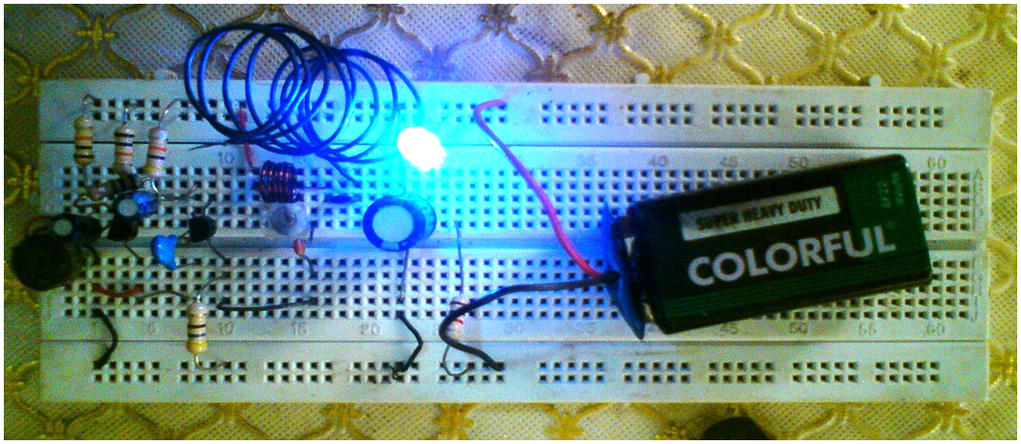
Picture 5.1 Prototype of the FM transmitter mounted on a bread board.
The prototype did not work as desired though audio signals were transmitted to the receiver. This happened because, to get a good results the leads of the components must be as short as possible and the components compact which was not so in this case which led to undesirable conditions like distortions in the modulated signals.
5.7.0.0 Part list
Part number | Component value | Type | Function
J1 | 3.5mm | Jack socket | To Connect A Microphone
J2 |  | Phono socket | To connect the transmitter to either an MP3 player or PC.
R1 | 10K | Carbon film | Bias for electret mic
R2 | 1M | Carbon film | Dc bias for the base of Q1
R3 | 10K | Carbon film | Dc bias for the base of Q1
R4 | 10K | Carbon film | Sets the DC and AC gain of Q1
R5 | 10K | Carbon film | Sets the DC and AC gain of Q1
R6 | 220 | Carbon film | Sets the gain of the oscillator
R7 | 820Ω | Carbon film | Reduces the voltage across the LED.
R8 | 100 | Carbon film | It helps ZD to regulate the voltage
C1 | 10uF 50v | Electrolytic capacitor | Audio coupling capacitor
C2 | 0.1uF |  | It’s a coupling capacitor
C3 | 10uF 50V | Electrolytic capacitor | Forms a high pass filter with R4 and biases Q2 and also a coupling capacitor.
C4 | 103pF | Ceramic capacitor | It AC grounds the base of Q2
C5 | 27pF | Ceramic capacitor | Coupling signals to the antenna.
C6 | 1-45pF | Silver mica | Tuning capacitor for multichannel.
C7 | 5.6pF | Ceramic capacitor | Feedback for oscillation
C8 | 47uF 63V | Electrolytic capacitor | Its decoupling capacitor
C9 & C10 | 2200uF 50V | Electrolytic capacitor | Filtering capacitors
Q1 | BC 547 | TO-92 | Amplification of signals
Q2 | BC 547 | TO-92 | The heart of oscillation
D1 | Bridged diodes | 1N4001 X 4 | Rectification diode
D | LED | Tri-color LED | A power indicator
ZD | 12V |  | Voltage Regulator
T1 | 240V to 12V |  | Steps down the AC voltage to 12V AC.

5.8.0.0 Preparing the Circuit Board
A printed circuit board will be the best option because it is easily to mount components and also easy to trouble shoot in case there is a fault. In this project a printed circuit board was not used because it is time involving to design it and the chemicals used are not common in the Ghanaian market. I made use a perforated circuit board cleaning the copper surface with steel wool to remove the corroded surface of the circuit board.
5.9.0.0 Assembly
The components were assembled on the perforated board and soldered as shown in picture 5.2 below.
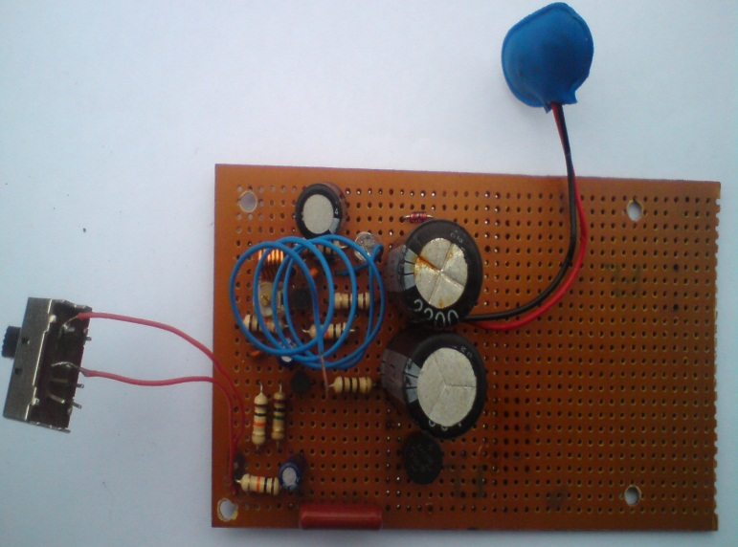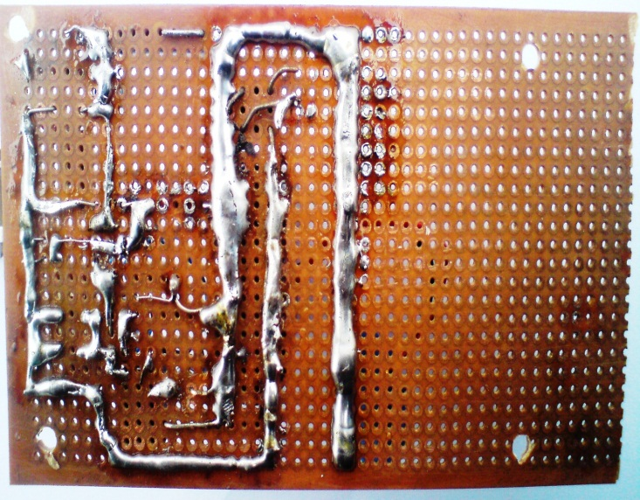
Picture 5.2 components of the FM transmitter mounted on a circuit board.
Though the soldering is not the best it was done to give the circuit a good grounding to prevent distortions.
5.10.0.0 Casing the Transmitter
In casing the transmitter a Dell system unit power supply case was used. This was done because it was the only case on hand. You can make a case for it yourself using a metal sheet but it is cost involving. In this project the power supply was housed with the transmitter which will cause the transmitter to hum when connected to the mains. This can be reduced by separating the transmitter from the main supply or shielding the RF section or using a very smooth, ripple free power supply or battery.
5.11.0.0 Testing the FM Transmitter
To test the transmitter you will need the following;
- The transmitter
- An FM radio receiver
- Microphone
- Phono pin plug
First, put the receiver and the transmitter next to each other. Turn on the receiver and tune it to a place on the FM dial where there is no radio station broadcasting (so you hear only static). Now carefully turn the trim cap inside the transmitter slowly until you hear the static disappear from the radio receiver and hear only silence. This may take a few attempts. If all is well you should be able to tune the receiver like this so it broadcasts silence on the place where you have tuned the radio receiver.
Now, if you have silence on your radio plug in a CD player or MP3 player to the transmitter via the phono socket and press play. Alter the volume of the player until you have a nice clear sound on the radio receiver. You can also connect a microphone to the transmitter to transmit speech via the 3.5mm jack socket in front of the transmitter.
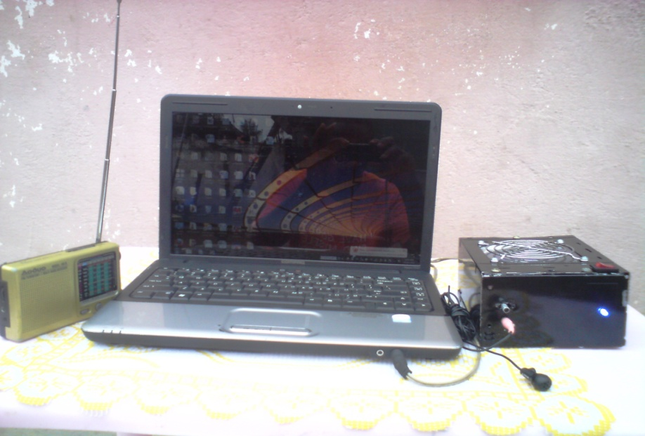
Picture 5.3 Testing the FM transmitter with a radio receiver.
5.11.1.0 Spectrum Analyzer
The spectrum analyzer is exactly what the name implies; it shows the frequency response over a specified width in the frequency domain. The spectrum analyzer that was used was the MS610C from Antristu. The Antristu has a dynamic range of 9 KHz to 2GHz. The spectrum analyzer was used to view the varying effects of the carrier when it was modulated by the base band audio signal. The signal strength was also measured using the analyzer.
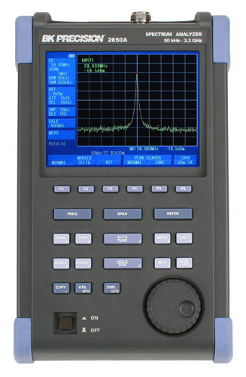
Picture 5.5. The picture above shows the spectrum of the carrier been modulated by the base audio signal.
CHAPTER SIX
6.0.0.0 CONCLUSION AND RECOMMENDATION
6.1.0.0 Introduction
The fundamental aim of this project was to practically analyze electronic components and use them in the design construction an FM transmitter for modulation across Accra Polytechnic main campus. This final chapter shall begin with a detail discussion of the main topics from initial approach to final design and implementation. Also in this chapter a number of conclusions shall be drawn from the approach that I have taken and finally recommendations on what should be done.
6.2.0.0 Report Overview
When considering a design for modulation, a number of key elements have to be considered, such as a good understanding of the concept of modulation schemes and the electronic circuitry that goes into creating the scheme.
In chapter 1 and 2 of this project the theory of frequency modulation was covered. Chapter 3 gave a practical analysis of some common electronic components like resistors, capacitors, inductors, diodes, transistors and integrated circuits(IC) and their properties. In chapter 4 the various building blocks were introduced and their possible use in the design was considered. In chapter 5 a quantitative overview of some of the possible designs that were considered in the progress of the project was given. A detailed description of how each design works was given along with why the design was not chosen. The final design was discussed in full along with detail of construction and assembly, pictures of the final circuit enclosed in a Dell system unit power supply case to give the reader of the project report a general feel of what the final transmitter looks like. The chapter finally ended with the results of the various test used on the design.
6.3.0.0 Discussion
The design chosen was miniature, low powered and tunable to different frequencies. Most of the parts used are very common and the circuit easy to construct. The circuit was first built on a bread board and it well without applying any real effective RF techniques. All that had to be adhered to was to keep the leads short and the circuit compact as much as possible. The circuit board as expected performed exceedingly well, but more of a better attempt had to be made in matching the antenna (section 4.20.0.0) and shielding the RF section from the output as the circuit board layout allows a lot more efficient in radiating power out. Unwanted Electro-magnetic radiation had to be stopped from destructively interfering with the carrier modulation. This is mostly seen when the transmitter is connected to the mains, there is a hum in the output. This is caused by ground loops, which happens when two or more devices are connected to a common ground through different paths. The ripples from the mains enter the transmitter and hence cause distortion.
The effective range of the transmitter was 50 feet in open air and 30 feet indoors which makes it to be used in a small community for example the electrical engineering department on Accra Poly campus. The device can also be used as a baby monitoring device. The transmitter designed is actually a prototype just to show the basics.
6.4.0.0 Conclusion
Working on a topic of such nature involves a deal of time, research, determination and hard work. For the past few months this project was being prepared and the system had been constant test. Although it is not very sophisticated, it has proved worthy. Considering the fact that the system has worked almost satisfactory and reliably during testing period, it would not be an exaggeration to proclaim that the project has been a success.
But there has been so many problems encounter during the research on the construction of this project title. Some of the problems encountered are as follows;
- The main problem i encounter was the unavailability of some of the components. Because most of the components in the circuit were experiment components, they were not available on the market so some of the equivalent components were substituted which at the long run produced defect on the circuit since they have similar but slightly different characteristics.
- Men on the work refuse to give information especially on the circuit design of which they all exercised fears of competition on the market with other manufactures.
- Unavailability of case for the transmitter made me to case the power supply and the transmitter which made the transmitter to hum when an AC cord is connected to it to the mains.
Besides, this project work has really helped me a lot. It has made me aware of how possible it is to connect integrated circuits i.e. IC and also to know how to accurately test some common electronic components. The project further elaborated on the advantages of FM signals over AM signals.
Others include the use of passive and active components in a circuit, preparing and mounting of components as well as soldering on a printed circuit electronic board. And the last but not the least, it has taught me what to do and where to go for information about any project i will carry out in the near future.
Finally, this project has enlightened me a lot about the whole project work, what it entails, how it works and how it is constructed. This project has really been a success. The FM transmitter is essentially a design and implementation project. To approach a project like this a parallel path has to be taken in regards to the theory and the practical circuitry. I conclude that the FM transmitter is perfectly working and well designed.
6.5.0.0 RECOMMENDATIONS
As this project has been successfully completed, it means much had been done but I can still say there is more to do. During the design of this project, heat was not considered for a reason. I would like to recommend that, in case a construction of such nature is done the exact components must be used. Heat effect can be eliminated by placing circuit component liable to be affected by variation of temperature in thermostatically controlled apartment.
Unstable voltages, heat under positioning and defects which contribute to unstable carrier frequency must be seriously considered or avoiding sideband overlapping which causes interference when frequencies drift and gets nearer to an already allocated carrier frequency.
The power supply should not be housed with the transmitter because this will cause serious humming in the output of the transmitter. If this is done then the supply should be free of any ripples.
The correct size of resistors must also be used for the work to ensure appropriate power dissipation. An input sensitivity of 10mV and input impedance of 10Ω are recommended for this circuit. A maximum DC voltage supply of 12V is also desired where the work is possible to generate a carrier frequency ranging from 88 – 108MHz. The impedance of the feeder to the antenna should range from 50 – 70Ωs.
Finally, the strength or power output of the transmitter depends on the strength or rating of the radio frequency amplifier or the driver stage.
REFERENCES
- Dugan Frank (199 3): ELECTRONIC COMMUNICATION,
Delmar learning New York USA Page 188-120, 127, second Edition.

- Hughes Edward (1996): ELECTRONIC TECHNOLOGY
Prentice Hall Harlow, England Page 187, seventh edition.

- Bets J.A (1973): SIGNAL PROCESSING, MODULATION AND NOISE.
Hodder and Stoughton Limited UK Page 63, second edition

- Graf F Rudolf(1997): Modern Dictionary Of Electronics
In the United State of America page 296 - 297

5. Green DC: RADIO SYSTEM FOR TECHNICIANS,
Longman UK Page 131, 132
6. www.paia.com
Visited on the 27th July, 2010
7. www.membertripod.com
Visited on 3rd August, 2010.
8. www.uashem.com
Visited on 5th May 2010.
9. www.electronics-project-design.com
Visited on 5th August 2010.
10. www.microe.com
Visited 7th August 2010
11. www.nca.org.gh
Visited 15th August 2010

